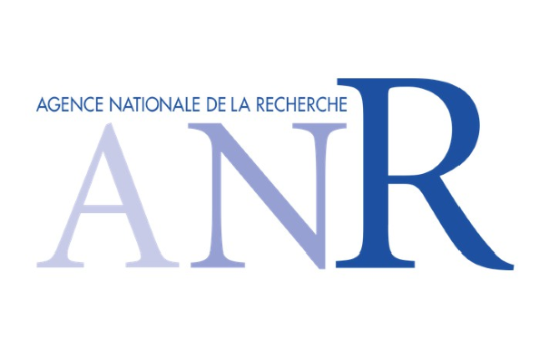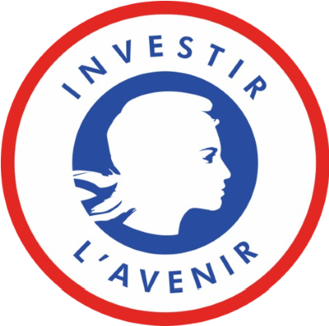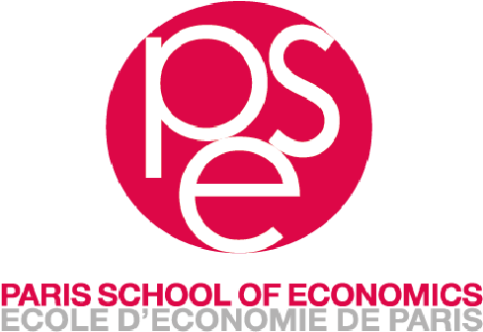
Paris, 23 April 2024
Call for Projects – 2024/42

The steering committee of the EUR PGSE (University Research School-Paris Graduate School of Economics) has decided to establish a "Research Fund" aimed at providing material support for research projects by members of the EUR PGSE. This call for projects is open to researchers and doctoral students of the EUR PGSE.

These funds are made available to the researcher for a period of one year to finance, for example, data collection, assistant recruitments (exceptionally for doctoral students). The use of these funds for disbursements to third parties (partners or non-partners of the EUR) aimed at pooling multiple sources of funding (for data purchase or payment for data access) is not possible. Support from the EUR PGSE cannot exceed €5000. The jury will pay particular attention to:
- Projects involving young researchers
- The originality of the projects and their scientific relevance to the EUR PGSE
- The difficulty for the researcher in finding other sources of funding (young researchers and researchers who have recently arrived in France or at PSE)
- Efforts devoted to seeking additional funding. It is reminded that PSE has established a funding scheme for doctoral stays at foreign universities, therefore, these stays are not prioritized for funding by the FDR EUR PGSE. Similarly, missions (conferences, etc.) are not covered by this call.
- The effort to pool resources with other researchers, particularly for funding access to CASD (shared projects, shared devices...)

The application must be submitted in English and include the following documents:

- A title specifying the project name and the amount requested
- A brief description of the project and its objectives (maximum 5 pages)
- A detailed budget specifying, if applicable, financial partnerships.

If you need to engage a service provider (for example, for data digitization or database purchase), please provide the corresponding quotes. You must clearly indicate your status when requesting quotes (for example, CASD rates are lower for doctoral students than for researchers).

Applications must be sent by email to the following address: elisabeth.dedieu@psemail.eu

The deadline for project submissions is set for May 12, 2024, at midnight.

48 Boulevard Jourdan – 75014 Paris France SIRET 49.39.02.662.000.11- APE 9499 Z

