. The self-made man Carrette Emilie, Gherbaoui Samy
Self-made man: a man who comes from unpromising circumstances, who is not born into privilege and wealth, and yet by his own efforts, manages to become a great success in life. The qualities required for a self-made man are : hard work, perseverance, personal responsibility.
- How does the figure of the self-made man embody the American dream?

- The self-made man and the American dream
The self-made man is one of the three key myths that are at the roots of American individualism. Closely linked to the American dream the ideal according to which equal opportunities are available to any American, allowing the highest aspirations and goals to be achieved.
The self-made man first traces : first settler they believed in the doctrine that hard work would pay off.
The concept really took hold in American culture during the post-Civil-War period.
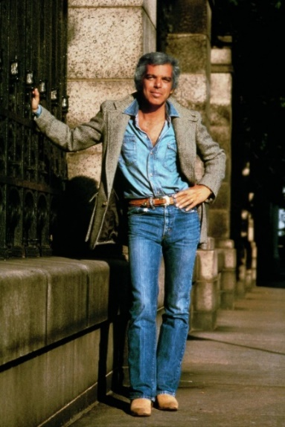
However, the self-made man is not an absolute principle Great Depression
- An example of a self-made man: Ralph Lauren
He was born in the Bronx of the 40s from Ashkenazi Jews parents who had immigrated from Belarus. He never hung out at the country club, played polo, or went sailing on a yacht, although his brand is now a famous symbol of gentility and affluence.
He was selling his home-made tie to his classmates to purchase stylish suits.
1967: Ralph Lauren borrowed $50,000 to an entrepreneur to launch his brand of Polo in reference to the elite sport the famous polo shirt bearing the no less famous little horseman was born.
Conclusion
It doesn’t matter who your parents are, where you’re born, or how much education the difference is in your character and willingness to do whatever it takes to be the best and achieve your dreams.
However, this myth can be questioned by the fact that today, it is more difficult to become a self-self-made man because of the social inequalities, the cost of education, etc Ex: when a father is in the poorest 20% of Americans, there is a 40% chance that his son will not be able to do better. On the other hand, in Denmark, there is a 25% chance that his son will not be able to do better.

