L1TD2
FOUNDATIONS OF AMERICAN GOVERNMENT : FROM INDEPENDENCE TO THE CONSTITUTION

Oral Presentation : The American Dream
I. The American Revolution

Just twenty years earlier, at the outbreak of the Seven Years’ War in the wilderness of western Pennsylvania, no one could have predicted the future would bring such swift and dramatic change to Britain’s New World colonies. Yet that conflict simultaneously removed France from North America and created a huge debt that Britain had to find means to pay, developments with major implications for the imperial relationship.

In the years after the war ended in 1763, momentous changes occurred in the ways colonists thought about themselves and their allegiances. The number of colonists who defined themselves as political actors increased substantially. Once linked unquestioningly to Great Britain, they began to develop a sense of their own identity as Americans, including a recognition of the cultural and social gulf that separated them from Britons. They started to realize that their concept of the political process differed from that held by people in the mother country. Most important, they held a different definition of what constituted representation and appropriate consent to government actions.

John Adams to Thomas Jefferson, 24 August 1815
What do We mean by the Revolution? The War? That was no part of the Revolution. It was only an Effect and Consequence of it. The Revolution was in the Minds of the People, and this was effected, from 1760 to 1775, in the course of fifteen Years before a drop of blood was drawn at Lexington.

British authorities believed that Parliament – which included the King, Lords and Commons – represented all British subjects regardless of where they lived and their voting status. In this system of virtual representation, the people’s consent to Parliament’s actions was assumed. Americans, on the other hand, increasingly believed in direct representation, that they could only be represented by men who lived nearby and whom they elected. Living on the other side of the ocean, colonists were also accustomed to a central government with limited authority, and embraced the notion that good government was one that left them alone to manage their affaires. Colonial political leaders reached such conclusions only after a long train of events, some of them violent, had altered their understanding of their relationship with the mother country. Parliamentary acts such as the Stamp Act and the Townshend Acts elicited colonial responses—both ideological and practical—that produced further responses from Britain. Tensions escalated until they climaxed when Bostonians destroyed the East India Company’s tea.

> Questions
a) What are the “major implications” mentioned in the first paragraph ?
b) In your own words, define the British and the Americans’ opposite conceptions of “representation”.
c) Explain the importance of the events referred to in the last paragraph.
d) What is John Adams’ opinion on the causes of the Revolution ?
e) Devise a timeline of your own, selecting up to 5 dates.
II. The Constitution

1. The main principles

Written in 1787, ratified in 1788, and in operation since 1789, the United States Constitution is the world’s longest surviving written charter of government. Its first three words – “We The People” – affirm that the government of the United States exists to serve its citizens. The supremacy of the people through their elected representatives is recognized in Article I, which creates a Congress consisting of a Senate and a House of Representatives.

The positioning of Congress at the beginning of the Constitution affirms its status as the “First Branch” of the federal government. The Constitution assigned to Congress responsibility for organizing the executive and judicial branches, raising revenue, declaring war, and making all laws necessary for executing these powers. For over two centuries the Constitution has remained in force because its framers successfully separated and balanced governmental powers to safeguard the interests of majority rule and minority rights, and of the federal and state governments. More a concise statement of national principles than a detailed plan of governmental operation, the Constitution has evolved to meet the changing needs of a modern society profoundly different from the eighteenth-century world in which its creators lived.
https://www.senate.gov/about/origins-foundations/senate-and-constitution/constitution.htm

> Questions
a) What are the four main principles delineated in the Constitution ?
b) To what extent can the text help understand the following quote ?
“The U.S. Constitution functions as something more than a binding legal instrument. As often observed, it has taken on over time something of the character of a civic religion – in the sense that commitment to the Constitution is a central, indeed constitutive, element of national identity.”
Vicki C. Jackson, Constitutional Engagement in a Transnational Era (New York: Oxford University Press, 2010), 104.

c) Draw a diagram explaining checks and balances using the following text

The framers of the U.S. Constitution, who were influenced by Montesquieu and William Blackstone among others, saw checks and balances as essential for the security of liberty under the Constitution: “It is by balancing each of these powers against the other two, that the efforts in human nature toward tyranny can alone be checked and restrained, and any degree of freedom preserved in the constitution” (John Adams). Though not expressly covered in the text of the Constitution, judicial review—the power of the courts to examine the actions of the legislative and the executive and administrative arms of government to ensure that they are constitutional—became an important part of government in the United States. Other checks and balances include the presidential veto of legislation (which Congress may override by a two-thirds vote) and executive and judicial impeachment by Congress. Only Congress can appropriate funds, and each house serves as a check on possible abuses of power or unwise action by the other. Congress, by initiating constitutional amendments, can in practice reverse decisions of the Supreme Court. The president appoints the members of the Supreme Court but only with the consent of the Senate, which also approves certain other executive appointments. The Senate also must approve treaties.
Checks and balances | Definition, History, & Facts | Britannica
2. The Articles of Confederation vs the Constitution
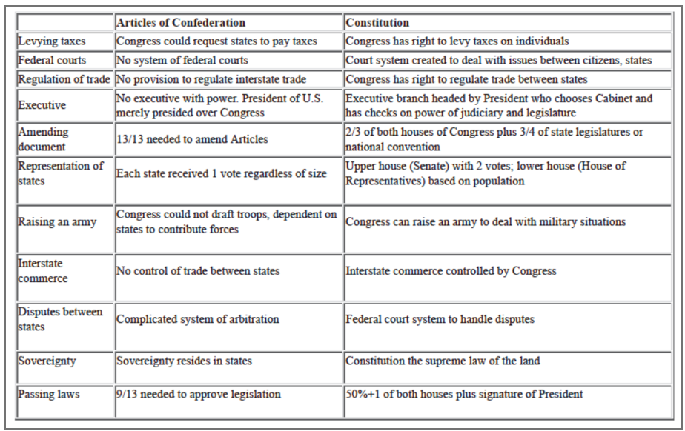
a) How different are these two visions of what national government should be ?
b) Which is in favour of a weak form of government ?
c) What is different concerning the role of the US President ?
d) What is different about Congress in each system ?
e) In terms of control, which one seems more libertarian? What may explain this in the particular period they were written (1780s) ?
f) Why was a strong national government considered as a sort of failure by the defenders of the Articles ?

