Week 3

Ayça
Loic

English Presentation:

THE AMERICAN DREAM

Introduction:
Definition of the american dream : The American Dream is the idea that any person living in the United States, through their work, courage, and determination, can become prosperous.
=> The American Dream started way back when there were just 13 groups of people, or colonies, trying to make a new life in America. The first European settlers arrived in the United States in the early 17th century, around 1607, at Jamestown in Virginia.
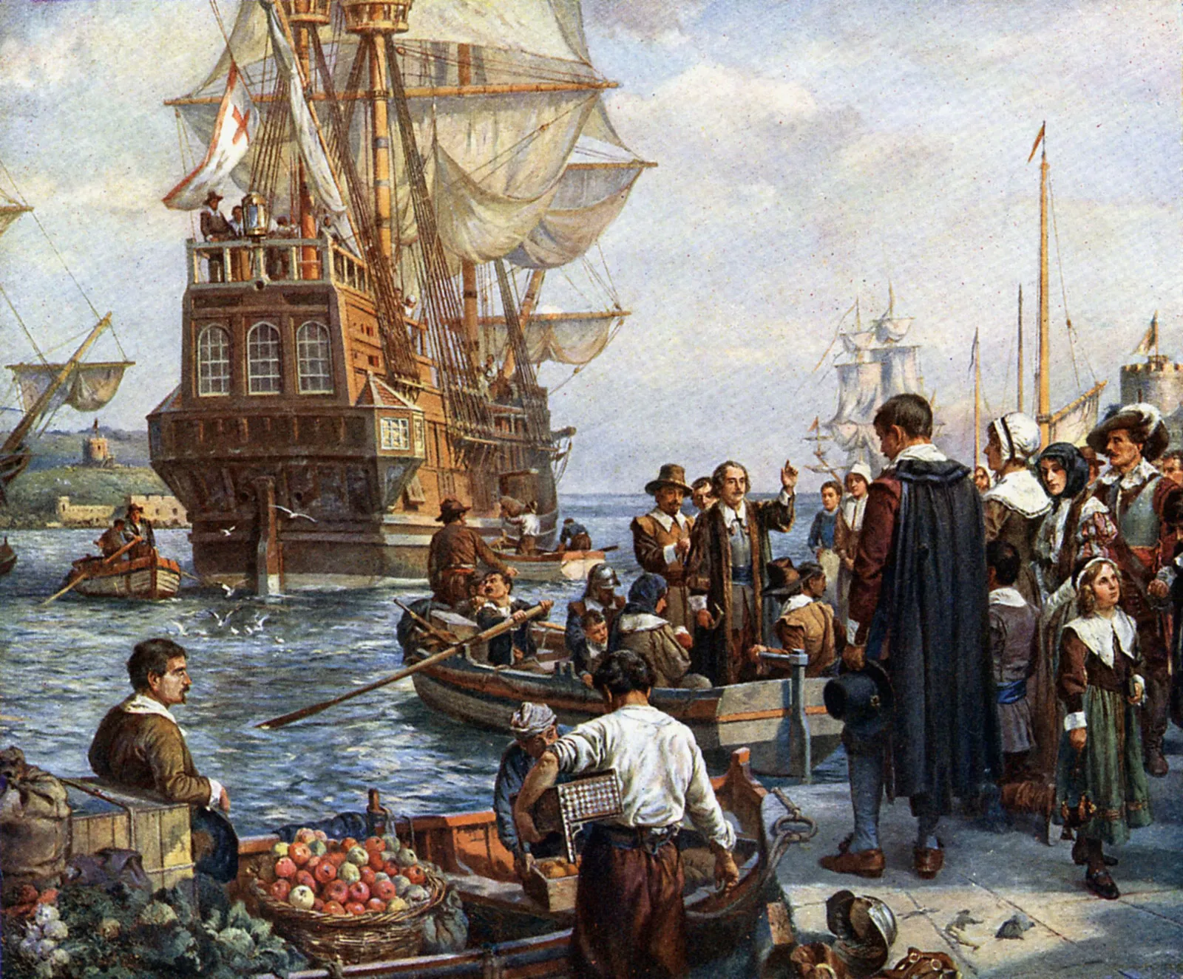
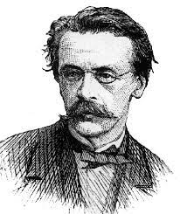
=> As America grew, in the 19th century, there was this belief called Manifest Destiny, which said it was America's destiny to stretch and grow westward.

John O’ Sullivan, the originator of the term “manifest destiny

I - Is the American dream real?
People who embody the American Dream
Every myth needs some hint of reality to stay alive. To this day, some figures remain in the collective consciousness when the American dream is mentioned such as : Walt Disney, Oprah Winfrey, Martin Luther King Jr...

II - The myth of meritocracy: Who deserves to actually fail?
Meritocracy: a system of government in which those who merit according to their abilities and accomplishments are presented with the opportunity to rule.

One example of meritocratic line of government: being promoted at work according to the person’s qualifications

Talent and hard work are two terms frequented in the discourse surrounding the American dream, however this idea can turn into something dangerous.

American individualism takes this to extremes and ends up assuming there is a leveled out playing field when in reality the background of an individual determines a lot and those from more underprivileged backgrounds have to struggle multifold to achieve what comes so easily to others.
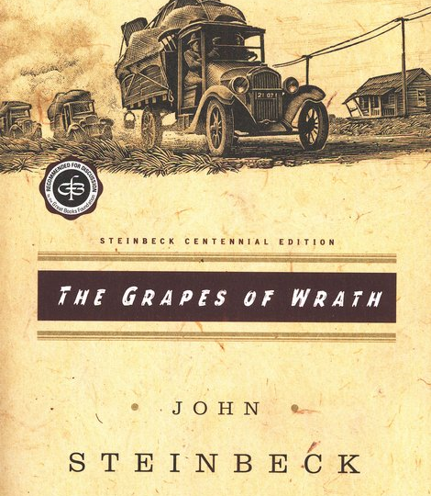
This gap is highlighted especially during periods of struggle such as the Great Depression between 1929 – 1939, as demonstrated in the novel by J. Steinbeck “Grapes of Wrath”

The American dream is also a myth of meritocracy, as seen in “The Great Gatsby” by F. Scott Fitzgerald. The cliff between new and old money, and the futility of the American dream are thus major themes.

Conclusion:
In conclusion, the American Dream, a concept about working hard for a better life, has changed over time. Starting from the colonists arriving at American soil and exploiting it to their advantage with the maxim “manifest destiny” to the way it has become now with a myth of meritocracy that in reality is limited by various factors so much so that reaching success has become more difficult over the centuries.

