The American Civil War
1861 - 1865

Introduction : Conflict that claimed 600 000 - 800 000 human lives.
Opposing the Union which mobilized 2 million soldiers in the war and the Confederacy
- What led to the Civil War, and to what extent did it impact the United States ?

I. Causes and progress of the war

A. Context
Election of Lincoln (Republican) in 1860 : opposed the expansion of slavery into the western territories.

In reaction to his election, 7 states seceded and 4 more joined after the war had started.
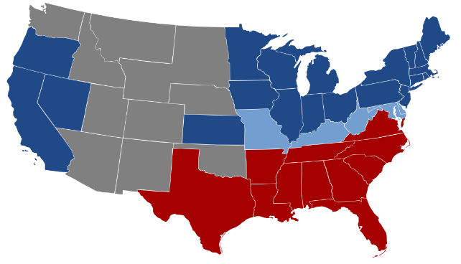
forming the Confederation

B. Progress of the war
April 15th 1861 : attack on Fort Sumter, beginning of the war
Period of confederate victories → wind turns and the Union starts pushing back the confederates (Gettysburg battle, July 1-3th 1863)
Splitting the Confederacy in half (Mississippi campaign)
General Lee capitulates after the Appomattox battle (April, 9th 1865)

II. Impact on federalism and slavery

A) Slavery
Emancipation act, September 1862
13th, 14th, 15th amendment of the Constitution
- Creation of secret societies in the Southern states → KKK
- Segregation in the Southern states
For many former slaves : new forms of dependencies

B) Federalism
Highlighted the fragility of the Union because of a lack of national identity.

Victory of American federalism : preservation of the Union by Lincoln.
Increase in the authority and power of the national government.
1863 : National Bank Act ⇒ establishes a federal banking system

Conclusion : A war that traumatized America and led to the strengthening of the federal state to avoid further secession.
Huge impact on slavery and racial discriminations.

Still has an impact today (Confederate nostalgists, Texas immigration issues)

