Libertarianism

Libertarianism: political philosophy stemming from liberalism. It advocates individualism as a natural right and as the supreme value.
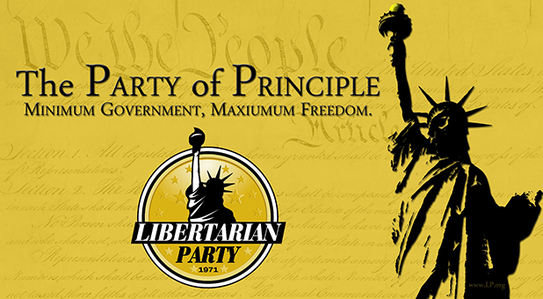
Main ideologies :
- Indivudalism
- Natural right to property
- Free education
- Limitation of government powers
- No use of force (except for self-defense)
- Remove taxes

Historical background :
- Developed in the mid-20th thanks to Locke and Hayek
- Libertarian Party founded in Colorado (1971)
- Ranked as the 3rd largest political party in the USA (huge place of this ideologie in the USA)

Slogan: “The Party of principles”

Historical importance of libertarianism in the US:
- 18th century: wave of libertarianism in North America and Europe
- US Declaration of Independence (1976): inspired by libertarianism
- “It is the right of people alter or abolish” the government
- US Constitution inspired by libertarianism too in terms of:
- Limitation of government’s power
- Rule of law
- Limitation of economic intervention …
- Evolution of the Constitution in another way ?

Debate and criticism :
- Under-regulated markets lead to a host of socially undesirable outcomes (increasing poverty and disparities of wealth and income)
- Libertarian conception of individual freedom is unrealistic: it fails to recognize forms of nonviolent coercion

The importance of libertarianism today:
- libertarianism as rejection of the "big state"
- big state:
- a State that exercises significant control over the privacy and individual freedoms of its citizens
- a State whose government is interfering excessively in individuals’ lives and businesses.
- libertarianism as a growing distrust of the "deep state"
- deep state: political theory that suggests that there is a permanent and hidden power structure within a government (senior officials, military, elites) that exerts significant influence on government policy and decisions.

