L1W3
FEDERALISM

Introduction : defining federalism
Federalism is defined as, “a hybrid arrangement that mixes elements of a ‘confederation’ and a ‘unitary’ government.” (Kernell & Jacobson, 2020).
> Question
1/ Look up the respective definition of “confederation” and “unitary government” and explain them in your own words.
2/ Try to word a definition of “federalism”.
1. Historical background : from the Articles of Confederation to the Constitution
1.1. The Articles of Confederation
Before the United States of America became the United States of America, the 13 original colonies agreed to work together under something called the “Articles of Confederation.” Under the Articles of Confederation, separate states viewed themselves as separate governments able to carry out their independent government activities, while loosely tied to a central government that had very limited authority.
However, the Articles of Confederation proved incapable of dealing with threats to the new nation. For instance, the decentralization of power to the states proved a huge problem for the government when an uprising in Western Massachusetts, led by Revolutionary War veteran Daniel Shay from 1786-1787, challenged the collection of taxes.
Moreover, under the Articles of Confederation, the Congress could not enforce laws, could not tax, and could not regulate commerce. Under the Articles there was no “Executive Branch” (lead by the President), and no “Judiciary Branch” (the Federal Courts system). The limitations of Articles of Confederation led to the Constitutional Convention in Philadelphia in 1787 and the creation of new federal laws under the United States Constitution.
> Questions
1/ How can the historical background explain the Americans’ reluctance to establishing a strong federal government ?
2/ Watch the following video and explain in your words what Shay’s rebellion was about, and what impact it had on the Confederation : https://www.youtube.com/watch?v=YOR9O9mUObE
1.2. Drafting the new Constitution
When representatives from the various states came together in Philadelphia to iron out some of the details of the confederation, they instead decided to scrap the articles and replaced them with what became the United States Constitution.
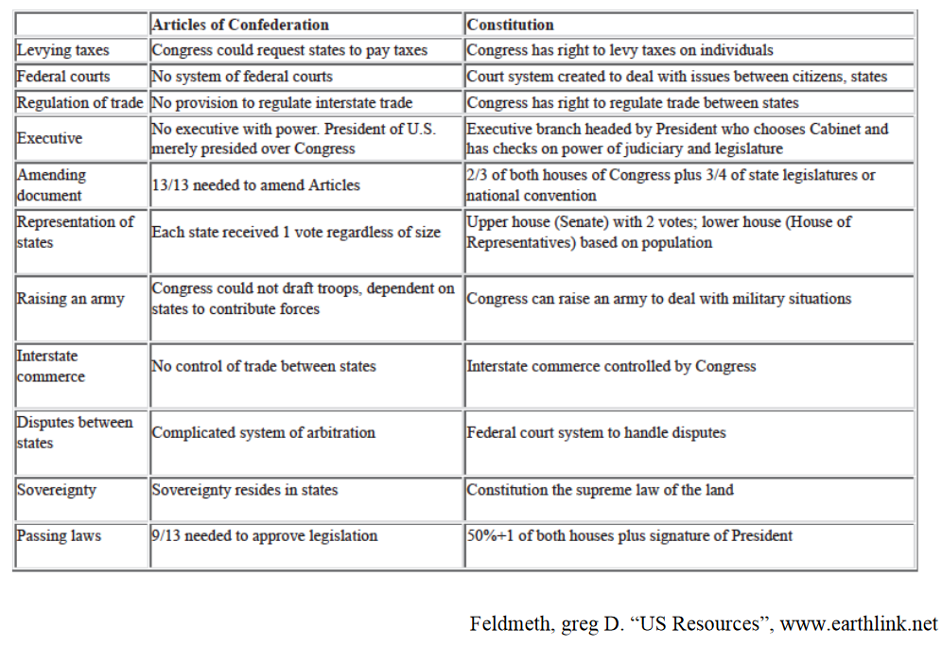
> Question
Compare the powers given to the federal state in both system and comment.
2. The Evolution of U.S. Federalism
From its beginning in 1787 to the present day, two major political theories have developed around the concept of Federalism. One theory is called “Dual Federalism.” The other theory is known as “Cooperative Federalism.”
2.1. Dual Federalism
The beginning of the United States marks the beginning of Dual Federalism. Under Dual Federalism, the Federal government and the state governments occupied “separate spheres of influence.” The federal government had areas that it controlled and the state governments had areas that they control. The federal government and state governments were co-equal entities.
Article I, Section 8 of the United States Constitution listed a number of things that the federal government was empowered to do. The federal government could: tax, declare war, establish foreign policy, regulate interstate commerce, make copyright and patent laws, establish post offices, and coin money.
Under this theory of Dual Federalism, it was believed that the federal government could only operate based on those items listed in the U.S. Constitution. As a result of this the states possessed a large amount of “reserved” powers. The United States operated under a Dual Federalism model from 1787 until about 1937 when the federal and state governments began to intersect, and sometimes conflict with one another.
2.2. Cooperative Federalism
From about 1937 to the present, the United States has operated under a Cooperative Federalism model. Cooperative Federalism came about during the Great Depression, beginning in the late 1920 and lasting through the 1930’s and early 1940’s, when so many Americans were struggling to make ends meet.
“In Principle” under Cooperative Federalism the federal government and the state governments work collectively with one another to address common problems. During the Presidency of Franklin D. Roosevelt (1933-1945), the federal government began to get more involved in the day-to-day lives of U.S. citizens. During the FDR Administration a federal jobs program was established to get Americans back to work; as was an expansive social safety net to provide for people who fell on hard times, because many Americans had fallen on hard times. With a more expansive role for the federal government, there became a need for states and national authorities to work more in tandem with one another.
However, with the post-WWII phase of the Civil Rights movement on the horizon, the shift to Cooperative Federalism set the stage for conflict as black activists pressured the federal government to enforce racial justice initiatives in states, both North and South, that sought to maintain the structures of segregation and white supremacy.
> Questions
1/ Carefully read both definitions and contrast dual and cooperative federalism in your own words.
2/ Identify the following pictures and match them with the corresponding crisis. What impact did these events have on the notion of national government within a federal system ?
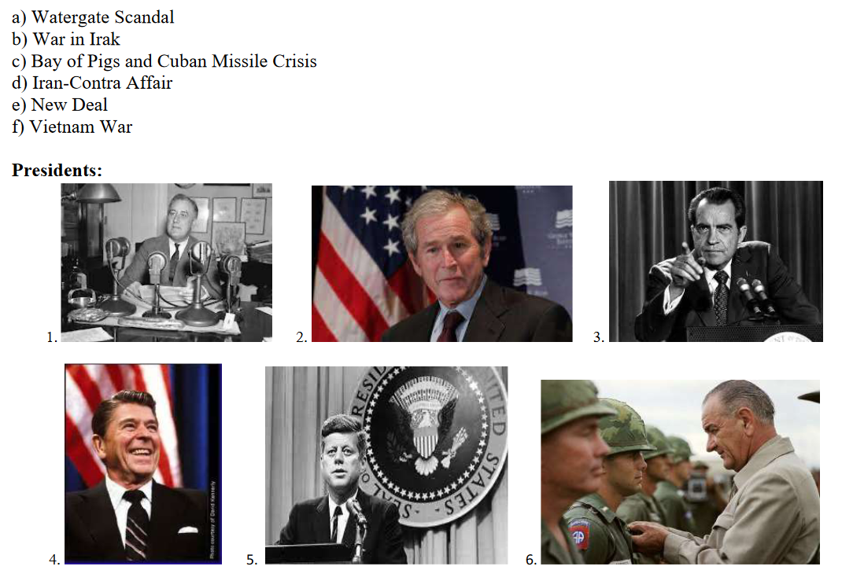

3. How Federalism works
3.1. Different types of powers
Delegated Powers are those powers specifically assigned to the Federal Government by the United States Constitution. The U.S. Constitution lists very specific powers that the Federal Government enjoys. The Federal Government can declare war, maintain armed forces, regulate interstate commerce, admit new states, establish post offices, coin money, establish foreign policy, and make all laws necessary and proper carryout out its delegated powers.
Reserved Powers are powers not specifically delegated to the Federal Government by the U.S. Constitution, but which are “reserved’ for the State governments. Powers reserved to the states include the power to: establish schools, establish local governments, regulate businesses within the state, make marriage laws, and provide for public safety. States can assume all powers not delegated to the national government or prohibited to the states. States also have “police powers.” Police powers have nothing to do with law-enforcement or a specific police department. Police Powers means the states can regulate for the health, safety and welfare of its citizens.
Concurrent Powers are powers that the Federal Government and the state governments have in common or share simultaneously. These are things that both the Federal Government and the state governments can do. Both the Federal Government and the state governments can: maintain law and order, tax, borrow money, charter banks, establish courts, and provide for the public welfare.
Implied Powers are powers that are not specifically delegated in the U.S. Constitution, but are understood to be necessary and allowed. The “Necessary and Proper clause” also known as the “Elastic Clause,” from Article I, Section 8 of the U.S. Constitution gives Congress the power to make all laws it deems necessary to make the government work well. This clause constitutionally authorizes the vast majority of U.S. laws created by the U.S. Congress.
3.2. The role of the Supreme Court
Federalism is always at work in the United States. “In principle” if states, groups, or individuals believe that there are problems with the laws created by the Congress, or being enforced by the President, then the United States Supreme Court can step in and say whether those laws are Constitutional or Unconstitutional. Sometimes the Supreme Court weighing in on questions of Federalism can uphold the power of the federal state, as the court did in the 1819 McCulloch v Maryland. However, in other cases, the Supreme Court has empowered states, for instance by overturning Roe v. Wade (1973) in Dobbs v. Jackson County Health Organization (2022).
> Question
1/ Watch the following videos on McCulloch v Maryland and fill out the following chart.
https://www.youtube.com/watch?v=tPdhWW6Bz-Q
Initial situation (initial act, Maryland’s decision, main issue):

Steps in the procedure :

What were the two questions raised, and what was the decision of the Supreme Court ?
Question 1 Question 2
Question 1 | Question 2
Decision | Decision

2/ Work in pair to elucidate the last two cases.
Conclusion
Oral presentation : Libertarianism

