Jemima Jacmart
Jeanne Champion

PRESENTATION: SLAVERY IN THE UNITED STATES OF AMERICA

What was the history of slavery in the United States?

- The history and rise of slavery in the Americas
  - the origins of American slavery

- 1619 deportation of Angolans to British Colony of Virginia
- Triangular Trade shipping:
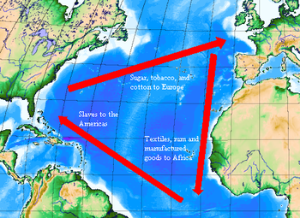

- Need for a New Labor Source in the Colonies
  - Despite dehumanization of an entire population
- Developmment of the Coton Industry in the South

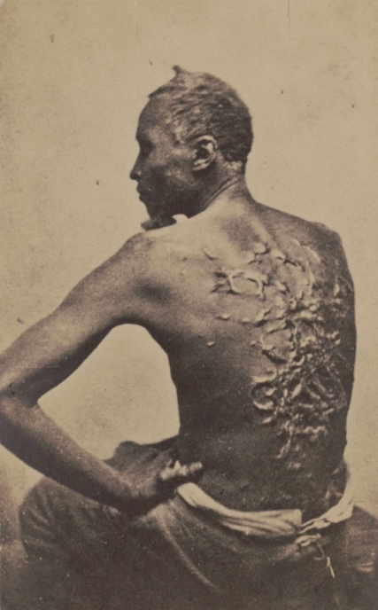
  - The treatment of slaves in the US
- Violence

- Poor Diet and Healthcare

- Dependance

- Submission

- The end of slavery and the civil war

    - Slave Rebellions and abolitionist movements

Slave Rebellions:

1831 - Nat Truner Rebellion in Southampton County Virginia:
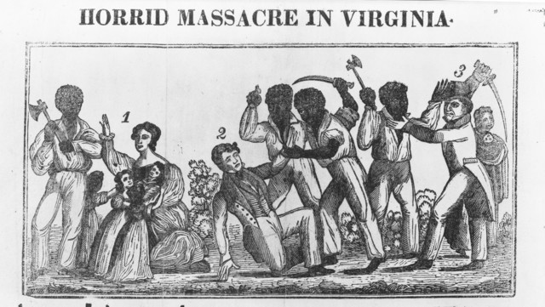
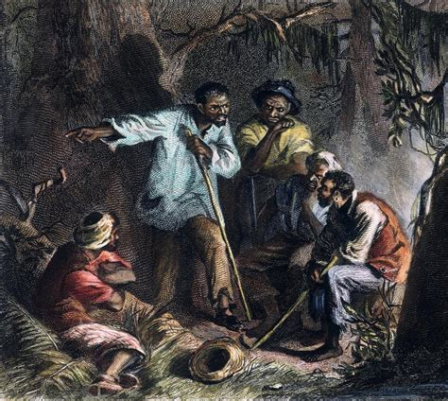

Abolitionist Movements

- 1830s to 1860s Frederick Douglas

- Uncle Tom’s Cabin – Hariett Beecher Stowe

- The Underground Railroad

- The division between North and South and the Civil War

- 1820 Missouri Compromise
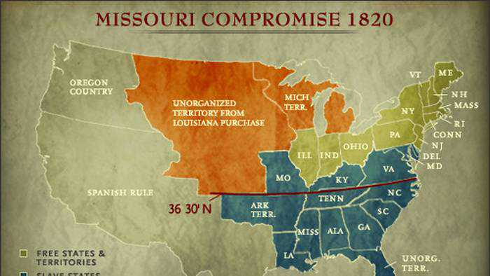
  - 11 free states and 11 slave states

- Secession of Southern States
- 1862 The Emancipation Proclamation

