The American Civil War
1861 - 1865

I. Causes of the war

A. Differences North / South

Dynamic and modern North :
→ industrialised states with manufactures,
industries allowing urbanisation and innovations
(canals, roads, steamboats and railroads,
telegraph, newspapers, )
→ 22 million of people Rural and conservative
South:
→ economy relied on slaves’ workforce in
plantations. Crops, tobacco, cotton were exported
to Europe
→ 9 million of people: more than 1/3 of slaves

B. Lincoln’s election

Election of Lincoln (Republican) in 1860 : opposed the expansion of slavery into the western territories.
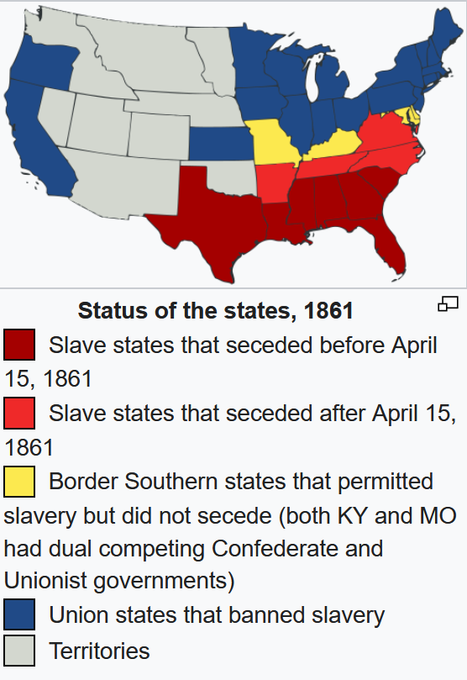
In reaction to his election, 7 states seceded, forming the Confederation
II. The war

The war began when on April 12, 1861, Confederate troops fired on Fort Sumter in South Carolina. Four more southern states seceded after the war began and, led by Confederate President Jefferson Davis, the Confederacy asserted control over about a third of the U.S. population in eleven states. Four years of intense combat, mostly in the South, ensued.

The last significant battles raged around the ten-month Siege of Petersburg, gateway to the Confederate capital of Richmond. The Confederates abandoned Richmond, and on April 9, 1865, surrendered following the Battle of Appomattox, setting in motion the end of the war. Lincoln lived to see this victory but on April 14, he was assassinated.

The Confederacy collapsed, slavery was abolished, and four million enslaved black people were freed. The war-torn nation then entered the Reconstruction era, in an attempt to rebuild the country, bring the former Confederate states back into the United States, and grant civil rights to freed slaves. In total, the war left between 620,000 and 750,000 soldiers dead, along with an undetermined number of civilian casualties, making the Civil War the deadliest military conflict in American history.

III. “The Lost Cause”

https://www.nationalgeographic.com/history/article/how-confederate-battle-flag-became-symbol-racism

