Leading question : What is Libertarianism ? What are the main principles it defends ?

I - Roots and theories of American libertarianism

Definition : Sébastien Caré, a French political scientist specializing in libertarian thought, defines libertarianism as the transformation into utopia of classical liberalism. This mutation takes place at two levels:
- by following a generalization process ;
- by a process of subversion.
Libertarianism has different versions.

In the US, the Libertarian Party was founded in 1971 by David Nolan.
Libertarianism is inspired, in particular in the political sphere, by authors of the 19th century such as Wilhelm von Humboldt in his Essay on the limits of state action.

There are two ways of conceiving the emergence of libertarianism in the United States:
- the first: one considers that it has always existed and first appeared during the colonial period.
- the second: one considers it necessary to understand this conception in its form as a contemporary movement. Thus it should only be born at the end of the 1960s following a
violent break with the conservatives and an alliance with the radical left.

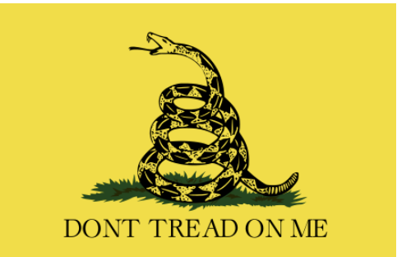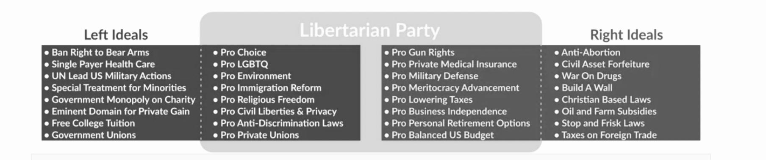

II - The individual freedom : individuals achieve themselves by being autonomous

⭢ individual freedom is an absolute value protected by institutions
No authority can be legitimate to decide + consecration of many civil and political rights such as freedom of speech, freedom of circulation, and the right to private property.

⭢ the principle of “non-agression”
Individuals have to find the best ways to fulfil themselves within this society but no one can compel the freedom of an individual, even the state (drug use not regulated by libertarians)

III - The economic and political freedom

⭢ no regulation and state intervention in economy
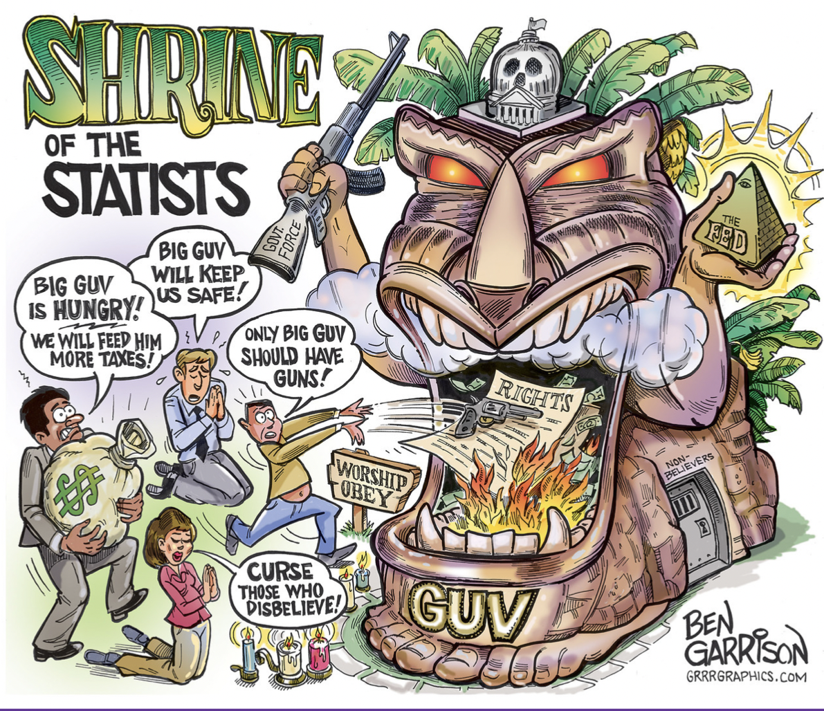
Elon Musk as a businessman and investor promotes entrepreneurial freedom. He wants to get rid of the constraints imposed by the state concerning legal working time of employers and the one regarding administrative declarations.

⭢ the denunciation of the “deep state” concept
deep state = organizations that are said to work secretly in order to protect particular interests and to rule a country without being elected
- January 2021 United States Capitol attack by Trump’s supporters

