Ambre & Alexandre 29/02/24
Presentation : The American Civil War
Question :
"To what extent did the American Civil War (1861-1865) shape the country's history and influence the creation of federalism by subtly redefining the relationship between central government and the states?”

Context
→ Origin: many economic and political differences between the Northern and Southern States
→ Triggers:
- the election of President Abraham Lincoln
- the desire to abolish slavery in the Northern States
→ Proceedings: Opposed the Union (North) and the Confederation (South)

I/ History of the American Civil war
→ From 1861 to 1865
→ Considered the first modern war: new weapons and strategies
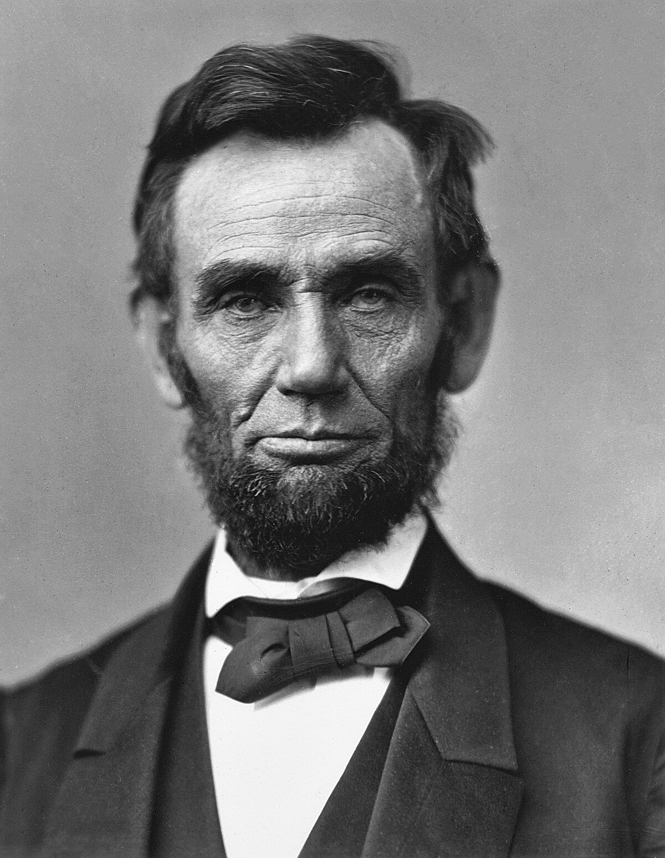
→ Historical Landmarks :

- Series of majors battles: Battle of Bull of Run (Confederation won) or Battle of Gettysburg (one of the deadliest in the American history)
- On January, 1st 1863: Emancipation Proclamation signed by President Abraham Lincoln
- April 1865: General Robert E. Lee's surrenders at Appomattox (defeat of Confederation)

II/ Effect of the war on the development of federalism
→ Bloody conflict: more than 600 000 died on the battlefield
→ Federal power: considerably strengthened + perception of the Union as an indissoluble entity => Union victory: no more doubts about federalism capacity, development of human rights, protected by the federal government

III/ Legacy and memory of the American civil war, with the example of the myth of the “Lost Cause”
→ Complexity and diversity memory of the conflict
→ Development of a patriotic feeling in order to preserve dignity of the South during the war
→ Nowadays:
- a part of the Southern Americans refuse to believe the will of the Northern Americans to abolish slavery as the real origin of the war
- some of the American people, mostly Republicans, desire the comeback of a “white supremacy”
→ Southern states continue to have doubts about federalism, through political speeches against this type of organisation + they also want to preserve the honour and dignity of the South during the war
→ “Lost cause” = denialist theory : denial of the role of slavery → idea that the goals of the confederation were noble

