NATIVE AMERICANS

First part : an ancient people impacted by European colonization.
A: Historical Overview
- Before European colonization, North America was home to a multitude of Native American tribes.
- indigenous peoples inhabited various regions across the continent, from the Arctic Circle to the southern tip of South America.
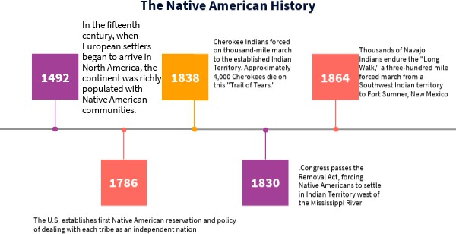
- Native American tribes had sophisticated social structures.
- Each tribe had its own governance system

B: Impact of Colonization

- After 1492, European exploration and colonization of the Americas
- Colonization led to displacement, loss of land, and cultural assimilation.
- From the 16th through the 19th centuries, the population of Native Americans sharply declined.
- European colonization forced removal of Native Americans from their ancestral lands.
- The European colonization of North America had a range of effects on the Native Americans such as starvation, loss of land and culture, disease, and slavery.
  - When the first colonist began to colonize America, they brought with them many diseases.

Second Part: Contemporary Issues
- In terms of political rights
- the Indian Citizenship Act in 1924,
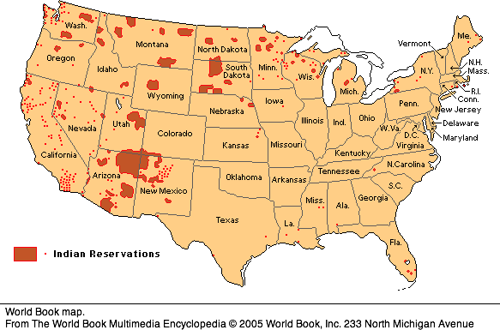
- Native american communities still conserve some of their internal and tribal institutions,
- Their relation with the US was often fixed
through treaties.
- occupation of the island of Alcatraz in 1970
- geographical and demographical situation :
- 573 federally recognized tribal governments and 326 Indian reservations in the United States.
- lands are dispatched in the entire territory of the US, especially in the west ;
- ethnic minority, only represents 2,9% of the american population

- Issues and challenges
- Native americans are 5 to 7 times more likely to commit suicide
- native americans don’t form a homogenous ethnic and cultural group.

