Native Americans

To what extent has colonization impacted the cultural, social, and political evolution of native Americans tribes in the United States of America?

I – A history marked by violence and cultural mutations

A - The conflictual relations between the European settlers and native Americans

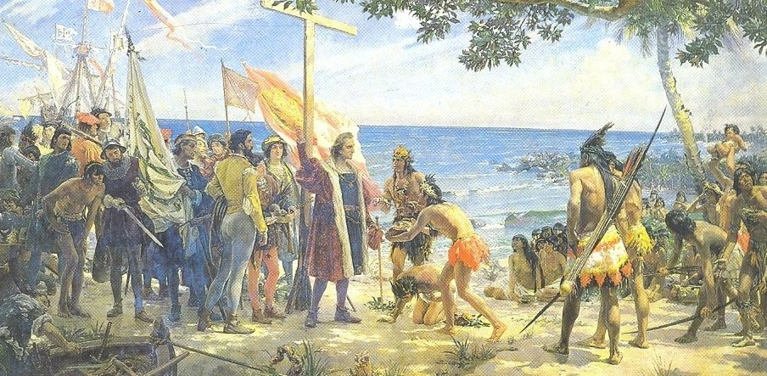
The encounter between Christopher Columbus and the natives

- Border’s myth: the native Americans are seen like an obstacle to the conquest of West.

- European countries used to exploit the rivalries between the different tribes to extent their territories.

- Evangelization policy.

- Extermination policies: 1784 – Spain – Apache.

- Thirteen colonies: practice of squatting = land grab.

- European vision of the natives = savages / salves / beings to slaughter.

`

B - The cultural interweaving and mutations

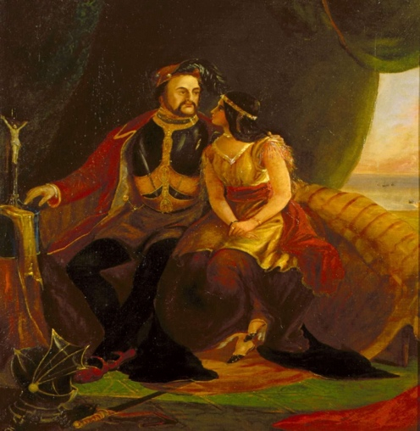
Pocahontas and John Rolf

- Diseases: smallpox.

- New products: alcohol / arms / animals like horses and sheeps.

- Mixed marriage: Pocahontas and John Rolf in 1613.

- No freedom of worship and language.

- Ethnocide = extermination of a culture

- Moral crisis

- Support of American personalities and Supreme Court

II. The evolution of the rights of the native Americans inside of a complicated historical context

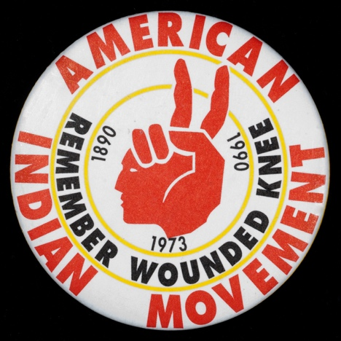
American Indian movement (AIM)

- The evolution of the native Americans fights for their rights

- A revaluation of the native Americans’ place in the American society during the 20th century.

- July 1968: foundation of the AIM Minneapolis

- August 1970: the ascension of the mount Rushmore

- 1975: Self-determination and education act

- 1978: American Indian religious act is passed

- 2020: the Washington national football league dropped the name redskins

- The difficulties in the actual situation of the native American because of the historical context

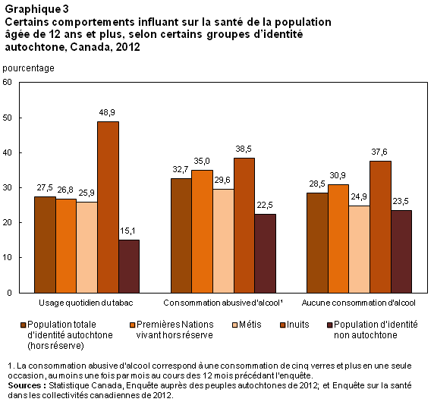

- Health disparities: big differences between other “races” and American Indians.

- Big alcohol issues, suicide issues and drug issues and diabetes.

- Difficult access to education for the native American children: lack of educational opportunity because of the poverty

- Native American tribal land and the struggle for native American tribes’ property rights

