L1W5

THE EXECUTIVE

The executive branch consists of the President, his or her advisors and various departments and agencies.
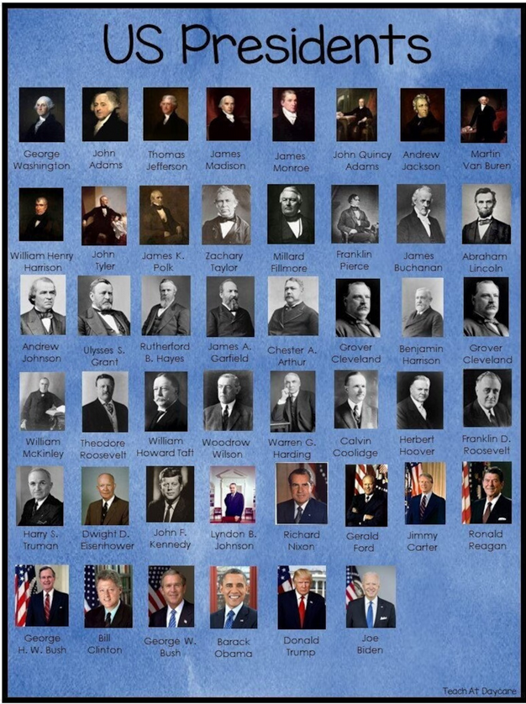
I. The President
1. Powers
The powers of the President are primarily defined in Article II of the United States Constitution. This article outlines the executive branch of the government, which is headed by the President, and covers the various powers and duties they are charged with.
This section of the Constitution sets out that the president has the power to sign or veto legislation, make appointments, and sign treaties. Other specific powers outlined in the Constitution include:
- Serving as Commander-in-Chief of the Armed forces ;
- Granting pardons ;
- Appointing federal officers and judges ;
- Conducting foreign policy ;
- Having a larger role in domestic policy, through executive orders.
The U.S. Constitution requires several things of the President. Notably, the President must be at least 35 years old, a natural-born citizen of the United States, and have lived in the U.S. for at least 14 years.

1/ Where are the powers of the US president defined ?
2/ List the various powers vested in him.
3/ What are the requirements for running for president ?
4/ Look up what the 22th Amendment to the Constitution provides as far as term limit is concerned.

2. Presidential elections
Time of the year | Event
Spring of the year before an election | Candidates register with the Federal Election Commission to run for president.
Spring of the year before an election | Candidates announce their intentions to run.
January to June of election year | States and parties hold presidential primaries and caucuses.
July to early September | Parties hold nominating conventions to choose their presidential candidates.
September and October | Candidates participate in presidential debates.
Early November | Election Day is the first Tuesday after the first Monday.
December | Electors cast their votes for president in the Electoral College.
Early January of the next calendar year | Congress counts the electoral votes.
January 20 | Presidential Inauguration Day
> Questions
1/ Look up the words in bold.
2/ Summarize in a short paragraph how presidential elections work in the US.

II. The Vice President
The primary responsibility of the Vice President of the United States is to be ready at a moment’s notice to assume the Presidency if the President is unable to perform his or her duties. This can be because of the President’s death, resignation, or temporary incapacitation, or if the Vice President and a majority of the Cabinet judge that the President is no longer able to discharge the duties of the presidency.
The Vice President is elected along with the President by the Electoral College. Each elector casts one vote for President and another for Vice President. Before the ratification of the 12th Amendment in 1804, electors only voted for President, and the person who received the second greatest number of votes became Vice President.
The modern vice presidency is a position of significant power and is widely seen as an integral part of a president's administration. While the exact nature of the role varies in each administration, most modern vice presidents serve as a key presidential advisor, governing partner, and representative of the president.

> Questions
1/ What change was introduced by the 12th Amendment ?
2/ Can this explain to a certain extent what you learn in the last paragraph ?
3/ Match the VP to the facts.
John Adams

Theodore Roosevelt

Harry S. Truman

Thomas Jefferson

Gerald Ford

George H. W. Bush

Lyndon B. Johnson
These vice presidents have later been elected presidents.

These vice presidents became presidents after the former presidents’ assassinations.

This vice president became president of the resignation of the former president.

This vice president was the first vice president in the history of the US.

III. The Cabinet
The Cabinet is an advisory body made up of the heads of the 15 executive departments. Appointed by the President and confirmed by the Senate, the members of the Cabinet are often the President’s closest confidants. In addition to running major federal agencies, they play an important role in the Presidential line of succession — after the Vice President, Speaker of the House, and Senate President pro tempore, the line of succession continues with the Cabinet offices in the order in which the departments were created.

