L2W5

INMATE COUNT

U.S. prison population dwarfs that of other nations – NYT, Adam Liptak - April 23, 2008

Full text available at : https://www.nytimes.com/2008/04/23/world/americas/23iht-23prison.12253738.html

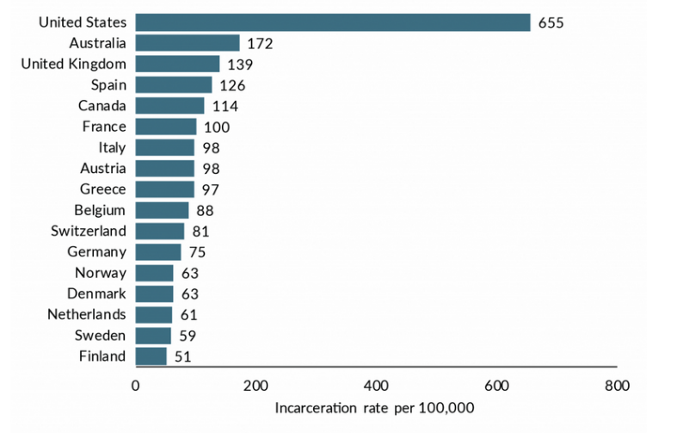
Introduction : Incarceration rates
The United States has less than 5 percent of the world's population. But it has almost a quarter of the world's prisoners.
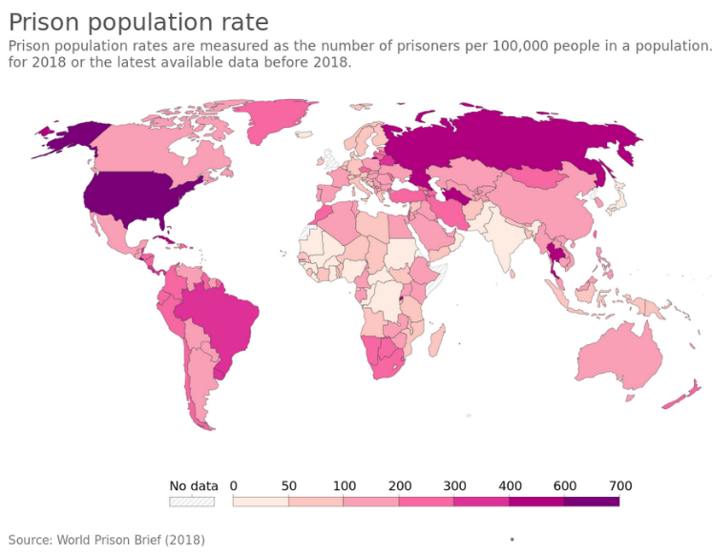
The United States comes in first, too, on a more meaningful list from the prison studies center, the one ranked in order of the incarceration rates. It has 751 people in prison or jail for every 100,000 in population.
The only other major industrialized nation that even comes close is Russia, with 627 prisoners for every 100,000 people. The others have much lower rates. England's rate is 151; Germany's is 88; and Japan's is 63.
The median among all nations is about 125, roughly a sixth of the American rate.
Criminologists and legal experts here and abroad point to a tangle of factors to explain America's extraordinary incarceration rate: higher levels of violent crime, harsher sentencing laws, a legacy of racial turmoil, a special fervor in combating illegal drugs, the American temperament, and the lack of a social safety net. Even democracy plays a role, as judges — many of whom are elected, another American anomaly — yield to populist demands for tough justice.
Whatever the reason, the gap between American justice and that of the rest of the world is enormous and growing.
I. Causes
1/ A cultural explanation (see Week 1 : American Individualism)
Some scholars have found that English-speaking nations have higher prison rates. "Although it is not at all clear what it is about Anglo-Saxon culture that makes predominantly English-speaking countries especially punitive, they are," Tonry wrote last year in "Crime, Punishment and Politics in Comparative Perspective."
"It could be related to economies that are more capitalistic and political cultures that are less social democratic than those of most European countries," Tonry wrote. "Or it could have something to do with the Protestant religions that were long influential." The American character — self-reliant, independent, judgmental — also plays a role.
"America is a comparatively tough place, which puts a strong emphasis on individual responsibility," Whitman of Yale wrote. "That attitude has shown up in the American criminal justice of the last 30 years." French-speaking countries, by contrast, have "comparatively mild penal policies," Tonry wrote.
2/ The importance of violent crimes (see Week 10 : Gun Control)
The nation's relatively high violent crime rate, partly driven by the much easier availability of guns here, partly driven by the strong social inequalities, helps explain the number of people in American prisons. "The assault rate in New York and London is not that much different," said Marc Mauer, the executive director of the Sentencing Project, a research and advocacy group. "But if you look at the murder rate, particularly with firearms, it's much higher."
Despite the recent decline in the murder rate in the United States, it is still about four times that of many nations in Western Europe. However, that is only a partial explanation. The United States, in fact, has relatively low rates of nonviolent crime. It has lower burglary and robbery rates than Australia, Canada and England.
People who commit nonviolent crimes in the rest of the world are less likely to receive prison time and certainly less likely to receive long sentences. The United States is, for instance, the only advanced country that incarcerates people for minor property crimes like passing bad checks.
3/ Sentence length
Still, it is the length of sentences that truly distinguishes American prison policy. Indeed, the mere number of sentences imposed here would not place the United States at the top of the incarceration lists. If lists were compiled based on annual admissions to prison per capita, several European countries would outpace the United States. But American prison stays are much longer, so the total incarceration rate is higher.
Burglars in the United States serve an average of 16 months in prison, according to Mauer, compared with 5 months in Canada and 7 months in England.
4/ Recent policies (oral presentation)
The spike in American incarceration rates is quite recent. From 1925 to 1975, the rate remained stable, around 110 people in prison per 100,000 people. It shot up with the movement to get tough on crime in the late 1970s.
5/ Private prisons (oral presentation)
6/ Judicial selection (see Week 7)
Several specialists here and abroad pointed to a surprising explanation for the high incarceration rate in the United States: democracy.
Most state court judges and prosecutors in the United States are elected and are therefore sensitive to a public that is, according to opinion polls, generally in favor of tough crime policies. In the rest of the world, criminal justice professionals tend to be civil servants who are insulated from popular demands for tough sentencing. *
7/ Juvenile detention (See Week 7, oral presentation)

II. A few nuances
1/ Differences between states
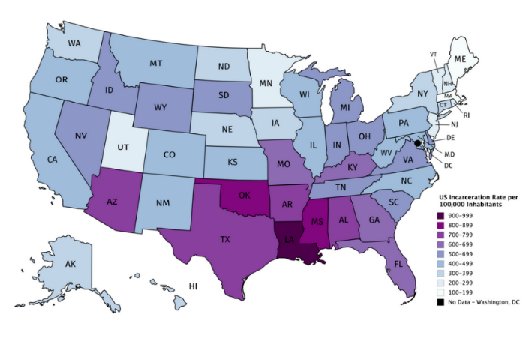
Of course, sentencing policies within the United States are not monolithic, and national comparisons can be misleading.
"Minnesota looks more like Sweden than like Texas," said Mauer of the Sentencing Project. (Sweden imprisons about 80 people per 100,000 of population; Minnesota, about 300; and Texas, almost 1,000. Maine has the lowest incarceration rate in the United States, at 273; and Louisiana the highest, at 1,138.)
2/ Ethnic minorities
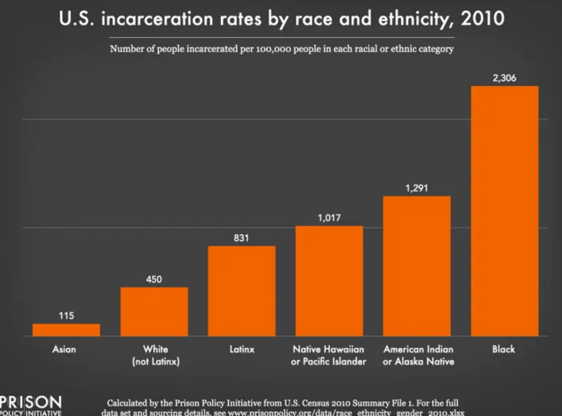
Black Americans are incarcerated in state prisons at nearly five times the rate of White Americans, according to a new report by The Sentencing Project.
The report released on Wednesday, found “staggering disproportionalities” among the rates of incarceration of Blacks and Latinx people compared to Whites. In 12 states, more than half of the prison population is Black. And Latinx individuals are incarcerated in state prisons at a rate that is 1.3 times the incarceration rate of Whites, according to the report.

Conclusion : Is this policy efficient ?
"As one might expect, a good case can be made that fewer Americans are now being victimized" thanks to the tougher crime policies, Paul Cassell, an authority on sentencing and a former federal judge, wrote in The Stanford Law Review.
From 1981 to 1996, according to Justice Department statistics, the risk of punishment rose in the United States and fell in England. The crime rates predictably moved in the opposite directions, falling in the United States and rising in England.
"These figures," Cassell wrote, "should give one pause before too quickly concluding that European sentences are appropriate."
Other commentators were more definitive. "The simple truth is that imprisonment works," wrote Kent Scheidegger and Michael Rushford of the Criminal Justice Legal Foundation in The Stanford Law and Policy Review. "Locking up criminals for longer periods reduces the level of crime. The benefits of doing so far offset the costs."
There is a counterexample, however, to the north. "Rises and falls in Canada's crime rate have closely paralleled America's for 40 years," Tonry wrote last year. "But its imprisonment rate has remained stable."

