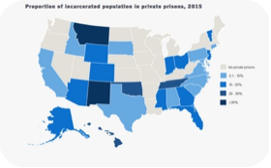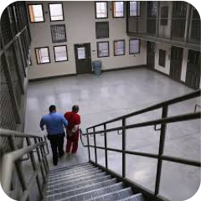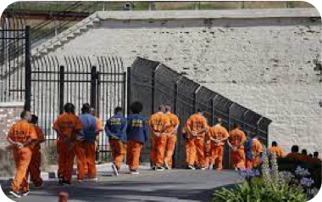THE SYSTEM OF PRIVATE PRISONS
INTRODUCTION : Th e in cr eased relian ce on pr ivat e pr ison s
The role of the private sector in criminal justice system has become increasingly significant and it shows no sign of abating ;
More than one in every 100 adults is in jail in USA ;
This system started early and was accelerated after the Civil war which ended in 1865.

8 %
Som e num ber s :
The United States has the highest number of people incarcerated in the world → more than 2 million
8% of the US prison population is held in privately-run prisons
Private prisons in the world :
In other English-speaking countries like Canada, Australia or New Zealand;
Also in Brazil, Japan or South Korea.

I/ Pr ivat e pr ison s ver su s pu blic pr ison s
privat e prison : people are imprisoned by a third party that is contracted by a state or a local government agency.
Goal = run facilities and profite from anything they deal in.
public prison = one that is completely run by the government.
goal = to house incarcerated individuals in an attempt to rehabilitate them or remove them from the streets

States with no private prisons : Washington, Minnesota or Alabama
However, the state of Montana incarcerates almost half of its prison population in privately run facilities

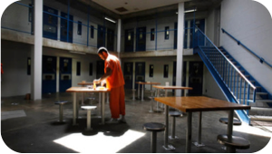II/ Th e con sequ en ces and challenges
✅ Pr os :

1.
2.
❌ Con s :
3.
Reduces the cost of housing ;
The private sector claims to be able to build facilit ies fast er and cheaper, and to operate them more economically and more efficiently ;
The governm ent lacked t he financial resources to
build more prisons in the face of rising incarceration

1.Morally inappropriat e because private rates.
prisons are searching for profits
2.Hum ans Right s -> prisoners held for profit
are not always treated with dignity, but rather, they are more likely to be seen as a source of profit.
3.Consequences on t he st aff -> no stability
or protection of the public service
4.Consequences on t he m edical access of
prisoners -> medical offerings at private prisons are often bare-bones operations
5.Consequences on t he prisoner program s -> private prisons would rather save money than give prisoners access to rehabilitation programs

