L2W6

INMATE COUNT - SUITE

6/ Judicial selection
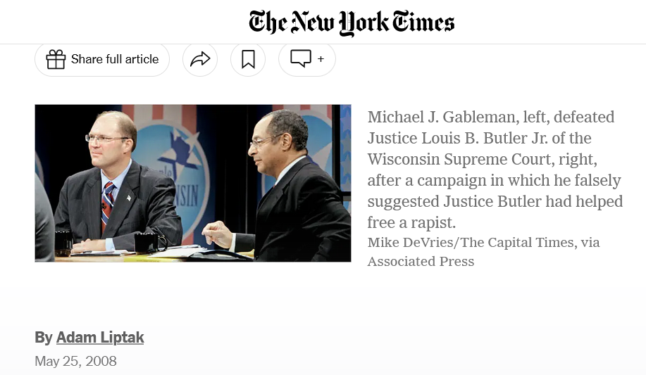
Last month, Wisconsin voters did something that is routine in the United States but virtually unknown in the rest of the world : they elected a judge.
The vote came after a bitter $5 million campaign in which a small-town trial judge with thin credentials ran a television advertisement falsely suggesting that the only black justice on the state Supreme Court had helped free a black rapist.
Indeed, Judge Gableman’s campaign ran a television advertisement juxtaposing the images of his opponent, Justice Louis B. Butler Jr., in judicial robes, with a photograph of Ruben Lee Mitchell, who had raped an 11-year-old girl. Both the judge and the rapist are black.
“Butler found a loophole,” the advertisement said. “Mitchell went on to molest another child. Can Wisconsin families feel safe with Louis Butler on the Supreme Court?”
Justice Butler had represented Mr. Mitchell as a lawyer 20 years before and had persuaded two appeals courts that his rape trial had been flawed. But the state Supreme Court ruled that the error was harmless, and it did not release the defendant, as the advertisement implied. Instead, Mr. Mitchell served out his full term and only then went on to commit another crime.
The challenger unseated the justice with 51 percent of the vote, and will join the court in August.
Contrast that distinctively American method of selecting judges with the path to the bench of Jean-Marc Baissus, a judge on the Tribunal de Grand Instance, a district court, in Toulouse, France. He still recalls the four-day written test he had to pass in 1984 to enter the 27-month training program at the École Nationale de la Magistrature, the elite academy in Bordeaux that trains judges in France.
The question of how best to select judges has baffled lawyers and political scientists for centuries, but in the United States most states have made their choice in favor of popular election. The tradition goes back to Jacksonian populism, and supporters say it has the advantage of making judges accountable to the will of the people. A judge who makes a series of unpopular decisions can be challenged in an election and removed from the bench.
“If you want judges to be responsive to public opinion, then having elected judges is the way to do that,” said Sean Parnell, the president of the Center for Competitive Politics, an advocacy group that opposes most campaign finance regulation.
Nationwide, 87 percent of all state court judges face elections, and 39 states elect at least some of their judges, according to the National Center for State Courts.
In the rest of the world, the usual selection methods emphasize technical skill and insulate judges from the popular will, tilting in the direction of independence. The most common methods of judicial selection abroad are appointment by an executive branch official, which is how federal judges in the United States are chosen.
Outside of the United States, experts in comparative judicial selection say, there are only two nations that have judicial elections, and then only in limited fashion. Smaller Swiss cantons elect judges, and appointed justices on the Japanese Supreme Court must sometimes face retention elections, though scholars there say those elections are a formality.
The much more rigorous French model, in which aspiring judges are subjected to a battery of tests and years at a special school, has its benefits, said Mitchel Lasser, a law professor at Cornell and the author of “Judicial Deliberations: A Comparative Analysis of Judicial Transparency and Legitimacy.”
“You have people who actually know what the hell they’re doing,” Professor Lasser said. “They’ve spent years in school taking practical and theoretical courses on how to be a judge. These are professionals.”
But some American law professors and political scientists say their counterparts abroad should not be so quick to dismiss judicial elections.
“I’m not uncritical of the American system, and we obviously have excesses in terms of politicization and the campaign finance system,” said Prof. David M. O’Brien, a specialist in judicial politics at the University of Virginia and an editor of “Judicial Independence in the Age of Democracy: Critical Perspectives from Around the World.”
“But these other systems are also problematic,” Professor O’Brien continued. “There’s greater transparency in the American system.” The selection of appointed judges, he said, can be influenced by political considerations and cronyism that are hidden from public view.
Herbert M. Kritzer, who was until recently a professor of law and political science at the University of Wisconsin, said judicial elections had deep roots in the state and the nation.
“It’s a remnant of the populist Jacksonian image of public office,” he said. “We’re crazy about elections. The number of different offices we elect is enormous.”
There is reason to think, though, that the idea of popular control of the government associated with President Andrew Jackson is an illusion when it comes to judges. Some political scientists say voters do not have anything near enough information to make sensible choices, in part because most judicial races rarely receive news coverage. When voters do have information, these experts say, it is often from sensational or misleading television advertisements.
“You don’t get popular control out of this,” said Steven E. Schier, a professor of political science at Carleton College in Minnesota. “When you vote with no information, you get the illusion of control. The overwhelming norm is no to low information.”
Judge Baissus, the French judge, said his nation had once considered electing its judiciary.
“It’s an argument that was largely debated after the French revolution,” he said. “It was thought not to be a good idea. People seeking re-election would not be independent. They are indeed close to the electorate, but sometimes uncomfortably so.”
Judges often alter their behavior as elections approach. A study in Pennsylvania by Gregory A. Huber and Sanford C. Gordon found that “all judges, even the most punitive, increase their sentences as re-election nears,” resulting in some 2,700 years of additional prison time, or 6 percent of total prison time, in aggravated assault, rape and robbery sentences over a 10-year period.
> Questions
1/ What is the main issue raised in this article ?
2/ What are the two methods mentioned in the article for selecting judges ?
3/ What is the tradition in which judicial election is said to be rooted ?
4/ Make a list of the pros and cons mentioned in the article about judicial election.
5/ Answer the following question in the form of an essay : “Do you think electing judges can have positive effects ?”.
7/ Juvenile detention (oral presentation)

