L1W6

Executive 2/2 : 2024 Presidential Election

Could the United States be headed for a national divorce ?
https://www.chathamhouse.org/2024/02/could-united-states-be-headed-national-divorce

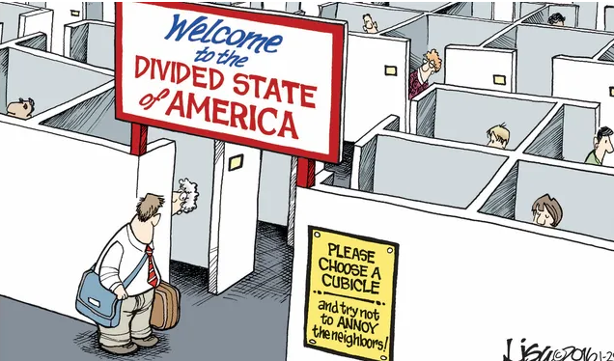

The American Civil War (1861-65) was fought over slavery and, to a lesser extent, states’ rights and the future of the economy. In the run-up to the 2024 US elections, there is talk of another civil war brewing over the country’s future.
While there is no imminent threat of armies clashing on the battlefield, increasing hyperbolic insurrectionist sentiment is a product of a growing realization tha the US is now more divided along ideological and political lines than at any time since the 1850s.
An increasingly Balkanized US is likely to be even more inward-looking, preoccupied with internal divisions over immigration, race, inequality, and sexual and gender identity issues. Such self-absorption is already manifesting itself in isolationism and protectionism at the expense of the security and economic alliances that have greatly benefitted the US and the world for decades.
> Questions
1/ Describe the picture above, and explain its meaning.
2/ What is the leading statement of this article ? Rephrase in your own words.
3/ What are the consequences of this situation ?
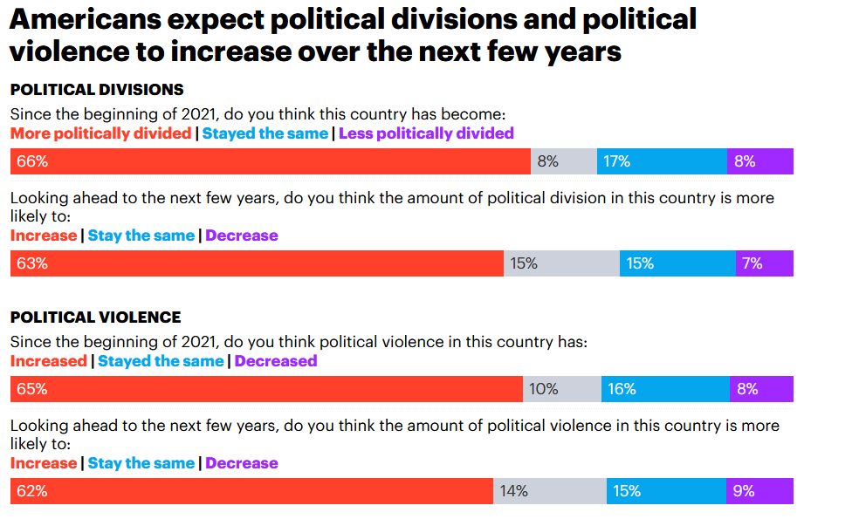
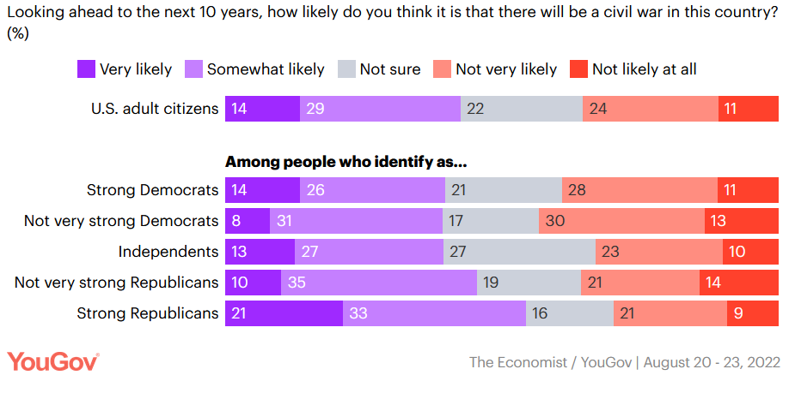
This split could be seen in the 2020 election between the blue states that voted for Joe Biden and the red states that voted for Donald Trump, with many of the Trump states among those that seceded from the Union in 1861. However, the two Americas can also be seen across a range of divisive social issues that reflect deeper divisions than those that merely manifest themselves at the ballot box.
Of the 15 US states with the most restrictive abortion laws, all voted for Trump in 2020 and seven were originally in the Confederacy. Of the 21 states with the most permissive gun laws in 2023, 19 voted for Trump, and six were in the Confederacy. Of the 19 states that enacted laws in 2022 making it harder to vote, 14 voted for Trump and seven were in the Confederacy. And of the 23 states that enacted legislation in 2023 imposing restrictions on gender-affirming care, transgender participation in school sports, school instruction touching on LBGTQ issues and related matters, 22 voted for Trump and nine were in the Confederacy.
The deep divisions in the American electorate manifest themselves in early projections of the possible outcome of the 2024 presidential election. At this stage, Biden is judged by the highly respected Cook Political Report to have 226 out of the necessary 270 votes in the electoral college, with the majority (116) coming from former Union states. Trump has 235 votes, with a majority (135) coming from former states in the Confederacy. The continuing legacy of the civil war remains.
> Questions
1/ What does each survey show ? Summarize their findings in a few sentences.
2/ What is this list showing ?
Moreover, these civil war era divisions have now emerged in a constitutional confrontation over immigration. In January, the US Supreme Court ordered Texas to remove razor wire it had put up along the Rio Grande river to stop migrants from crossing. Texas Governor Greg Abbot refused to comply, claiming the compact between the states and the United States had been broken by President Biden’s failure to halt illegal immigration.
Abbot’s suggestion that the US Constitution is a mere compact that states may ignore at their discretion is reminiscent of the Confederacy’s rationale for being able to leave the Union in 1861.
Rep. Majorie Taylor Greene, a right-wing Republican from Georgia, has called for a ‘national divorce’. ‘We need to separate by red states and blue states’. And one in four (23 per cent) Americans support their state seceding from the Union.

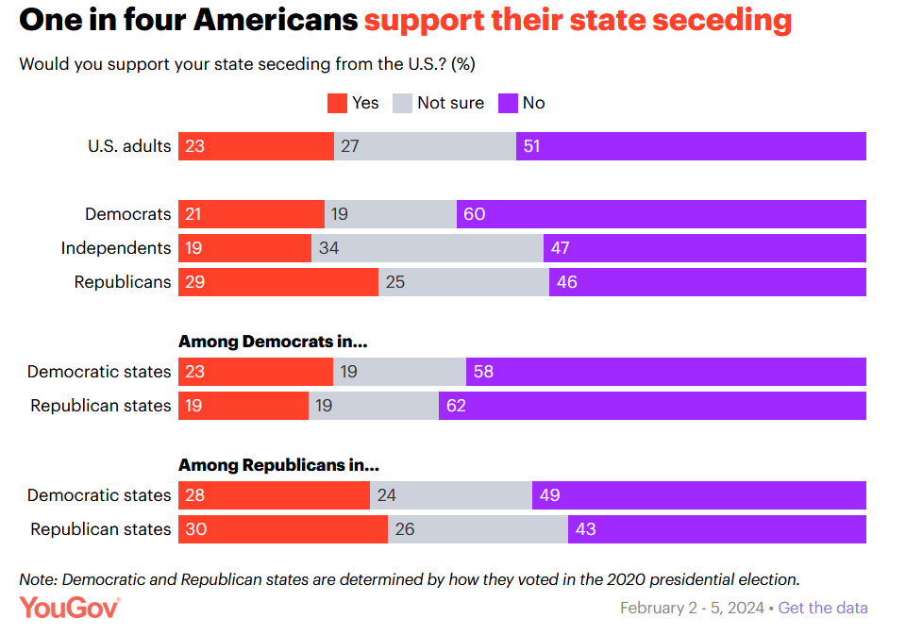
America’s friends and allies need to understand that the United States has become a Disunited States. There are effectively two Americas – and they are at war. They are fighting over social, political and constitutional issues, and over what role the US should play in the world. The 2024 US election is just another battle in this war.
> Questions
1/ What is at stake in the issue opposing Texas to the federal state ?
2/ What are the two opposing views about federalism ?
3/ Answer the following question in the form of an essay : “Do you think federalism can lead to the implosion of the US ?”

