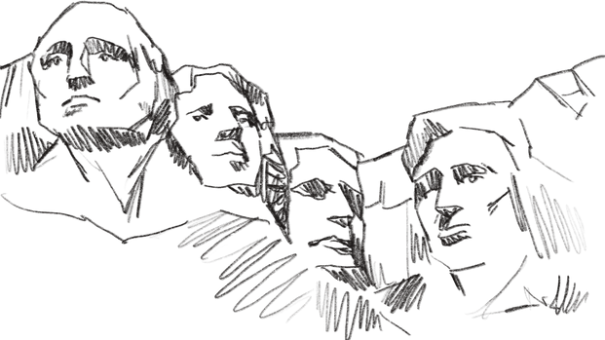
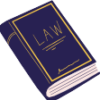
Washington and Jefferson

What influence did these two founding fathers have, both in the American War of Independence and during their presidency, and how is their legacy still fundamental to the United States today?

A. His leadership during the Independence War
He was a British army officer during the Seven Years war => Fort Duquesne battle ⚔
His military experience → continental Congress named him as the chief of the new Continental Army against British
Chief of Patriot forces during the American Revolutionary War → led to the victory)
Difficulties = in front of organized and well- commanded military troops, there were only undisciplined soldiers with less materials and weapons His strategy → avoid confrontations and wait for the superiority.
Help of the French, Polish, Prussian + an operation to encircle the British forces in Yorktown by the navy and the army → the British forces surrendered in 1781
➡Peace was signed in 1783 with the Paris Treaty →
end of the war and independence

B.His contribution to the redaction of the Constitution, presidency and strong legacy
President of the constitutional convention in 1787 📖
Known as “the father of his country” + “ideal president”
1st President of the USA (1789-1797)
==> his two mandates marked the apparition and the reorganization of a new state and his entry on the international scene → controverses on his decisions: “Whisky revolt” and political oppositions (creation of the US two-party system)
Foreign policies -> he tried to be impartial in European affairs (French Revolution and France/GB war)
General of the army 🎖 in 1976 → highest rank in the US army

➡An icon of American culture → commemorated by monuments, a federal holiday, the national capital, the state of Washington, his figure on stamps and currencies, the construction of the Capitol during his mandate etc.
“First in war, first in peace and first in the hearts of his fellow citizens,” → eulogy

️ he was a slave owner, which breaks with the image of an ideal president
A. Different philosophical and political ideas, his impact on the writing of the Constitution and on the definition of
fundamental rights
Great political culture + education through the study of the great Enlightenment thinkers💡 > Declaration of independence that “all men are created equal”
In reaction to the Intolerable Act he joined a group of “radicals” opposed to the King and wrote a pamphlet "Summary Views on the Rights of the English Colonies in America" in 1774
Principle that “the government results from the consent of the governed” → Libertarianism
He wrote a Bill of Rights which established the principle of the separation of church and state for the 1st time
⚠However, as a planter, he owned more than 600 slaves during his life = contradictory speech

B.His access to the presidency and his foreign policies
Vice president in 1796 after his defeat in the presidential election
In 1800 (until 1809) he became president and he broke with the monarchical traditions
During his presidency he appointed democrats-republicans to cabinet posts (James Madison), replaced the employees with party loyalists and reduced government spending
Political reforms: Marbury V. Madison decision and the XIIth Amendment
He left the domestic politics to the states and turned his attention to foreign affairs
He doubled the size of the USA by purchasing Louisiana from France in 1803
He inaugurated the exploration and colonization of the West🏜(Lewis and Clark)

Different political visions and leaderships styles but central figures in American history, embodying the founding ideals of the USA, made essential contributions to the development of the constitutional framework, shaped the american identity.

⚠Jefferson controversy: October 2021: removal of his statue by New York City Hall

