Two remarkable cases of punitive damages in the US

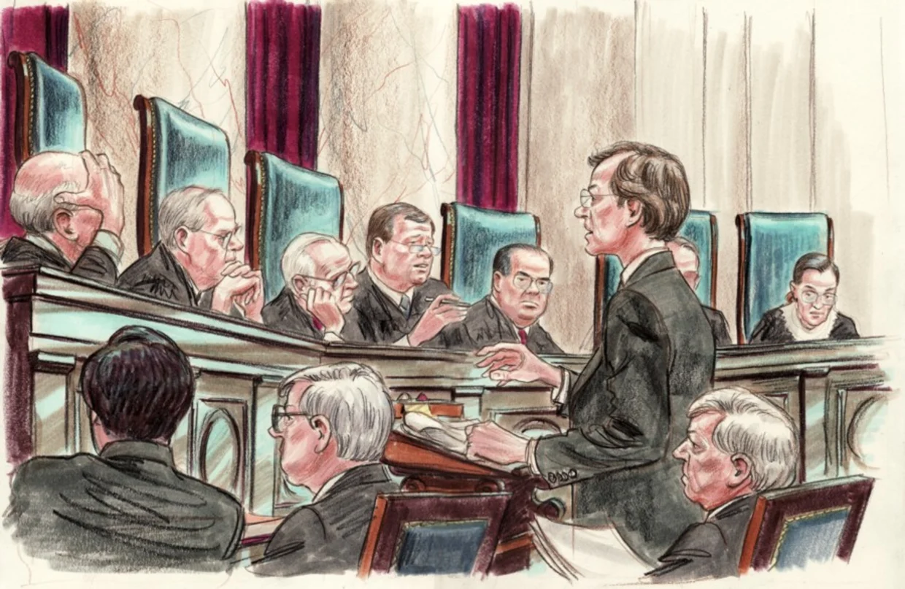
Precedent: Vaughan v. Menlove 一 All individuals have a duty of care to act the way in which a reasonably prudent person would act under similar circumstances

Compensatory damages: “the amount of money that a court orders to be paid to someone in return for something that has been lost or damaged” -Cambridge Dictionary
Punitive damages: “Damages exceeding simple compensation and awarded to punish the defendant”-Oxford Dictionary

The Exxon Shipping Co. v. Baker case :

- Exxon Valdez oil spill - Captain intoxicated.
- Victims sued for damages - Awarded $2.5 billion.
- Supreme Court: Punitive damages too high.
- 1:1 limit on punitive vs. compensatory damages (maritime).
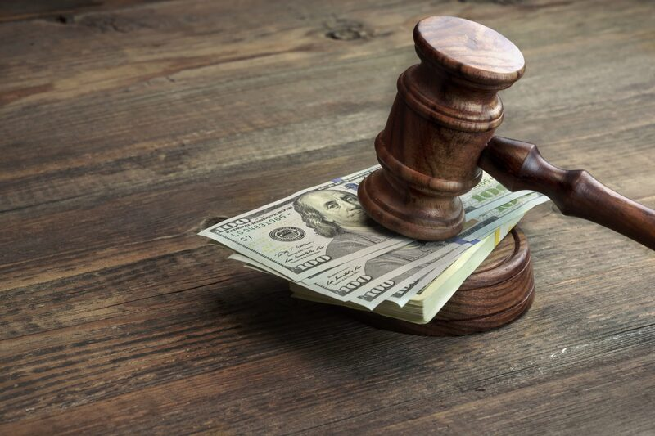
- Reduced award to $500 million.

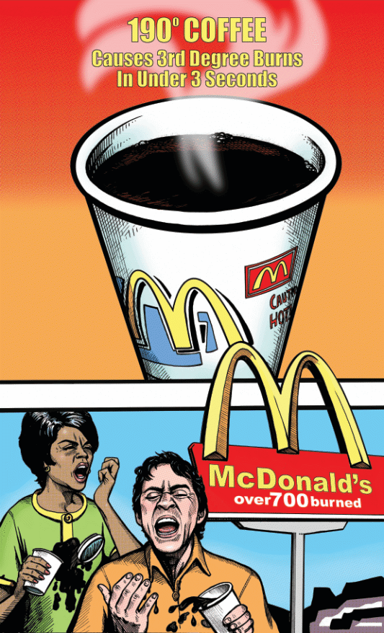

The Liebeck v. McDonald's Restaurants case :

- 79-year-old Liebeck suffered burns from spilled McDonald's coffee.
- Sued McDonald's claiming coffee dangerously hot (190°F).
- The jury awarded $2.7 million, raising concerns about beverage temperature.
- Settled for an undisclosed amount, sparking debate on lawsuit fairness.
- Increased awareness of hot beverage dangers and safety practices.

Parallelism between Exxon and McDonald's cases:

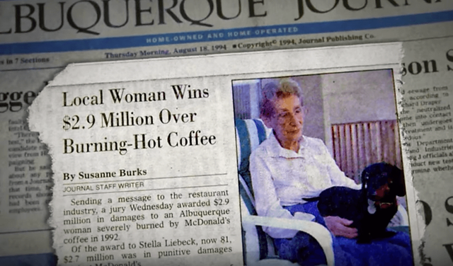
- Unreasonable person
- Negligence
- Deterrence

