Abraham Lincoln
Abraham Lincoln, one of America's most revered figures, left an indelible mark on the nation's history and legal system, particularly during the tumultuous period of the Civil War

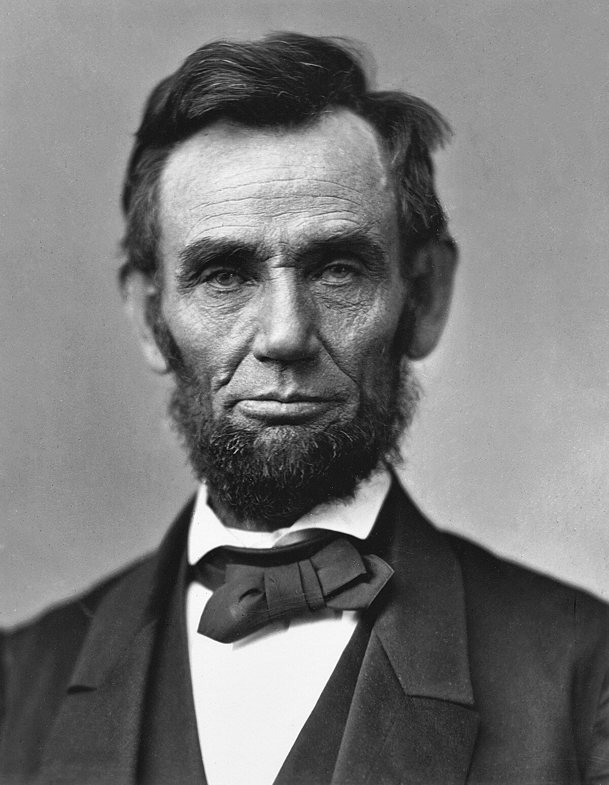
II- Presidency and leadership during the civil war
- November 1860 : Abraham Lincoln won the presidential election.
- This led to the secession of seven slave-holding States of the South and the formation of the Confederate States of America.
- April 1861 : the Confederacy’s attack of Fort Sumter, South Carolina marks the start of the Civil War.
- August 1861 : the Confiscation Act was adopted, authorizing legal procedures intended to free the slaves of the Confederacy, the starting point of a political process aimed at the total abolition of slavery
- Second Confiscation Act of July 1862 : Banning slavery from federal territory
- Emancipation Proclamation in September 1862 supplemented in November with the Gettysburg Address
- April 9, 1865 : end of the Civil War.
- 8 novembre 1864 : Abraham Lincoln re-election
- 13th amendment voted in December 1865.
- April 14, 1865 : Abraham Lincoln was assassinated on his way to Ford's Theater in Washington. His assassin was a comedian known for his Confederate sympathies.
- Abraham Lincoln before presidency
- He became a lawyer in 1836.
- He ran for the Illinois state Legislature in 1832 but lose.
- He finally was elected in 1834, serving four consecutive terms.
- In 1846, Lincoln was elected to the U.S. House of Representatives, where he served one term.
- The 1850s were a turbulent time in American politics, mainly due to the issue of slavery.
- The Kansas-Nebraska Act of 1854, which allowed territories to decide for themselves whether to allow slavery, deeply troubled Lincoln.
- In 1858, Lincoln ran for the U.S. Senate against Stephen A. Douglas. He lost the election, but the debates between Lincoln and Douglas garnered national attention.

In conclusion, Abraham Lincoln's legacy is far-reaching and timeless. His political foresight transformed the legal and institutional landscape of America, while his cultural and symbolic influence endures to this day. Lincoln not only saved the Union but also laid the foundation for a more just and equitable nation. As we reflect on his legacy, we're reminded of the enduring power of leadership and the enduring spirit of America.

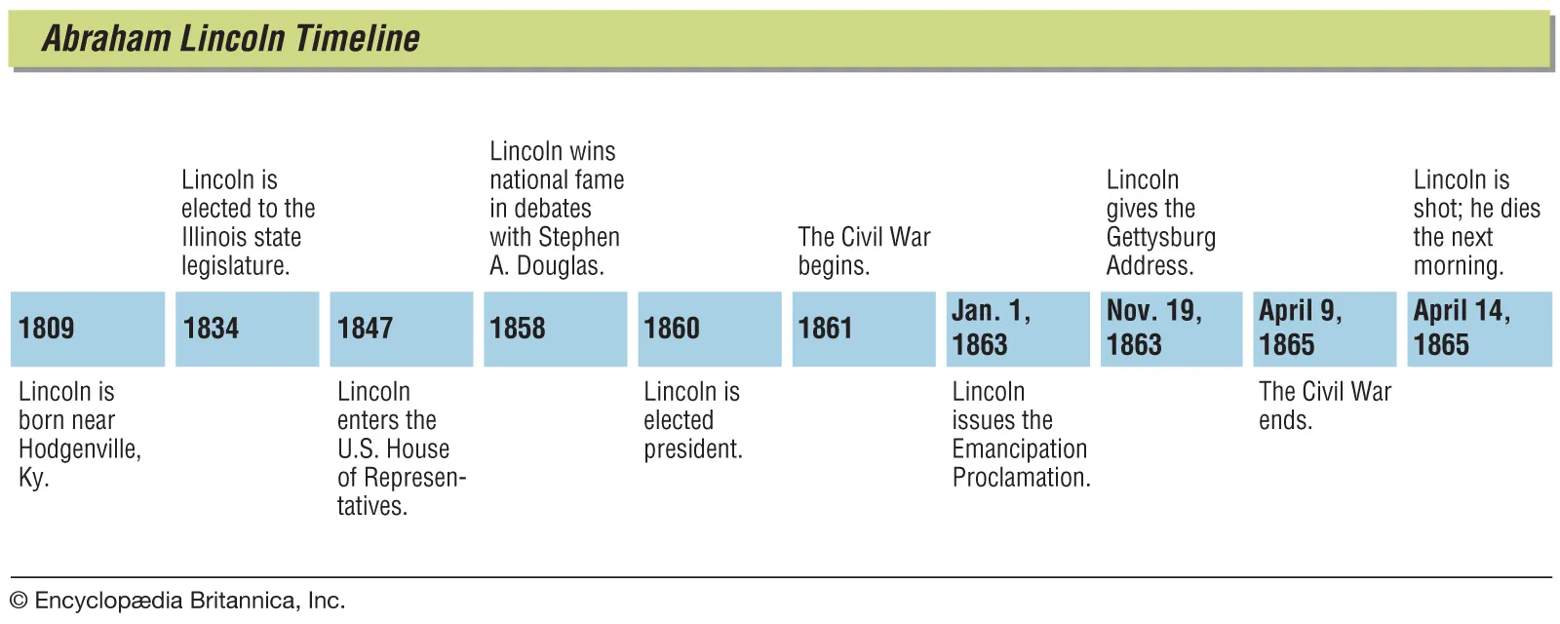

III- Legacy and impact on American history
- Political and institutional legacy : Emancipation and abolition of slavery and the strengthening of Presidential Power
- Cultural and symbolic legacy : Lincoln’s image in Popular culture and the influence of his speeches and writing

In conclusion, Abraham Lincoln's legacy is far-reaching and timeless. His political foresight transformed the legal and institutional landscape of America, while his cultural and symbolic influence endures to this day. Lincoln not only saved the Union but also laid the foundation for a more just and equitable nation. As we reflect on his legacy, we're reminded of the enduring power of leadership and the enduring spirit of America.

