Frederick Delano Roosevelt
  - Why is FD Roosevelt one of the most eminent political figures of the XXth century?
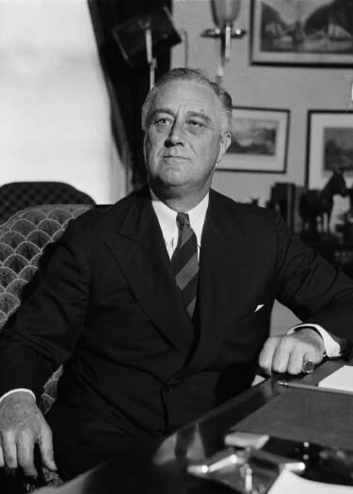
Nina Barthélémi & Lucile Binick

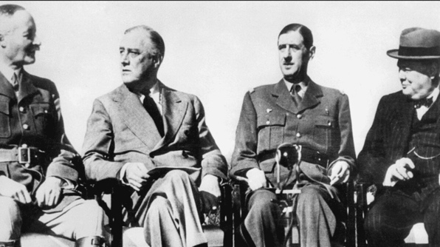
I. Biography of Roosevelt : from his studies to his rise to presidency (early political career)
- Born in 1882, in an aristocrat family nearby New York. His fifth cousin was Theodore Roosevelt (president of the USA from 1901 to 1909).
- He had access to an elitist and private education. In college, he went to Harvard and then to Columbia law school. He quickly dropped out (1907) to practice law and focus on his real vocation: politics.
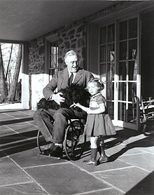
- Elected in 1911 as a democrat senator, supported W. Wilson and in 1913 got nominated as assistant secretary of the navy.
- 1920: F.D. Roosevelt got diagnosed with a paralytic illness. As a governor he later tried to address the aftermath of the Wall Street Krash and of the depression before running for president in 1933 for the Democrat Parti and getting elected.
- Longest serving president : from 1933 to his death in 1945 => 4 mandates.

- The NEW DEALs, milestones of his presidency
- The Great Depression and the New Deals
- Three Rs :
- Relief for the unemployed
- Recovery of the economy
- Reform of the financial system to prevent from a repeat depression.

- Reduce the crisis
- Bank reform laws, emergency social assistance programs, workfare programs and agricultural programs => major investments from the federal state.
- Creation of the welfare state = social security program (starting 1934)
    - Fighting mass unemployment with STATE INTERVENTION IN THE ECONOMY

- A nuanced overview on the results of the New deals.
- Improved infrastructure
- Increased the power of the federal state = development of its monetary and fiscal policy instruments
- Questioning the economic effectiveness of the new deal = WWII may have been the event that got the Usa out of the crisis.
- Critics =
  - Howard Zinn > Roosevelt should have been more radical in the nationalization of American industries.
  - F. Hayek > critics on state interventionism => led to inflation, unemployment, and economic stagnation.

- American implication in the WWII and Roosevelt Heritage
- August 1939 = Manhattan project
- In 1940 the USA first pursuing an isolationist and protectionist policy, stood aside from the conflict.
- 7 December of 1941 : Pearl Harbor
- Pacific front + European front => American troops sent to fight against axe forces.
- November 28, 1943: Tehran Conference

- Roosevelt gradually abandoned isolationism to turn to an interventionist policy.
- Roosevelt: crucial role for the USA to have a greater international involvement.
- Shaped federalism: from dual to cooperative with more federal state intervention
- Mandates limitation

