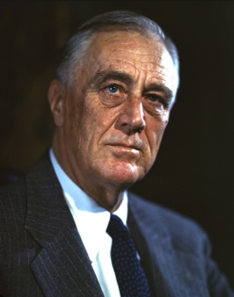 How did Roosevelt become a major figure of the 20th century? 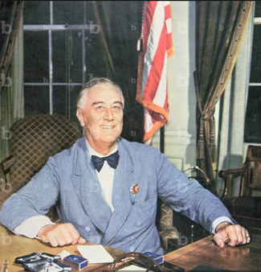
Franklin Delano Roosevelt

- The life of Roosevelt before being a President

- Roosevelt's education.

He benefited from an excellent education, which enabled him to enter Harvard in 1989. He went on to study law at Columbia and passed the bar exam. His cousin Theodore Roosevelt was elected President and became his role model, although they did not share the same political colours.

- His beginnings in politics.

Although a lawyer, Roosevelt became more interested in politics. In 1910, he became a Democrat senator and was appointed assistant secretary in 1913. He then retired from politics for a few years before being elected Governor of New York in 1928. He finally became President of the United States in 1933.

- Roosevelt’s action for America as a President

- Economic development in the United States.

One of Roosevelt's most important tasks when he became President of the United States was to resolve the economic and financial crisis caused by the Great Depression that began in 1929. His response was the New Deal, introduced in 1933.
Franklin Roosevelt also took action in favour of the environment: he created the Civilian Conservation Corps, which was made up of young Americans working against deforestation, among other tasks.

- Social policy under his mandate.

Roosevelt promoted policies to improve the lives of Americans, including reforms in health care, education and housing. His administration also introduced policies to support workers, farmers and small businesses.
However, although some New Deal policies benefited Afro Americans, racial discrimination and segregationist practices in many areas, including work and housing, persisted during and after Roosevelt's presidency.

- Roosevelt's interventions on the international stage

- Foreign policy during the WW2.
Roosevelt's foreign policy during the Second World War was characterized by a strong commitment to the Allies and effective strategic military coordination.
Before the USA entered the war, he set up the Lend-Lease programme and played a central role in several international conferences.
- Founding of the United Nations.

Through his interventionism and his desire to keep the peace, F. Roosevelt played a part in the Allied victory in the Second World War and helped to launch a new world order with the aim of maintaining peace.

