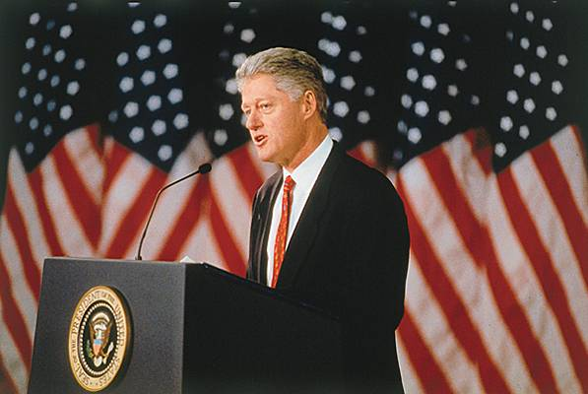
BILL CLINTON
To what extent did the Clinton presidency (1993-2001) overturn the traditional vision of the Democratic party?
Who is Bill Clinton?
- 42nd president of the USA, first democrat to be elected twice
- Born and raised in Arkansas + came from a modest family: illustration of a man who started from nothing and built his dream with his determination to work hard
- Graduated from Georgetown University and Yale Law School
- Became the State attorney general (1977-79) and the Governor of Arkansas (1979-81 and 1983-92)
I / Policies implemented by Bill Clinton
- A desire to reduce poverty, typical of democrats
- Strong growth: since 1993, creation of 10.5 million jobs
- Unemployment reduction: 1992 = over 7% =/ 1993 = between 5.1% and 5.3%
- Medicare: 1993 = plan to provide universal health care for all Americans

- A policy contrary to the protectionist ideology of the Democrats
- International treaties: ALENA + peace plan for the Balkans
- Interventions: in Haiti (1994) + in Serbia in order to avoid ethnic cleansing of Bosnian Muslims
- Missions with NATO: war in Yugoslavia + peacekeeping in Kosovo
- Oslo agreements: 1993
II / Paradoxical end to his presidency: scandals and strong political legacies
- Scandals and impeachment procedure
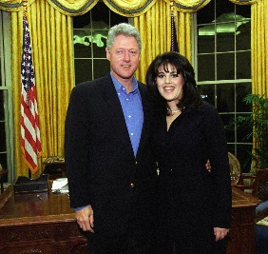
- Sexual affairs: he has been accused of sexual harassment by several women. In 1994, Paula Jones initiated a lawsuit against him for sexual harassment. Kenneth Starr was designated as independent counsel to investigate about this affair + the Whitewater affair.
- Clinton-Lewinsky scandal: Bill Clinton swore that he never had sexual relations with Monica Lewinsky in the context of Paula Jones lawsuit (1998) + Monica Lewinsky denied to having had sexual relations with the president BUT Starr promised her the immunity if she said the truth = Monica confessed and gave her dress to prove with DNA tests that it was Bill Clinton. Thus, he lied in his deposition.
- Impeachment procedure: “Starr Report”, which included 11 charges against the president, led to the impeachment of Clinton by the House of Representatives in December 1998. But in 1999, he was acquitted by the Senate and the impeachment proceedings failed because the 2/3 majority was not obtained.

- Political legacy
- His popularity is still strong despite the scandals and the impeachment proceedings: his popularity has even risen against the odds = 70% of Americans are for him.
- His wife's political career: during the 2008 Democratic presidential primary campaign, he succeeded to raise $10 million for his wife’s campaign, Hillary Clinton.

