THE FEDERAL JUSTICE SYSTEM & THE SUPREME COURT

Introduction
The U.S. Constitution is the supreme law of the land in the United States. It creates a federal system of government in which power is shared between the federal government and the state governments. Both the federal government and each of the state governments have their own court systems.
I. A dual court structure
1/ Types of cases heard

The Federal Court System | The State Court System
- Cases that deal with the constitutionality of a law ;  - Cases involving the laws and treaties of the U.S. ;  - Cases involving ambassadors and public ministers ;  - Disputes between two or more states ;  - Admiralty law ;  - Bankruptcy ; | - Most criminal cases, probate (involving wills and estates) ;  - Most civil law cases : contract cases, tort cases (personal injuries), family law (marriages, divorces, adoptions), etc.
2/ The court systems

The Federal Court System | The State Court System
Article III of the Constitution invests the judicial power of the United States in the federal court system. Article III, Section 1 specifically creates the U.S. Supreme Court and gives Congress the authority to create the lower federal courts. | The Constitution and laws of each state establish the state courts. A court of last resort, often known as a Supreme Court, is usually the highest court. Some states also have an intermediate Court of Appeals. Below these appeals courts are the state trial courts.
Congress has used this power to establish the 13 U.S. Courts of Appeals, the 94 U.S. District Courts, the U.S. Court of Claims, the U.S. Bankruptcy Court and the U.S. Court of International Trade. | States also usually have courts that handle specific legal matters, e.g., probate court (wills and estates); juvenile court; family court; etc.
Parties dissatisfied with a decision of a U.S. District Court, the U.S. Court of Claims, and/or the U.S. Court of International Trade may appeal to a U.S. Court of Appeals. | Parties dissatisfied with the decision of the trial court may take their case to the intermediate Court of Appeals, and then have the option to ask the highest state court to hear the case.
A party may ask the U.S. Supreme Court to review a decision of the U.S. Court of Appeals, but the Supreme Court usually is under no obligation to do so | Only certain cases are eligible for review by the U.S. Supreme Court.

> Question
Fill out the following chart

State Courts Federal Courts

US Supreme Court

II. The Supreme Court
"An act of the legislature repugnant to the Constitution is void — it is emphatically the province of the judicial department to say what the law is." ̶ John Marshall, Marbury v. Madison (1803).
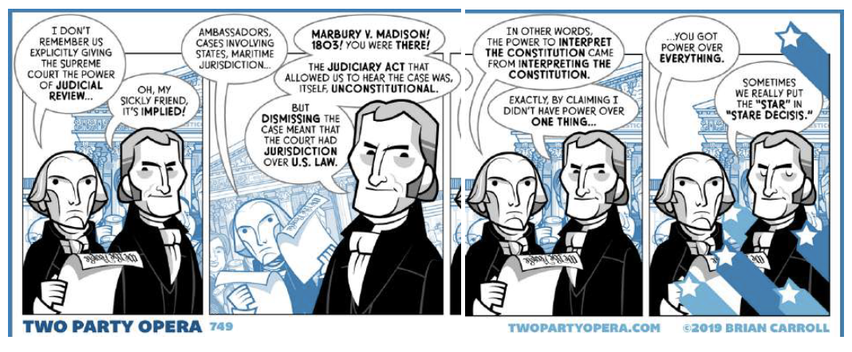
The Constitution painstakingly defines the structure and functions of the legislative (Congressional) branch of the government. It clearly (although less thoroughly) addresses the responsibilities and powers of the president. But, it treats the judicial branch almost as an afterthought. Article III specifically creates only one court (the Supreme Court), allows judges to serve for life and to receive compensation, broadly outlines original and appellate jurisdiction, and outlines the trial procedure and limitations of congressional power against those accused of treason. That's all.
The framers of the Constitution were clearly more interested in their experiment with legislative government than in the creation of a judicial system. Had it not been for John Marshall, the third chief Justice of the Supreme Court, the judicial branch might well have developed into a weak, ineffective check on the legislature and the presidency.
But Marshall changed everything by interpreting a power "implied" by Article III. Judicial review, or the power of the courts to overturn a law, was the vehicle he used to create the most powerful judicial branch in the history of the world.
The power of judicial review may be traced to the famous 1803 court case of Marbury v. Madison. The election of 1800 gave the presidency to an opposing political party for the first time. Fearing that the newly elected Thomas Jefferson, a Democratic Republican, would undo his policies, Federalist president John Adams, sought to "pack" the courts with Federalist judges. He worked feverishly on the judicial appointments until the very end of his presidency. When he left office, several of the orders were left on the secretary of state's desk, waiting to be delivered. The new secretary of state, James Madison, saw what Adams was up to, and refused to carry out the commissions. William Marbury, a Federalist whose commission was not delivered, sued Madison and demanded that the Supreme Court force Madison to act.
Marbury's demand was based on the writ of mandamus, a power given to the Court by the Judiciary Act of 1789 to command actions by officials of the executive branch. Chief Justice Marshall faced a huge dilemma. What if he commanded Madison to deliver the commissions and the secretary of state ignored his command? What could Marshall do to enforce the decision? The Court had no army, nor any other means to back up the command. If Marshall did nothing, the quarrel could spill over to Congress and tear the new country apart before it even got off the ground. Marshall's decision was to declare the writ of mandamus unconstitutional, claiming that Congress had passed a law "repugnant to the Constitution." He declared that because Article III did not grant the judicial branch the power of the writ of mandamus, and so the Supreme Court was unable to order Madison to act. Of course, Jefferson and Madison were happy with the decision, and the crisis passed, with only a disgruntled prospective judge (Marbury) to protest.
No one seemed to understand the grand implications of what Marshall had done: he had created the power of judicial review. This established the precedent that only the federal courts could interpret the Constitution. This power has given federal judges the final word in settling virtually every major issue that has challenged the government in American history.
Today, the judicial branch not only provides strong checks and balances to the executive and legislative branches, it possesses a tremendous amount of policy-making power in its own right. This power rests more on the precedent (a principle that later justices followed) of judicial review set by Marshall in 1803 than on the provisions of the Constitution.
> Questions
1/ How is the judicial branch originally defined in the Constitution ?
2/ Explain what President John Adams tried to do after the elections of 1800?
3/ Why did Marshall rule that the writ of mandamus could not be invoked?
4/ Why is the concept of precedent such an important concept here?
5/ Why has Marbury v. Madison been so important for the judicial branch?

Conclusion : Checks and balances
