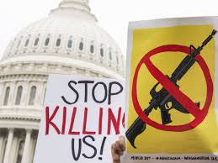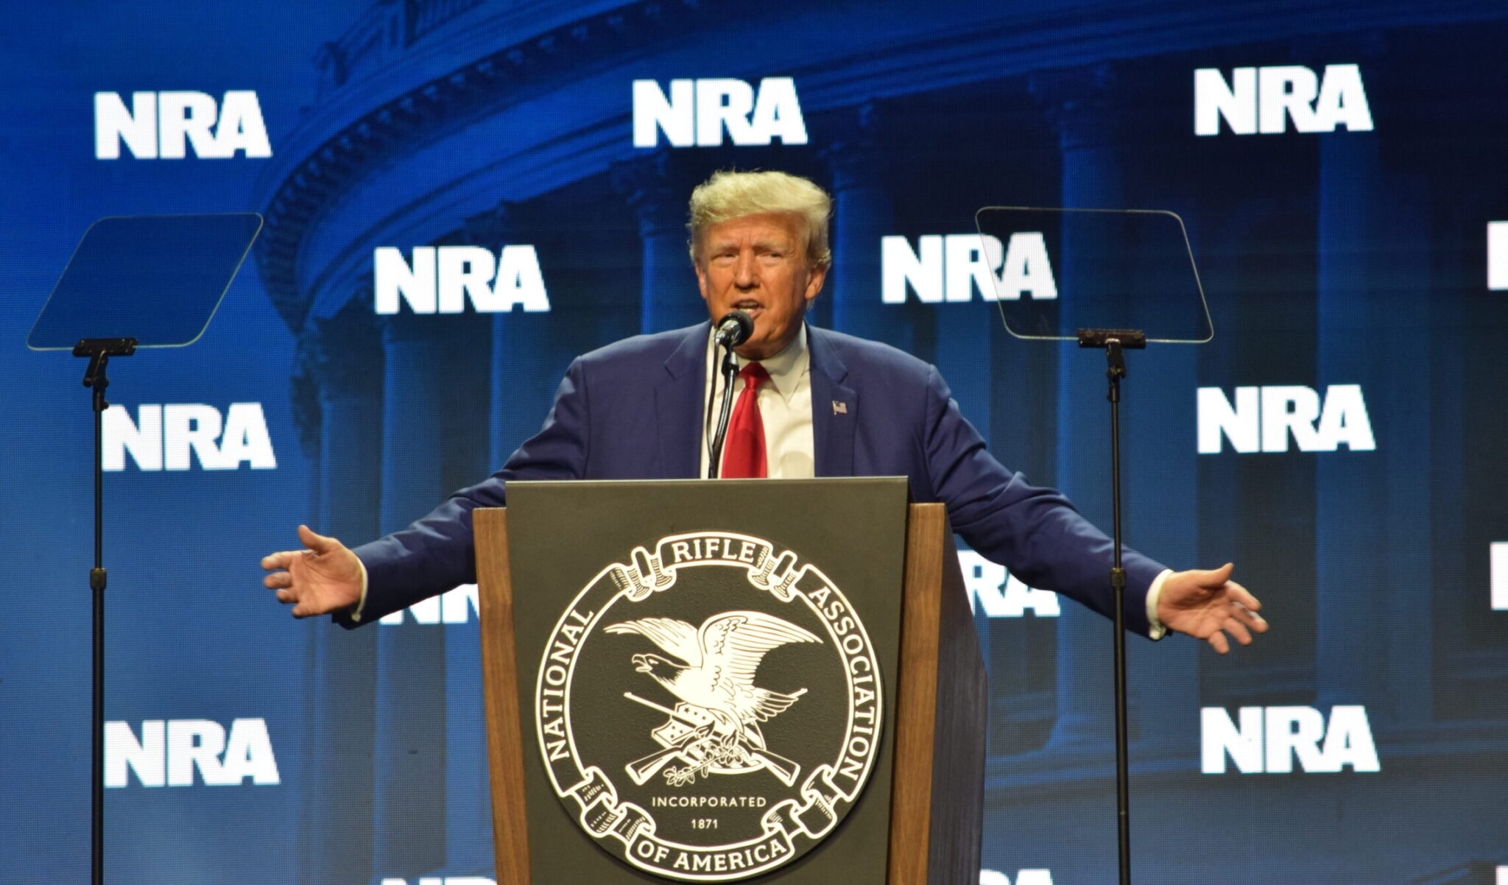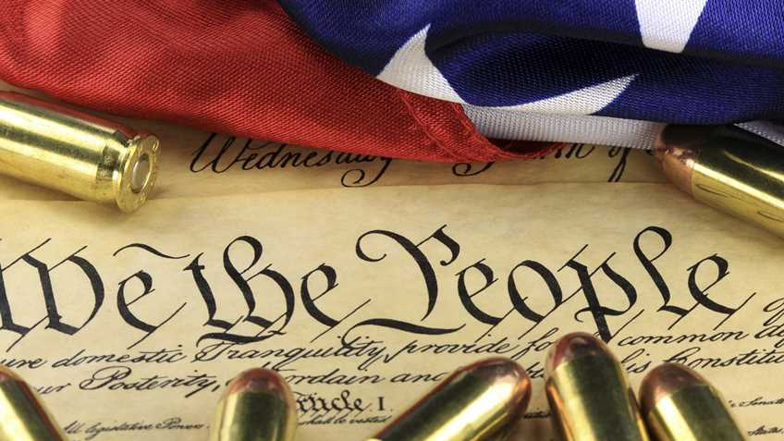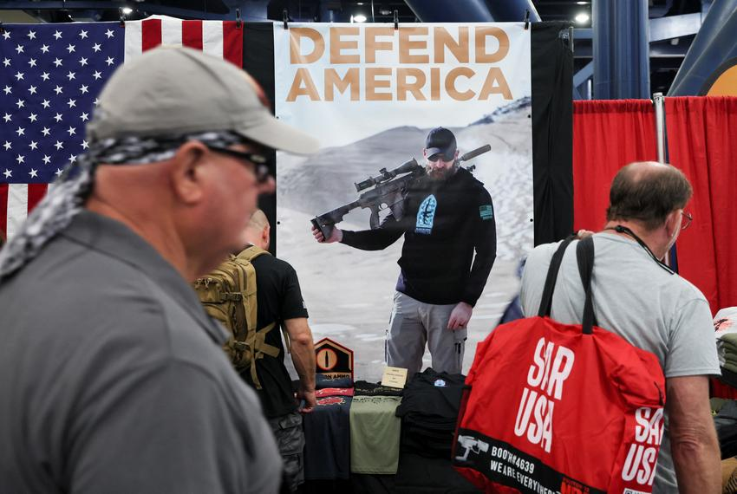Étoile en blanc étoile blanche' T-shirt Bébé | SpreadshirtÉtoile en blanc étoile blanche' T-shirt Bébé | SpreadshirtÉtoile en blanc étoile blanche' T-shirt Bébé | SpreadshirtÉtoile en blanc étoile blanche' T-shirt Bébé | SpreadshirtÉtoile en blanc étoile blanche' T-shirt Bébé | SpreadshirtÉtoile en blanc étoile blanche' T-shirt Bébé | Spreadshirt

* “*A well-regulated Militia, being necessary to the security of a free State, the right of the people to keep and bear Arms, shall not be infringed*”.
* The Second Amendment to the US Constitution protects the right to keep and bear arms. It was **ratified in 1791**.
* The Second Amendment drew inspiration from English common law's recognition of the right to possess and carry arms, and it was also influenced by the English Bill of Rights of 1689.
* Each State applies its own gun control laws as long as they do not contravene the Second Amendment.
* In 1911 the Sullivan Act, the first law to control the carrying of firearms, was passed. The NRA was already campaigning against it.
* The Second Amendment was born out of the War of Independence in which Americans fought against the English tyrant. There was no regular army in place yet.
* **Founded in 1871 by Civil War veterans**, the aim of the association was to improve the troops’ firearms handling skills.
* It was one of the **first associations to defend civil rights in the United States**.
* Nowadays, the Second Amendment is seen more as a way for citizens to protect themselves against other dangerous citizens.
* Today there are 120 guns for every 100 people and 45 mass shootings per year.
* The NRA has an annual **budget of $50 million**, which comes from the dues of the **five million members** it claims across the country, but it also receives numerous donations from the arms industry.
* Its influence is felt through advertising with celebrities, but also through firearms conventions.
* From 2000 to 2012, the NRA paid out **$80 million to influence elections** to the Senate, House of Representative and White House through both positive and negative advertising campaigns.
* Democrat Al Gore was victim of a massive NRA-funded smear campaign in 2000 because he wanted to reinforce Clinton’s Federal Assault Weapons ban.
* Since it is not officially a political organization, it has no spending limits.

A. An extensive political lobbying in support of firearms manufacturers

* Over the years, the NRA has **blocked numerous bills seeking to increase controls on the acquisition or possession of weapons**.
* Reagan was the first President to be strongly influenced by the NRA.
* Since 9/11 its influence has grown with the **increase in the number of firearms**.
* The NRA prevented **Barack** **Obama** from legislating on firearms despite his campaign promises.
* However, it has been weakened by internal scandals and the lobby is being sued for financial fraud.
* In 2022 **Joe** **Biden** passed into law the Landmark Gun Control Bill that imposes tougher checks on young buyers. This measure received a bipartisan support.
* The NRA is currently campaigning for its life member **Donald Trump** who promised to keep supporting the organization.

= taxes

B. An influence that prevents a change in legislation

A. An association defending the Second Amendment

Example of an NRA-funded ad that was broadcasted during the 2016 presidential campaign. It is stated at the bottom that the ad did not come from a candidate’s campaign team. Nevertheless, the fact remains that the NRA has strongly supported Donald Trump ([click to **watch the video**](https://www.youtube.com/watch?v=hPM8e_DauUw)).

II. A powerful influence on American society

B. From a right to self-defense against the British settler to a right to self-defense against other citizens

I. The evolution of a shooting club into a civil rights association

To what extent is the NRA preventing any reform in the USA to limit Americans’ access to firearms?

THE NRA

CYRIAQUE LÉCUYER

ALEXANDRE GAMET