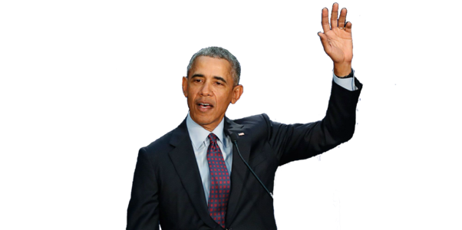
To what extent did Barack Obama give a new face to the American dream?
- Obama’s propelling journey, where it all begun:

- A unique backstory:
Raised by a white household = never really witnessed black oppression as a child.
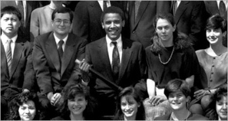
In Chicago : discovered the reality of the situation (poverty, racism, violence, unemployed people, and the black community’s problems in general) = nourished his realization of the necessity of being involved in politics and the need for change.
⇒ He got nominated as the president of the law review of Harvard (first black student to occupy the function) → Started to make changes from the beginning.
- A political debut, the staircase to his presidential mandate:
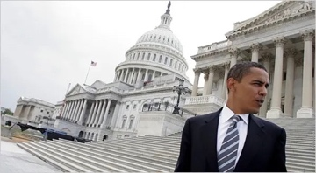
1995: elected senator of Illinois ⇒ first win that marks his entry to the domain of politics.
A few years later: an attempt to sit in the US senate in Washington against Bobby Rush = Failed.
2004: new chance of getting to sit in the US Congress. = Succeeded.
⇒ A real thunderclap for American politics : the democratic party found a candidate capable of uniting Americans with Democratic values across all political, racial or social divides.
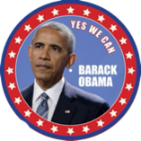
2008: allegations by the Republican Party ⇒ As an answer to that, Obama made a unifying speech : = He called for evolution.
- Obama’s achievements as the Head of State of America:

- His efforts for the development of social policies in the US :
⇒ 2003 : He became President of the Public health Commission and social services of Illinois → 26 bills about social health care, medical reimbursement and education.
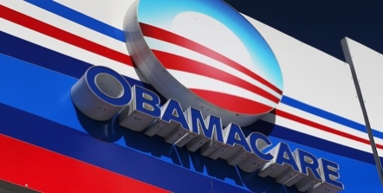
⇒ Obamacare 2010 : When he was elected, 45M Americans were uninsured. The main goals were to :
- make insurances available to more people ;
- make the healthcare more accessible ;
- stop private insurance companies from denying or charging people
more based on preexisting health conditions.
= By 2016, more than 20M previously uninsured people had acquired healthcare.
⇒ Reelection in 2012 : reinforced Obamacare, tried but failed to introduce gun control measures, samesexe marriage in the Constitution.
- Obama’s impact on the international political sphere:
He showed his will to make up with the Arab-Muslim World : started his speech in Egypt by Salam Aleikum + stepped back from Bush’s nuclear rearmament policy. Soon after, in 2011, he ordered the beginning of a progressive withdrawal of American troops in Afghanistan
⇒ 2011 : commanded the total withdrawal of American troops in Iraq, a war he qualified as a “Dumb war” in 2003

