**GPT-4: Module 4: Grassroots Action: Households and Individuals (2 hours)**

• 4.1. Carbon Footprint: Understanding and Measuring Personal Impact

• 4.2. Energy Efficient Homes

o Home insulation, smart technologies, and sustainable materials

o Solar panels and decentralized renewable energy systems

• 4.3. Sustainable Mobility for Individuals

o EVs, bicycles, carpooling, and public transport

o Behavior change and the psychology of sustainable choices

• 4.4. Food, Waste, and Lifestyle Choices

o Reducing waste, composting, and recycling

o Diet and the environment (e.g., plant-based diets)

• 4.5. Community Initiatives and Collaboration: Amplifying Impact

**• 4.1. Carbon Footprint: Understanding and Measuring Personal Impact**

**Plan :**

**I. Definition of the carbon footprint**

1. **History**
2. **Method**

**II. The carbon footprint worldwide:**

1. **By Region**
2. **By sector**

**III. Reducing the carbon footprint**

**A. Changes in consumption habits**

**B. Use of renewable energy sources**

**C. Policies and regulations**

1. **Definition:**

The carbon footprint makes it possible to compare the total amount of greenhouse gasses emitted from an activity, product, company or country. Carbon footprints are usually reported in tonnes of emissions (CO2-equivalent) per unit of comparison (years, persons and so on).

1. **History**

The carbon footprint has been originally created by an advertisement of an oil company, British Petroleum, to shift the burden of action (and blame) from fossil fuel companies to consumers.

1. **Method**

Calculating carbon footprint is not as simple as you think. There are experts for this task, because it can be calculated at a country, city, company, or individual levels.To achieve 95% carbon footprint coverage, it would be necessary to assess 12 million individual supply-chain contributions. There are a lot of online calculators that ask for your income, travel habits, meat consumption, and so on. All of this is aggregated, and then the calculator makes a mean. For example, my carbon footprint is equal to around 6 tons of CO2 every year.

1. **The carbon footprint worldwide:**

The carbon footprint experienced several shifts before and after the pandemic which reflect the important impact of global disruptions on human activities. Prior to the pandemic, the world faced an increasing carbon emissions, driven by rapid industrialization, transportation demands, and conventional modes of energy production.

However, with the policies of lockdown and travel restrictions, there was a reduction in human mobility and economic activities. This translated into a temporary decline in carbon emissions, notably from the transportation and industrial sectors.

Nevertheless, post-pandemic recovery efforts and a return to pre-pandemic lifestyles posed challenges to maintaining these environmental gains, emphasizing the need for huge efforts toward sustainable practices and resilient systems to mitigate the carbon footprint in the long term.

1. Carbon footprint by sector:

Emissions from the manufacturing and the energy sectors contributed the most to the global increases of carbon footprint. The most emissive sector is the power sector, Emissions were pushed up by cooling and heating demand from extreme weather pushed up global emissions.

The positive side is the fact that the Carbon footprint didn't return to the levels before the panademic.

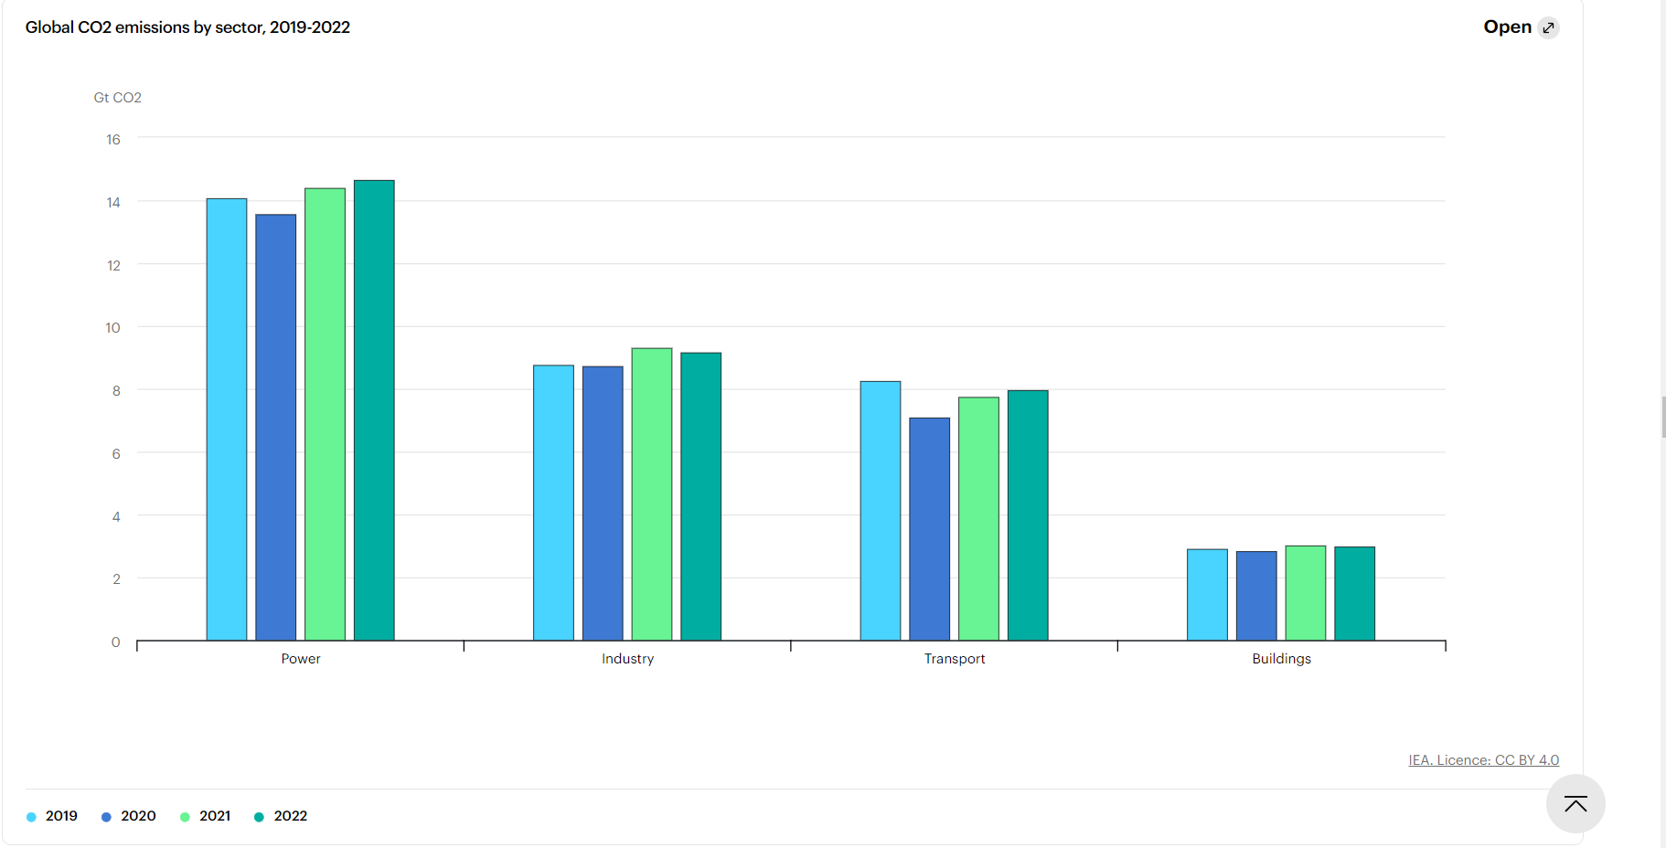

1. By countries/ region:

China, the United States, and India emerge as leading contributors to the global carbon footprint due to :

* Their large populations,
* Economic activities with significant industrial output.
* Dependence on fossil fuels
* An important role in global manufacturing and trade.
* The reliance on coal, oil, and natural gas for energy,
* Rapid urbanization and infrastructure development

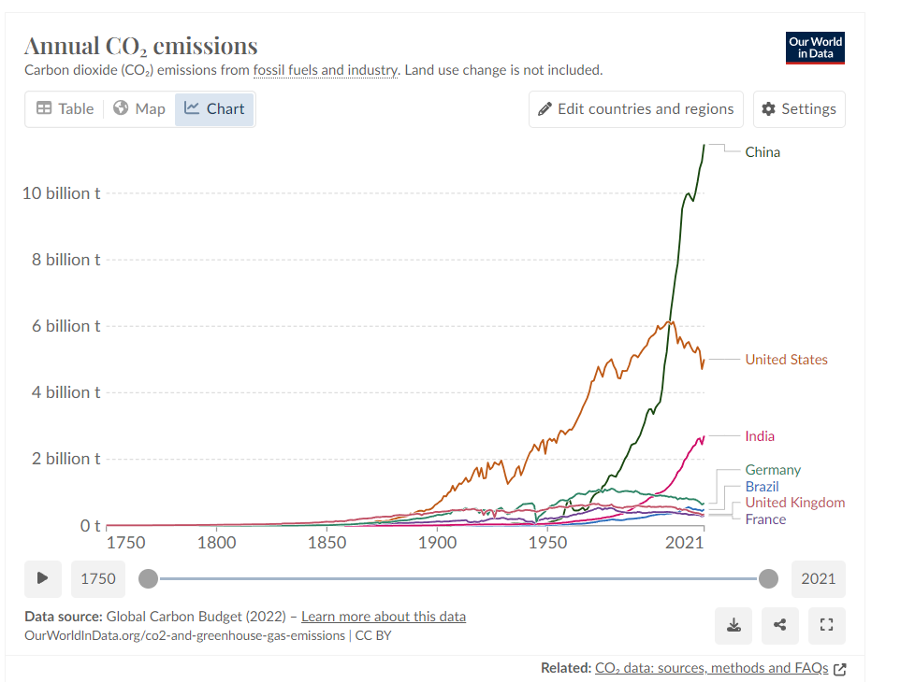g

**III. Reducing the carbon footprint**

Embracing a sustainable lifestyle involves mindful choices across various aspects of daily life. When it comes to food, opting for local, seasonal produce and limiting meat consumption, particularly beef, contributes to reducing one's environmental footprint. Additionally, choosing sustainably sourced fish, utilizing reusable shopping bags, and avoiding excessive plastic packaging all play a part in fostering eco-friendly eating habits. And for clothing, practicing responsible consumption and opting for recycled items supports a more sustainable fashion industry. Transportation choices, such as cycling, public transport, and mindful driving, further contribute to minimizing our impact on the environment. Finally, practicing energy conservation, waste reduction, and selecting energy-efficient products are integral steps toward creating a more sustainable and eco-conscious lifestyle.

**EU targets and policies :**

The European Union is leading the way in tackling carbon emissions through its Emissions Trading System (ETS), a groundbreaking initiative for industries. Companies must acquire permits for each tonne of CO2 emitted, obtained through auctions, with incentives in place to encourage innovation. Covering 40% of EU greenhouse gas emissions, the ETS governs 10,000 power stations and manufacturing plants. Recent updates align the system with the European Green Deal, targeting a 62% emissions reduction in ETS-covered sectors by 2030. The ETS now extends to aviation and maritime transport, promoting sustainability and emissions reduction. For aviation, the ETS applies to all flights departing from the European Economic Area, aiming to phase out free allocations by 2026. In maritime transport, emission cuts are mandated, emphasizing a transition to cleaner fuels. In the automotive sector, the EU Parliament supports zero CO2 emissions for cars and vans by 2035, with interim targets for 2030. These measures highlight the EU's commitment to combating climate change across different industries.

**Sources:**

<https://ourworldindata.org/co2-emissions>

<https://www.iea.org/reports/co2-emissions-in-2022>

<https://www.imf.org/en/Blogs/Articles/2022/06/30/greenhouse-emissions-rise-to-record-erasing-drop-during-pandemic>

**• 4.2. Energy Efficient Homes**

**Home insulation and smart technologies**

An eco-friendly home is a home that minimises its impact on the environment. Investing in eco-friendly features and smart technology at home can have serious benefits in the long run : help your budget and the planet.

For example, changing the insulation in the walls and the window glazing. But there are easier things which can make a difference such as switching your energy provider and reducing your consumption of heating, hot water and electricity

You can use smart technology: There is not a single definition of smart technology. ‘Smart’ was originally an acronym: Self-Monitoring, Analysis and Reporting Technology.

* Smart technology at home
* Smart lighting using an app
* Similar to smart lighting, you can use your phone or tablet to control the heating

**Sustainable materials**

You also can use Sustainable Materials such as :

Recycled or Eco-friendly Insulation: Consider using insulation materials made from recycled content or natural fibers like cotton, wool, or recycled denim. These materials are sustainable and often perform well in insulating properties.

Green Roofing: Choose roofing materials made from recycled or sustainable sources such as metal, clay tiles, or sustainably sourced wood. Green roofs or cool roofs can also reduce heat absorption and save energy.

Low VOC Paints and Finishes: Opt for paints, coatings, and finishes that have low volatile organic compound (VOC) content, which reduces harmful emissions and contributes to better indoor air quality.

Sustainable Flooring: Use sustainable flooring options like bamboo, cork, reclaimed wood, or recycled materials to reduce environmental impact and promote a healthier indoor environment.

**Solar panels and decentralized renewable energy systems**

1. **Solar power**

You can use the sun to generate electricity for your home through [solar photovoltaic panels](https://www.eonenergy.com/solar-panels/photovoltaic.html) that are installed on your roof. These panels take the sun's rays and convert it into electricity that you can use to warm your home and power your devices.

1. **Solar heating**

Solar energy can also be used to provide hot water and heating all year round. Solar heating systems use solar panels that can be fitted to your roof

**Air source heat pumps**

An [air source heat pump](https://www.eonenergy.com/air-source-heat-pumps.html) is a renewable energy system that uses the heat from the outside air to provide you with heating and hot water – working in a similar way to a fridge but in reverse by extracting energy from the air and using it to warm your home

Many Governments are offering grants.

1. **Wind energy**

Wind turbines are not just for the big [wind farms](https://www.eonenergy.com/about-us/our-wind-farm-legacy.html). Smaller wind turbines are available for homes. They generate electricity by the wind turning the blades, which drives the internal turbine and creates power.

1. **Biomass systems**

Biomass heating systems burn organic materials, such as wood pellets, chips or logs to provide heating and hot water.

1. **Hydroelectric systems**

This renewable energy source uses water flowing downhill to generate electricity - so if your home is close to a lake or river it could be a great option for you

1. **Renewable electricity supply**

Find a sypplier with 100% [renewable](https://www.eonnext.com/renewable) sources such as wind, biomass and solar.

**• 4.3. Sustainable Mobility for Individuals**

**1° EVs, Bicycles, Carpooling and Public Transport**

**EVs** : EVs stand for Electric Vehicles, as the name itself implies it, this kind of vehicles are equipped with a system that allows them to be charged and recharged with electricity.

Instead of using vehicles that use fossil fuels such as Diesel or essence, Electric Vehicles are a great alternative because they have quite a few benefits, in which the main one is the reduction of carbon dioxide and greenhouse gasses as a whole.

**Bicycles** : Even though EVs are a really great alternative for transportation, It also has its side effects, because it is still producing greenhouse gasses at a lower range than fossil fuel based cars.

This is where bicycles come in handy. In fact, bikes do not produce as much as cars whether they are electric, non-electric or hybrid.

Their carbon footprints are lower than the vehicles listed above.

They are great alternatives for transportation in short distances and also allow anyone that uses one, to maintain their health, because riding bikes is a sort of workout.

**Carpooling and Public Transport**

Transportation means such as carpooling and public transportation contribute to the reduction of the carbon footprint in several ways:

**Carpooling:**

* **Optimization of vehicle occupancy:** By grouping several passengers into a single vehicle, carpooling maximizes vehicle occupancy, thereby reducing the number of vehicles needed to transport a given number of people.
* **Reduction of individual emissions:** By sharing costs, passengers help decrease the number of vehicles on the road, thus reducing the individual emissions of each car.
* **Reduction of traffic congestion**: By decreasing the number of cars on the road, carpooling contributes to reducing traffic congestion, leading to smoother traffic flow
* and lower carbon emissions

**Public Transport**

* **Economies of scale:** Public transportation vehicles, such as buses and trains, can transport a large number of passengers at once, optimizing energy use per passenger and reducing the carbon footprint per person transported.
* **Cleaner technologies**: Many public transportation infrastructures adopt cleaner technologies, such as electric buses or trains powered by renewable energy, contributing to the reduction of greenhouse gas emissions.
* **Fewer individual cars**: By promoting the use of public transportation, there are fewer individual cars on the road, decreasing emissions from the overall vehicle fleet.

In summary, both carpooling and public transportation reduce the carbon footprint by optimizing vehicle use, decreasing the number of individual vehicles on the road, and adopting cleaner and more efficient technologies.

**2° Behavioral change and psychology of sustainable choice.**

The behavioral change of individuals is a complex process that depends on various factors, including their choices, awareness, and attitudes towards the environment.

According to a study titled 'Designing Sustainable Mobility: Understanding Users’ Behavior' (Sadeghian et al., 2022), about an investigation on people's behaviors towards sustainable mobility and the factors influencing their choices.

By analyzing 1150 Reddit comments from both climate-related and car-enthusiastic subreddits, they applied a-priori and emergent coding methods called ACP to categorize the comments along the 'stages of behavior change' and 'theory of planned behavior' components into two axes so that we can easily observe the the results.

The study revealed that behavioral change is not solely based on an information deficit but is strongly influenced by attitudes and control beliefs towards sustainable mobility.

While there is a positive opinion towards sustainable mobility, the study found that actual behavioral change is limited, with many individuals expressing a willingness to change but not taking concrete actions.

To address this, the researchers recommend designing interventions that target attitudes or social behavior in earlier stages and control beliefs in later stages of change to fulfill individual needs, shape positive experiences, inform individuals about available opportunities and the impact of their behavior, and be salient in social contexts, allowing connections to peers.

By understanding the factors influencing mobility choices, interventions can be tailored to promote sustainable behaviors, contributing to a greener future.

**Reasons why behavioral change is difficult to achieve** :

Public transportation is in multiple cultures looked down upon as a hassle and a less attractive alternative to private modes of transports such as a car.

This is the case of the US where cars were marketed as an expression of individual freedom as opposed to the collectivist public forms of transportation.

The Cold War and the ensuing cultural clash in the 50s between consumerist capitalism and collectivist russian style communism has created a society that is hostile to the idea of sacrificing personal comfort and perceived personal freedom in favor of the occasional discomfort caused by crowding in public transport.

Sustainable transportation limits personal freedoms because it requires sacrifice, such as limiting trips abroad which most people do not want to do because they feel that they’ve earned it after their long work hours.

For behaviors to change people need to be compensated for their sacrifices.

Another problem is tied to geography and access to public forms of transportation for work and personal expenses.

This is especially true in the countryside and in the American style suburbs where having a car is indispensable to survive.

Changing these behaviors require massive investment in spatial reorganization to create new daily habits. These changes might meet a lot of resistance because humans tend to resist deliberate social programming.

**• 4.4. Food, Waste, and Lifestyle Choices**

I – Food

-To buy less transformed food and to promote vegetable instead of meat (except if it is flexitarian)

- to cook food at home and incentivize batch cooking

-composting vegetable garbage for feeding ground

-recycle and sort garbage because it reduces waste.

- Reduce meat consumption or prefer white meat that emits less greenhouse gas emissions

- Consume locally without intermediary and seasoned products in order to reduce imported food that highly contributes to greenhouse gas emissions. Its action also promotes local economy and more profitable for cultivators

MIORA=vert

II. Waste

- Sort out garbage and compost food waste: it is more available in France even in metropolitan areas. Indeed, some city hall/ mayor, there are common compost vats near green spaces

- to give to associations the unused clothes, toys, or books if it not totally broke and throw less as possible

- give your devices that you don’t used or sell it to firms which can recondition it, instead of throwing it

III – Lifestyle choices

- Boycott Fast-Fashion that doesn’t last long

- resell clothes and objects that we no longer use to give them a second life and reduce waste

- Buy bicycle or buy a subscription on velib or veligo

- turn down the heating at 19°C and decrease it when you are not at home

-Turn off the lights at day and when you are not in the room

- Reduce your electric consumption

-close the windows when the radiator turns on

- Buy reconditioned devices and don’t buy too much electronic products, keep them at least for 5 years

- stop using cars for short distances

-Stop using airplanes too many times in a year

-Buy electric cars and second-hand cars instead of a new car

We have many things to do to reduce our footprint but if we all follow recommendation mentioned above the planet will be better off. Everybody can’t do all perfect but trying to do best and react are already a considerable step in the way of decarbonization.