**A) Spot the mistakes!**

Young people massively invested in cryptos, haven’t they?

How much hours did you spend at the “Bitcoin and us” conference? I didn’t stay until the end.

If the talk on cryptocurrencies were online, I would have been happy to join you.

**2- GDP Is a Wildly Flawed Measure for the Digital Age, *Harvard Business Review*, July 2016**

**access - nationalistic - information - capital - ownership - struggles - pace - industrial - stuck - interest - gig**

As the economy has evolved from one age to another (from to services to to network), our basic measurement systems have not kept . GDP was developed during the industrial age and to account for today’s intangible assets—services, insights, and networks. When you take a close look, though, a customer surplus is now emerging. Everyone carries a mobile phone with access to real-time banking, retail, music, and global communications in their pocket. Access to education, even free online options, is growing. And many new jobs are arriving to replace the old. So maybe the problem is that the world is in old ways of measuring and reporting growth based on making and selling *things* (i.e., physical ), rather than today’s growth drivers of developing and creating human, intellectual, and network capital.

It’s time to measure all the value that human beings produce around the world: networks of extraordinary value, digital assets of infinite use and reuse, and the new employment opportunities that are opening to everyone. Our research into business models clearly indicates a world where networks and digital assets are more valuable than things and “ ” is more convenient than . In the process of creating more efficient, happy, and technologically supported lives, we may have to blow up and recreate how we gauge economic prosperity and growth. As long as we hold onto our old ways of thinking, acting, measuring, and reporting, we will continue to see negative growth and rates as well as their accompanying responses from leaders around the world.

**🡪 Overall would you say that GDP no longer is the right metric for our age?**

**B) Oral presentations**

**C) Three basic functions of money (revisions)**

**-**

**-**

**-**

**D) Text and comprehension questions p. 44-45**

**🡪 bitcoin USD price (blockchain.com)**

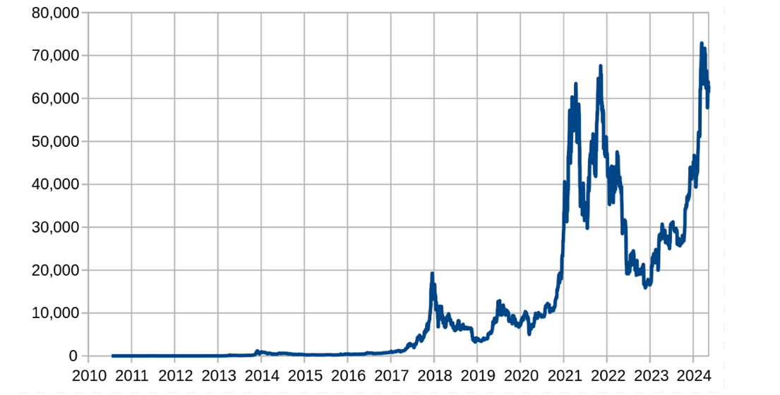

**E) Crypto: will the bitcoin dream succeed?, *The Economist*, 2021 (from 06:05 to 10:26)**

1) Why doesn’t bitcoin really work as a way of paying for things?

2) What happened in 2013 in Wales?

3) Why are regulators wary (= suspicious)?

4) “Leading economists have warned ………………………………………………………………..

…………………………………………………………………….…………………….. investments.”

5) Pick up two examples of historic bubbles.

6) What is for certain?

**E) Infinitive or gerund?**

**He remembered updating the file.**

**He remembered to update the file.**

**???**

Select the appropriate answer (checking the -INF / -ING rules on the EPI if necessary!)

1) Sky News has been ordered *to sell / selling* part of its stake in ITV.

2) Our team is not very good at *make / making* Zoom presentations.

3) We regret *to tell / telling* you that we are cancelling our contract immediately.

4) I forgot *to send / sending* an email to our client so he wasn’t too pleased.

5) When I tried *to speak / speaking* to the customer service, they didn’t do anything at all!

6) Have you considered *to apply / applying* for a promotion?

7) There are reports that Vodafone plans *to target / targeting* this company for takeover.

8) We stopped trying *to break / breaking* into the US market because of the recession.

9) They denied *to buy / buying* the shares using insider knowledge.

10) Our partners are very capable and deserve *to be / being* given more responsibilities.

**Grammar exercise p. 48-49**