About six months before #Metoo (which was something like September 2017 with the Weinstein affair), I had a very revealing telephone conversation with my 27 year-old daughter in which she explained to me why she didn’t like taking the metro.

Women are harassed never/seldom/sometimes/often / all the time.

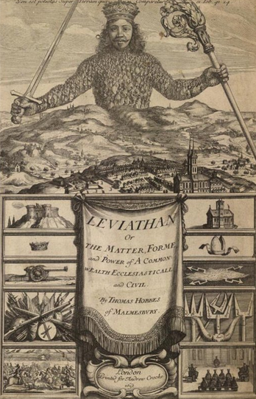

This is could be viewed as quite a fundamental question of political philosophy. Good Old Hobbes, the English political philosopher of the 17th century, said that naturally we (les mecs) are in a “state of war”, and therefore we enter a social contract with the Leviathan – an almighty power – to keep the peace.

Women always have to be on the lookout (on qui vive) in the public space… and certain spaces are to be avoided sometimes or all of the time.

At about the same time, I read a book called “Who Cooked Adam Smith’s Dinner”, by Katrin Marçal (2016).

Smith’s famous statement about the butcher, brewer and baker providing his dinner out of self-love (for money) is perhaps his most emblematic statement of economic individualism and one example of the “invisible hand".

“It is not from the benevolence of the butcher, the brewer, or the baker that we expect our dinner, but from their regard to their own self-interest. We address ourselves not to their humanity but to their self-love, and never talk to them of our own necessities, but of their advantages”

― Adam Smith, [An Inquiry into the Nature & Causes of the Wealth of Nations, V](https://www.goodreads.com/work/quotes/91605400)

Katrine Marçal

<https://www.youtube.com/watch?v=SnBEXUSNgQ8>

the premises: grounds and buildings (locaux)

broker (courtier)

dry containers 20 GP 40GP

GP general purpose

HC high cube

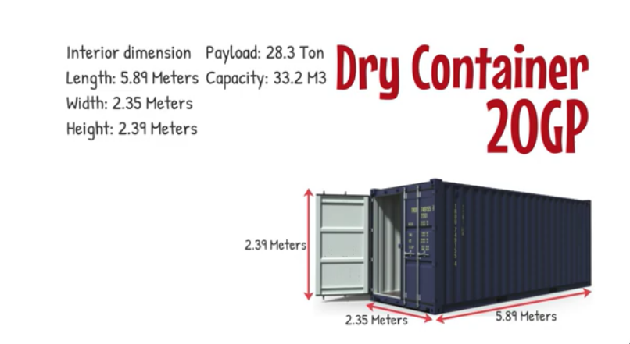

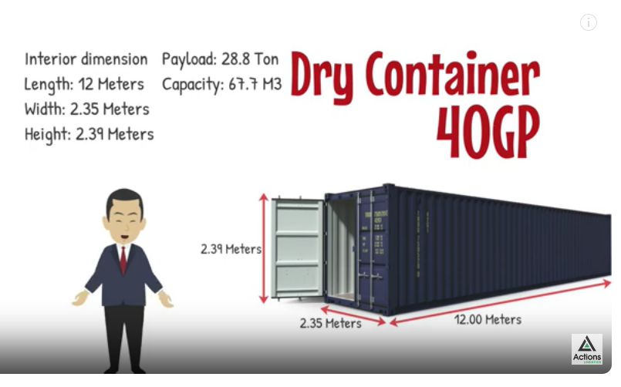

Refrigerated containers – refeers

Open top containers

Flat rack containers