The victory of Trump is hard to digest.

Trump was able to blame the increase in inflation on Biden – which is actually partly. Biden’s first stimulus of $1.7 trillion in February 2021 was too much, because the outgoing Trump administration had already passed two stimuluses (of about $2 trillion in March 2020 (the CARES Act), and in December, $1.3 trillion).

Nostalgia of when? Of when Trump was president – before Covid: there were no wars in Ukraine or Gaza. And there was the humiliating withdrawal from Afghanistan for Americans, which has been disastrous for Afghan society and women especially.

There was a ban on Muslims going to the US, which was eventually upheld by the Supreme Court.

Trump drew out of the nuclear arms deal with Iran, and he pulled out of the Paris Agreement signed at the Cop 21.

He launched a trade war with China, and introduced tariffs on certain goods – especially aluminum. He threatened Europe with making cars a strategic industry, and so limiting imports.

He talked about building a wall with Mexico – not that much was done?

He pulled US troops out of Syria, leaving the Kurds in the lurch.

He initiated the Abraham Agreements.

He did start any new wars.

People are anxious about their future, in 10, 15 and 20 years… blaming immigrants.

People are worried about protecting some sort of American legacy.

1/ domestic politics: Ryan, Harold and Arthur

2/ geopolitics:

3/ relations with China: William, Sirine and Matin

4/ climate change: Faridah, Alya, Abdelmajid and Davia

5/ US foreign trade relations: Rodrigues

6/ the impact on merchandise trade: Maryanne

**On domestic politics**: he has promised tax breaks on tips and overtime. There are no details about how these will be paid for.

Since Reagan (1981 to 1989), the mantra of the Republicans has been that tax cuts pay for themselves. This is partly linked to the “trickle down effect”.

Cutting taxes stimulates activity: cutting taxes for the rich will lead to more investment, which will lead to more jobs and growth and ultimately more tax revenues.

This was called “voodoo economics” by George Bush Sr during the 1980 election campaign before he agreed to be the vice-presidential candidate for Reagan.

It’s based on so-called supply-side economics and the Laffer curve:

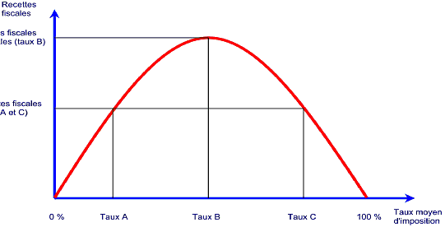

This was first applied by Reagan when the top income tax rate in the US was 70% (it had been as high as 90% in the 1950s): in Britain the top income tax rate in the 1970s, before Thatcher, was 83%.

In 2017, Trump pushed through a major corporate tax cut, from 35% to 21% (impôt sur les société).

He intends to weaponize the justice system against his opponents – lock up political opponents.

He has said to his supporters “I will be you retribution”.

**Relations with China**: his re-shoring policy is to bring jobs back to the US, using tariffs.

During the Biden administration, policies were adopted to stop commercial exchanges with China, especially in high-tech (the Chips Act). Exclusion of Chinese telecom technology, notably with 5G networks, where China was ahead of the US.

There has been a policy to restrict the sale of chips and microprocessors to China.

Taiwan is a major flashpoint in US-China relations. China has ramped up pressure on Taiwan, while the US has deepened its ties.

Traditionally the US follows a one-China policy, but embraces the strategic ambiguity of the Taiwanese governments selves.

2049 will be the 100th anniversary of the PRC.

I’m not so sure that Trump would defend China…?

Climate change is officially a climate skeptic, and has promoted fossil fuels. His administration relaxed regulations on methane emissions.

Under his presidency, he stepped back from renewables.

However, some states have maintained initiatives.

There is a slight paradox here in terms of the Inflation Reduction Act by the Biden administration which supports renewables. Texas and other “red states” have actually been leading investment in renewables or investments linked to the IRA.

**US foreign trade relations**: Trump has said that “tariffs” is his favorite word. He wants to pursue his protectionist policies, and wants to tax Chinese imports.

He has said that he wants to raise tariffs partly also to lower taxes – although economists say this is unlikely to work.

He has also talked about increasing taxes very substantially on countries that do not use the dollar in international trade.

According to Statista, 58% of SWIFT transactions were in dollars in September 2024.

<https://www.statista.com/statistics/1189498/share-of-global-payments-by-currency/>

Russia and some other BRICs are talking about creating a parallel payments system.

China could be the most serious player, but the renminbi is not freely convertible.

And China has no equivalent to the US bond market, as a liquid market for assets.

In the past, Trump talked about renegotiated US government debt. This would of course completely disrupt the US government bond market, and financial in markets in general.

The impact on merchandise trade: tariffs reduced trade with China. Further tariffs have already impacted commodity markets. Trump’s policy could affect trade relations with the EU.

This could potentially reduce physical trade flows.

The Conversation:

<https://theconversation.com/les-etats-unis-ne-croient-plus-en-la-mondialisation-et-leur-economie-se-porte-bien-malgre-tout-241966>?

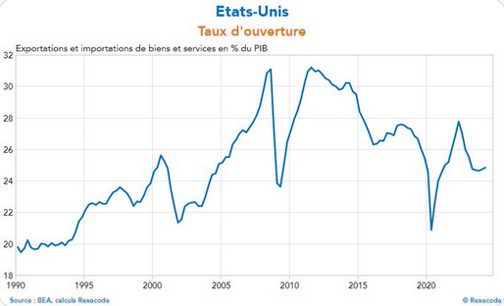

The graph shows a very common measure of openness:

(X + M)/Y (GDP)

The figure shows a remarkable decline in openness, from 31% to 25%. This is a big retrenchment. But, it has not prevented the US economy from growing strongly.

Free trade based on comparative advantage is holy writ in economics.

There is one other fundamental societal issue that has been raised by this election.

Before the results, it was said that women were going to vote for Harris and (young) men for Trump, including a lot of Black and Latino young men.

White, poorly educated men probably voted in large numbers for Trump.