**SUPREME COURT 12-11**

1. **Midterms**

* **From the papers**

1) Pour un étudiant en droit de Cambridge, ce n’est pas un problème mais pour la société dans son ensemble, ça l’est.

2) Le rôle du juge / des juges est tout à fait central dans le système de common law.

3) Le droit est à peu près partout dans la vie des gens.

4) Il y beaucoup de précédents à étudier donc cela prend du temps !

5) Il y a un vrai problème de diversité même si le système existe depuis des décennies.

6) Il faut reconnaître l’héritage du droit romain.

7) Donc, oui, les règles sont plus explicites dans les systèmes qui utilisent la civil law.

* **Adverbs**

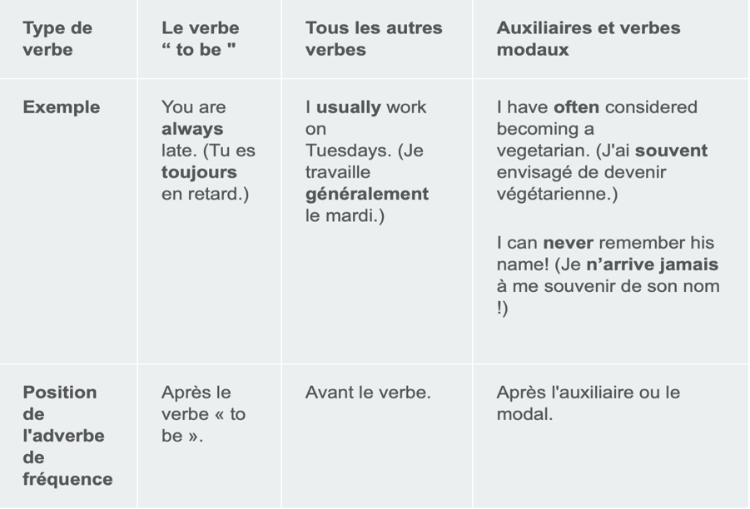

**Correct the following sentences.**

1. I always am happy when I finish work early.
2. Charles has been never to the House of Lords.
3. They need to take their medication three times for day.
4. Always I try to arrive at the office before 9:00 am.
5. I book sometimes business class seats when flying with my company.
6. They already have picked up the tab. We’ll invite them next time.
7. The company needs to monthly report on its financial results.
8. **Oral presentation – GD02 15’**
9. **Trump’s legal cases – where next? PBS News Hour, November 2024 (beg to 04:15)**

1) How has the US election changed the legal landscape for President-elect Trump?

2) What are the two federal cases involving Trump?

3) What impact can Trump and his Justice Department have on the cases?

4) Why is it admitted that sitting presidents shouldn’t be prosecuted?

5) What about the two state cases?

1. **Supreme Court text & qus pp. 188-189**
2. **Vocabulary 2-B p. 193**
3. **Pronouns p. 193**

**Who, whose, whom, what, which, or that?**

1) The letter Justice Parker sent us last month was very thoughtful.

2) Justice Parker’s ruling, I heard of this morning, is a landmark one.

3) My brother-in-law, is a pediatric consultant, lives in Cardiff.

4) My brother-in-law, with you played tennis last Saturday, lives in Cardiff.

5) Our house, stands right opposite Kew Gardens, was built in the 1930s.

6) The file I am going through is about inheritance law.

7) We have nothing about to complain really.

8) He’d like to have someone with to visit the Supreme Court!

9) They were given four books, three of were about corporate law.

10) Will the person car is parked in front of the office be so kind as to move it? 11) The clients for we are waiting are always late.

12) The defendant, was found guilty, decided to appeal the verdict.

13) They decided to work with that other lawyer, name I can’t remember.

14) They apologized most politely, we all very much appreciated.

15) Justice Hale, was appointed President of the Supreme Court in 2017, retired in 2020.