Course Title: Energy Transition in International Transport: Towards
Module 1: Introduction to Global Warming and Its Causes (2 hours)
•
• 1.2. Anthropogenic Causes of Global Warming
o Greenhouse Gas Emissions: Sources and Impact
o The Role of Industrialization and Urbanization
• 1.3. Natural Factors and Their Impact on Climate
• 1.4. Consequences of Global Warming on the Environment and Socio-Economic
Sectors
• 1.5. Brief Discussion: The Urgency of Addressing Climate Change

1.1. Understanding Climate Change: Basics and Definitions

Climate change designed the long-term alterations of temperature and the weather patterns all over the world and some regions like the region in Pacific ocean are more impacted. Mainly due to human activity which is ever more polluting.

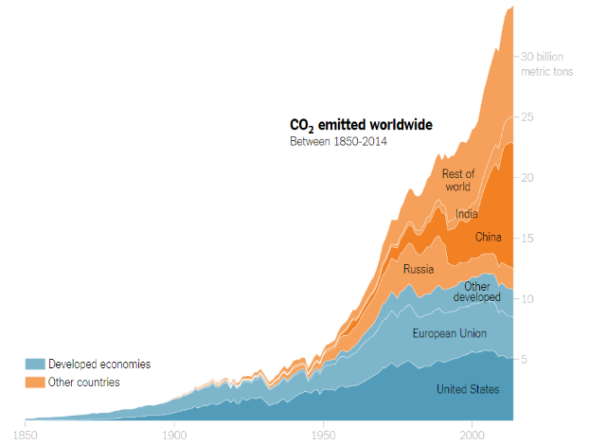 | 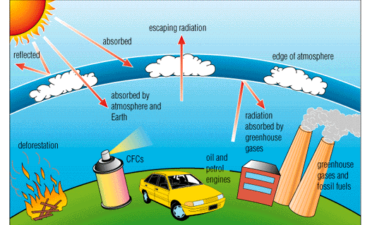

The industrial revolution with the intensive use of fossil fuels lead to an increase of greenhouse gases in the atmosphere. It's explaining by the crude oil refining which emits gases, but also by the using of these fuels like petrol, kerosene bunker fuel which is the more pollutant. These non-renewable energies give on to a significant CO2 emissions, methane and particles maters like carbon monoxide. Since the middle of the 20th century that refers to the glorious thirsty, we see an exponential increase of C02 emitted.
The global warming is explained by the fact that some solar radiation is reflected by Earth and the atmosphere, a part of this radiation is absorbed by Earth. Because of pollution the other part reflected is absorbed and re-emitted in all directions in the atmosphere that is call greenhouse effect.

1.2 Anthropogenic Causes of Global Warming

The world is experiencing a rapid increase in temperatures, and it's no secret that human activities are largely responsible for this phenomenon known as global warming
Greenhouse gases are gases that trap heat in the atmosphere and contribute to global warming. The most common greenhouse gases are carbon dioxide, methane, and nitrous oxide, which are released into the atmosphere through human activities such as burning fossil fuels, deforestation, and agriculture.
Sources
The sources of greenhouse gas emissions vary depending on the sector. The energy sector is the largest contributor to greenhouse gas emissions, accounting for approximately 73% of global emissions in 2019.
Carbon dioxide, methane, nitrous oxide are the main greenhouse gas emissions. Several human activities generate these gases: burning fuel, agriculture, deforestation, industry.

Global Emissions by Gas:
The anthropogenic causes of global warming are mainly related to greenhouse gas emissions resulting from human activities such as the combustion of fossil fuels, deforestation, and intensive agriculture. Carbon dioxide (CO2), methane (CH4), and nitrous oxide (N2O) emissions are the main sources of greenhouse gases.
At the global scale, the key greenhouse gases emitted by human activities are :

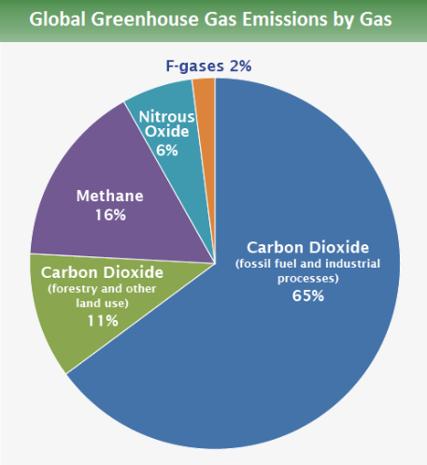 | 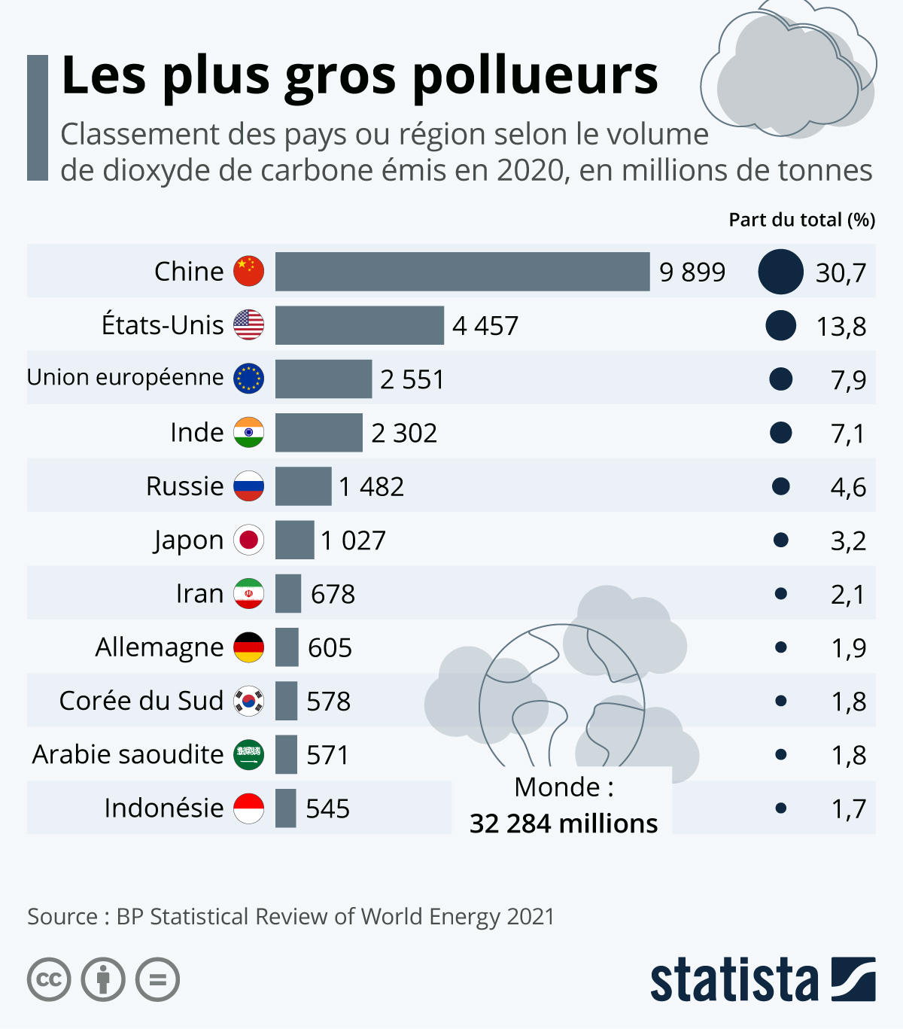

The World’s Top Three Emitters Contribute 16 Times the Greenhouse Gas Emissions of the Bottom 100
The top three greenhouse gas emitters — China, the European Union and the United States — contribute 41.5% of total global emissions, while the bottom 100 countries only account for only 3.6%. The world cannot successfully fight climate change without significant action from the top 10 emitters.

The Energy Sector is the Biggest Greenhouse Gas Emitter
Since reporting began in 1990, the energy sector — including electricity, transport, manufacturing, buildings, fugitive and other fossil fuels — remained the largest contributor to GHG emissions over any other sector, representing 73% of global emissions in 2017.

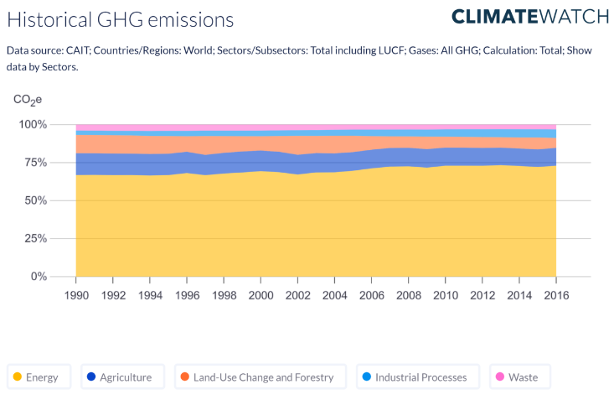

Impacts
Greenhouse gas emissions are the main cause of global warming and climate change. They trap the sun's heat in the Earth's atmosphere and prevent it from escaping back to space. This increases the average temperature of the planet and alters the natural balance of the climate system.
Some of the effects include more extreme weather events, such as heat waves, droughts, floods, storms, and wildfires; rising sea levels and coastal erosion; melting glaciers and ice caps; loss of biodiversity and habitats; food insecurity and malnutrition; water scarcity and pollution; spread of diseases and pests; social conflicts and migration; and economic losses and inequality.

Industrialization and urbanization are significant contributors to greenhouse gas emissions, which are the primary cause of global warming.
- Industrialization is the process of transforming natural resources into manufactured goods and services. It is often associated with economic development and social progress, but it also has significant environmental impacts.

- Urbanization is becoming an important player in the global carbon cycle. Urban residents currently control ~22% of the total land carbon uptake and ~24% of the carbon emissions from land globally. Cities are the main body of greenhouse gas emissions and an important field for decreasing carbon emissions. Urbanization provides market demand pulling forces for economic development that accompanies energy consumption and carbon emissions.

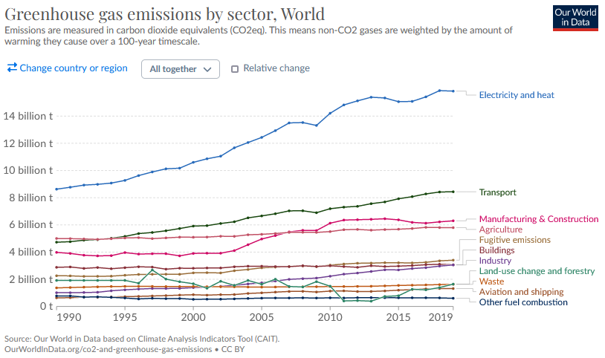
1.3 Natural Factors and their Impact on Climate
Natural factors and their impact on climate :

Natural factors can influence the Earth's climate in various ways, both on short-term and long-term timescales. While human activities, particularly the emission of greenhouse gases, are the primary drivers of contemporary climate change, natural factors also play a role in shaping the climate. We are to present some of the factors are some natural factors and their impact on climate:

1. Solar Variability: Changes in solar radiation can affect the Earth's climate. The Sun goes through cycles of varying solar activity, including the number of sunspots. While these variations can lead to short-term changes in solar radiation and climate, their overall impact on long-term climate change is relatively small compared to human-induced factors.

2. Volcanic Activity: Major volcanic eruptions release large amounts of ash and aerosols into the atmosphere. These particles can reflect sunlight back into space and temporarily cool the Earth's surface. This cooling effect can last for a few years but is usually a short-term climate influence.

3. Orbital Variations: Milankovitch cycles refer to changes in the Earth's orbit around the Sun. These variations in the planet's position and tilt can lead to long-term changes in climate patterns, influencing the timing and intensity of ice ages.

4. Ocean Currents: Natural climate variability is also driven by changes in ocean currents, such as El Niño and La Niña events in the Pacific Ocean. These phenomena can affect weather patterns and temperatures around the world, leading to regional climate anomalies.

5. Natural Climate Oscillations: Various climate oscillations, such as the Atlantic Multidecadal Oscillation (AMO), Pacific Decadal Oscillation (PDO), and North Atlantic Oscillation (NAO), have natural variability in sea surface temperatures and atmospheric pressure patterns that influence regional climate patterns over periods of several decades.

6. Greenhouse Gas Concentrations: While greenhouse gases like carbon dioxide (CO2) are primarily released by human activities, natural processes can also contribute to their concentrations. For example, volcanic eruptions can release CO2, and natural sources like wetlands can emit methane (CH4). These natural emissions can have an impact on the greenhouse effect.

7. Wildfires can release large amounts of carbon dioxide (CO2), carbon monoxide (CO), fine particulate matter and toxic chemicals into the air, contributing to to air pollution.

8. Erosion: Soil erosion due to natural factors such as rain, wind and geological phenomena can result in the runoff of pollutants into waterways, thereby affecting the quality of the water.

9. Carbon sinks: Carbon sinks are a vital part of the carbon cycle and are crucial when it comes to preventing further rises in our global average temperature and the rapid deterioration of our climate. However, today's carbon sinks may become tomorrow's carbon sources if we don't do more to protect these vital systems.

It's important to note that while these natural factors can influence climate, the current rapid and unprecedented warming of the Earth's climate is primarily driven by human activities, especially the burning of fossil fuels, deforestation, and industrial processes that release large amounts of greenhouse gases into the atmosphere. The cumulative effect of these human-induced emissions far outweighs the natural factors in driving contemporary climate change.
1.4 - The consequences of global warming on the environment and socioeconomic factors.

Hello Everyone, may we have your attention please ?

Today we are here to discuss this topic : “The consequences of the environment and socio economic factors.

In order to do so, we are going to follow few main points:

First we are going to give you a brief introduction about global warming, what it entails and what are the challenges that we as humans are facing towards this matter.

Global Warming is a topic that has been trending in the past few years in the news whether on TV or written articles.

It has been the subject of many studies by scholars, but which definition qualifies the most, this situation?
According to physicist Sir John T. Houghton, : “'Global warming' is a phrase that refers to the effect on the climate of human activities, in particular the burning of fossil fuels (coal, oil and gas) and large-scale deforestation, which cause emissions to the atmosphere of large amounts of 'greenhouse gasses', of which the most important is carbon dioxide”.

As you may know, we produce carbon dioxide as we breathe, but also in our daily lives by our way of living.

Many factors such as using cars for our errands and transportation, our utilization of the internet, or any electronic devices, contribute to global warming at many levels.

In order to set out what are the many consequences of global warming we are going to start by laying-out the causes.

I will let Farah the floor,

I) environmental consequences of climate change:

1- high temperatures
The last decade was the warmest on record. The last month of june was the warmest on record. Another side effect is unusual weather outside of the summer periods which can lead to an increase of snowfalls in some regions which can give the

2- drought and wildfires
Examples of recents wildfires are the Canadian wildfires of the summer 2023 whose smoke transformed New York’s landscape into the set of Blade Runner 2049.
FYI : The wildfires turned the NY sky orange while Canadian skies were red (the smoke).

3- fresh water/ water stress
Clean water is becoming scarce which in turn can lead to conflict over water rights. The current conflict brewing between the Taliban and Iran is a good example of the coming water wars.

4- biodiversity
Biodiversity is weakened by the droughts brought about by climate change and the recurring wildfires. In Australia the wildfires are estimated as having increased the number of endangered species by 14 percent because of the destruction of their natural habitats.

5- soils

6- maritime life/ sea level rise
The rising temperatures are having negative effects on maritime life forms such Corals and shell bearing lifeforms

7- more severe storms
The increasing heat results with clouds carrying more water as more is evaporated which results with a greater downpouring of rain that can be somewhat violent and overcome the resistance of human infrastructure. Examples include last week's wild storm in New York and the massive flooding during the Typhoon season in India this year.

8- disappearance of the island nations because of the rise of the oceans levels

The melting of the arctic contributes to the rise of the ocean levels. which in turns threatens to

socioeconomic factors:

1- health: the exposure to high levels of temperatures leads to many consequences on human health such as death and severe diseases. example of diseases: Diseases Carried by Vectors, respiratory diseases, Allergies and Infectious Diseases and Waterborne Diseases.

2- poverty: Climate change will cause poverty in multiple ways. Crop failures will cost farmers livelihood. Other industries especially in the energy sector and the coal production facilities will encounter transitional difficulties as the economy transitions to new energy models. This will require a transition time so that workers can learn new skills but if the transition is mishandled either by the government or because big businesses do not cooperate this can lead to a lot of economic suffering as some workers will be isolated in rapidly transitioning fields.

3- agriculture sector (the impact on the gross domestic product): Changes in rainfall, atmospheric carbon dioxide (CO2) and ozone concentrations, changes in pest and disease prevalence, and extreme events resulted by climate change will affect both existing and future agricultural activities, sometimes positively and sometimes negatively.

4- human security (civil conflict and migration): human security due to water wars for example the conflict between Iran and Afghanistan. And to a certain extent the Syrian civil war can be attributed to climate change as an increase in crop failures due to climate change led to more people moving to the cities which caused economic stress which the political regime was not capable of answering in an efficient manner.

5- energy demand: The main channels for changes in energy demand are through reduced need for heating in winter, and increased need for cooling in summer. Energy supply may also be disrupted by water shortages, and this may in turn affect energy demand.

6- infrastructure: Global warming and climate change are anticipated to significantly affect the economic infrastructure of the majority of nations. Adaptation-limited communities and poor countries are expected to be disproportionately affected. Homes, dams, transportation systems, and other elements of the built environment will be at risk due to projected increases in the frequency of severe weather, significant flooding, and wildfires in many places. Permafrost melting is expected to cause ground instability or rock avalanches in high-latitude and mountainous areas, significantly endangering structures there. A greater threat is posed to coastal populations around the world by rising sea levels and the likelihood of powerful tropical cyclones.

7- forest products
One of the motors of climate change is the forest product industry. The amazons for example suffered massive deforestation under Bolsonaro’s administration that for the first time the forests are producing less O2 then the CO2 they are emitting.

Socio economics consequences of global warming :

  - Economics losses in some regions and benefits in others
  - Agricultural productivity is expected to decrease with further warming
  - it impact water resources
  - Rising temperatures will increase the demand for air-conditioning but reduce the need for winter heating
  - Health Effects it increase infectious diseases
  - Vulnerable regions are likely to be affected by global warming

Reference list:

The Health Effects Of Global Warming: Developing Countries Are The Most Vulnerable | United Nations.

https://climate.ec.europa.eu/climate-change/consequences-climate-change_en

Causes and Effects of Climate Change | United Nations.

Iran and Afghanistan dispute Helmand water rights as climate change deepens crisis
OECD on GW
Diseases Carried by Vectors | CDC

https://www.britannica.com/science/global-warming/Socioeconomic-consequences-of-global-warming
https://www.britannica.com/science/radiative-forcing
https://www.niehs.nih.gov/research/programs/climatechange/index.cfm

Docs:
Canadian Wildfires impact on Canadian Skies - 2023 :

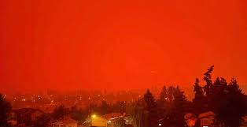

New York sky after the Canadian Wildfires in 2023

1.5 The urgency of addressing climate change (Sophie Duchesne, Armand Binet and Sabrina Bouhali)

The urgency of addressing climate change cannot be overstated. Climate change refers to long-term shifts in temperature, weather patterns, and environmental conditions due to human activities, primarily the emission of greenhouse gases such as carbon dioxide (CO2) and methane (CH4). Here are some key reasons why climate change is an urgent issue:

- extreme weather events : for example increasing ocean levels that flood; extreme heat events. All of this means a global migration: As climate change impacts intensify, there is a growing risk of displacement and migration. Communities may be forced to leave their countries, We need Plans to increase resilience to these problems

- public health, in particular governmental public health, plays a central role in addressing climate change. We need heat action plans for example, to adapt to climatic challenges, particularly for the most vulnerable elders, children, and those at higher risk due to underlying conditions.

- One major accelerator of climate change is population growth. The world population is currently 8 billion, with projections to grow to 9.7 billion by 2050 and 10.4 billion by the end of the twenty-first century. Population growth requires more energy

Given these urgent challenges, international efforts, such as the Paris Agreement, have sought to limit global warming to well below 2 degrees Celsius above pre-industrial levels. However, meeting these targets requires immediate and sustained action to reduce greenhouse gas emissions, transition to renewable energy sources, and implement adaptation measures. Individuals, communities, businesses, and governments all play crucial roles in addressing the urgency of climate change and working towards a more sustainable future.

Addressing climate change is a complex and urgent global challenge. There are several key responses and strategies that can help combat climate change:

- Reducing Greenhouse Gas Emissions: This involves decreasing the release of carbon dioxide (CO2) and other greenhouse gases into the atmosphere. This can be done by transitioning to cleaner energy sources, improving energy efficiency, and adopting sustainable transportation methods. Renewable Energy: Increasing the use of renewable energy sources like solar, wind, and hydropower can significantly reduce carbon emissions from the energy sector.

- Conservation and Reforestation: Protecting and restoring forests, wetlands, and other natural ecosystems can absorb carbon dioxide and help regulate the climate.

- Transition to Electric Vehicles: Promoting electric vehicles and developing infrastructure for them can reduce emissions from the transportation sector.

- Climate Adaptation: Preparing for the impacts of climate change is crucial. This includes building resilient infrastructure, planning for sea-level rise, and ensuring food and water security.

- International Cooperation: Climate change is a global issue, and international agreements like the Paris Agreement play a vital role in coordinating efforts to reduce emissions and limit global warming.

- Public Awareness and Education: Educating the public about climate change and its consequences is essential for building support for climate action.

- Policy and Regulation: Governments can implement policies and regulations that encourage sustainable practices and penalize environmentally harmful ones.

- Research and Innovation* Continued research and innovation are essential to developing new technologies and solutions to mitigate and adapt to climate change.

- Individual Actions: Individuals can contribute by reducing their carbon footprint through energy conservation, reducing waste, and making sustainable choices in their daily lives.

Vocabulary

- Solar Variability: Refers to changes in solar radiation that reach the Earth. This variability can be the result of variations in the Sun's activity, such as the number of sunspots or the solar cycle.
- Milankovitch cycles: These are cyclical changes in the Earth's orbit around the Sun and the tilt of the Earth's axis. These cycles influence the Earth's climate over tens of thousands of years and are thought to be responsible for the timing of ice ages.
- El Niño and La Niña: These are phases of the El Niño-Southern Oscillation (ENSO) climate pattern. El Niño refers to the warm phase and La Niña refers to the cold phase. Both phases influence global climate and weather patterns.
- Atlantic Multidecadal Oscillation (AMO): This is a mode of natural variability occurring in the North Atlantic Ocean which has its phases marked by sea surface temperature changes. It can influence climate in the North Atlantic region and beyond.
- Pacific Decadal Oscillation (PDO): A pattern of climate variability similar to ENSO but it operates over a longer timeframe (decades rather than years). It affects the Pacific and North American climate.
- North Atlantic Oscillation (NAO): It's a climate phenomenon in the North Atlantic Ocean of fluctuations in the difference of atmospheric pressure at sea level between the Icelandic Low and the Azores High. It influences the weather in Europe and the Eastern US.
- Greenhouse Effect: It's a natural process where certain gases in the Earth's atmosphere trap heat, preventing it from escaping back into space, thus warming the Earth's surface. It becomes problematic when human activities increase the concentration of these gases, amplifying the effect.
- Erosion: The process where soil and rock are removed from the Earth's surface by exogenic processes such as wind or water flow, and then transported and deposited in other locations.
- Carbon sinks: Natural systems, like forests or oceans, that absorb more carbon dioxide than they release. They help reduce the overall concentration of greenhouse gases in the atmosphere.
- Deforestation: The removal of a forest or stand of trees where the land is thereafter converted to a non-forest use. It's a major concern as it releases large amounts of CO2 and reduces the number of trees available to absorb CO2.

John Houghton 2005 Rep. Prog. Phys. 68 1343 // https://iopscience.iop.org/article/10.1088/0034-4885/68/6/R02/pdf
Doc 1 : Orange Skies in NYC due to wildfires in Canada

