What is new in France at the moment with high-speed rail lines?
In France, as is the rest of Europe, the network is being opened to competitors.

Trainitalia is operating on the Paris-Lyon and Paris-Marseille route.

Renefe is launching a service from Madrid to Marseille, and from Barcelona to Lyon.

€60 one-way.

In the UK, the state is progressively renationalising the train services.
When was the track re-nationalised?

When was British Rail privatised?
In the 1990s.
The whole system was privatised progressively in the 1990s, with the track being finally privatised in 1996.
As Rania said, it was complicated and did lead to rising prices. There were considerable problems with maintenance. There were at least two major accidents.
But, passenger numbers grew substantially.

Rolling stock > matériel roulant (locomotives and passenger carriages, freight trains)

The whole system was broken up and very many entities (private companies) were created to manage different parts of the system: the track, the rolling stock and the passenger service franchisees.

The idea was to foster competition, for example between the rolling stock companies (the ROSCOs).

There was competition for companies providing passenger services.
Essentially, monopoly licences to operate services in a particular region (or maybe on a particular line - Eurostar) were sold in auctions, with the winner being the company asking for the lowest subsidy to manage the service.
Licences were granted for fixed periods of time.

There were considerable problems with rising prices, and also general coordination and information problems, because suddenly there were so many actors, and if, for example, you wanted to travel from London to Edinburgh, you surely had to use more than one company.
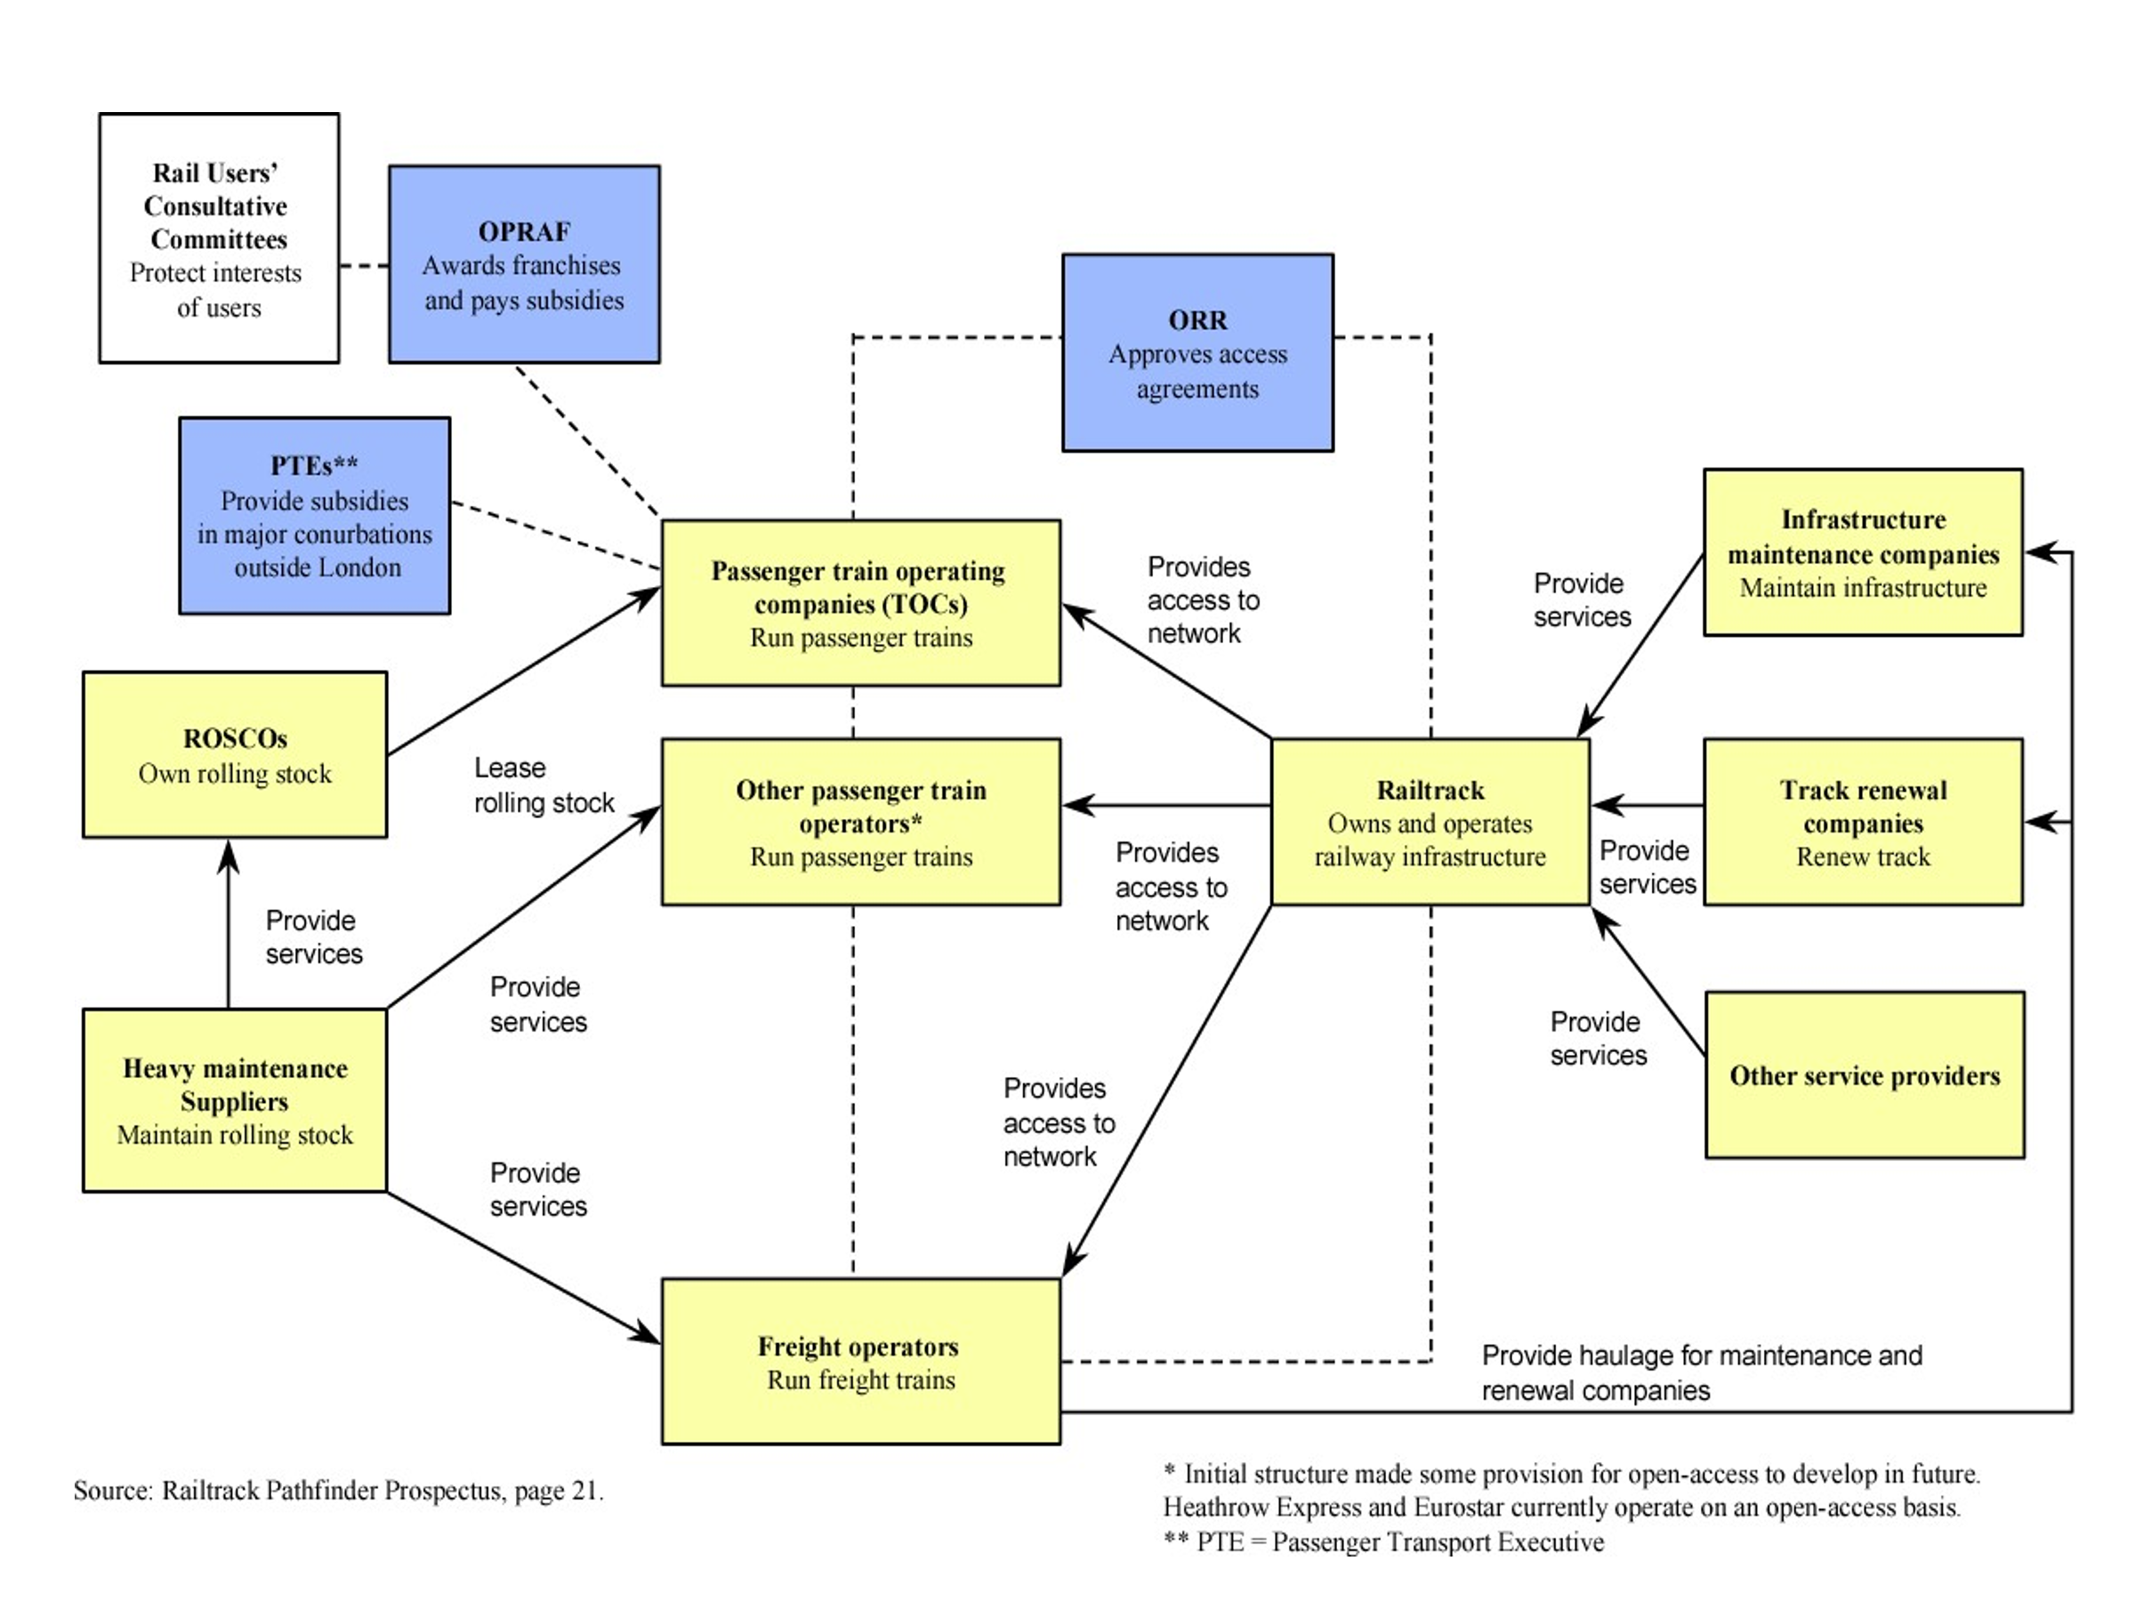

UK Rail Is Being Nationalised – The 10 Things You Need To Know
https://www.youtube.com/watch?v=gPsGlFnMmW8

back under public control
Why should we care?
Will it get better?

1/ Network Rail is already nationalised (2014)
As the franchise licences end, the services will come back into public management.
The government will be able to reunited track and trains within big regions and operate them as integrate systems – ending the spaghetti of contracts and agreements, thus cutting costs.

2/ Passenger journeys rose from 800 million to 1.7 billion by the time of the pandemic in 2020.

The rail network went bust/went bankrupt.

More trains were running on an increasingly congested network.

3/ there increasing difficulties with the structure of network.
“But what really did for it, was the collapse of passengers and revenues during the pandemic.”

Since 2020, companies have had strict contracts, and have been told what to do.

4/ The government will wait for the franchise contracts to end, to save money and to phase in the nationalisation and avoid organisational problems (chaos).

5/ £150 million in savings from not having to organise the competitive tenders (les appels d’offres) when franchises expire.

Hopefully, there will be other organisational savings.

6/ Are the trains all going to be the same?
They will keep regional identities, but also be part of Great British Railways.

To be able to use this brand (label) each company will have to meet “tough competitive standards”.

7/ Will prices come down?
Not immediately, and in any case the government wants to decrease the total subsidy.

What are the two sources of revenue: fares and subsidies. So if subsidies come down, fares won’t be able to.

8/ Will it make trains run on time.
The hope is that a single operator will make running the trains less complex.

9/ Will everything be renationalised?
Currently the trains are owned by private finance companies.
The idea is not to change this, because it keeps costs away from public borrowing.
(The Chancellor of the Exchequer is Britain’s Finance Minister.)

Rail freight companies will remain in the private sector. They were one of the success stories of privatisation.

Open access lines (I guess these are point-to-point routes) will not be affected, nor will Transport for Wales or Railways of Scotland be affected, and certain other lines (the Elisabeth line, etc.)

The supply chain enormous, and that is not going to come back into the public sector either.

Re-nationalisation is not creating the same vertical monopoly which existed after World War II.

10/ The hope is that the over-centralisation since Covid will diminish.

