What is AI?
What have you come up with so far?

The Turing test: 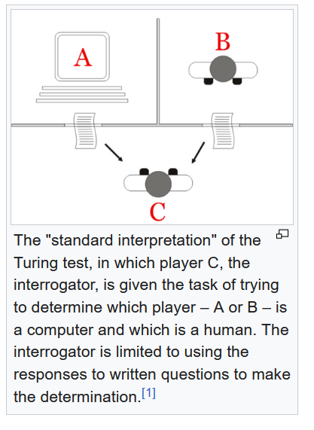
The term artificial intelligence was first used in 1956.
When did Big Blue beat Kasparov? 1997

“Do you read me?” > can you hear and understand what I am saying.

What is AI: https://www.youtube.com/watch?v=JcXKbUIebrU
How does the video define AI?
It combines computer science, large sets of data and problem solving.
3 types:
1/ artificial narrow intelligence ANI – used for automation, voice recognition, machine learning (robotics for automated task: apparently there are many dark factories now in China: there are no lights, only machines operating in the dark).
1b/ generative artificial intelligence (GenAI)
2/ artificial general intelligence – computers are as capable as humans
3/ artificial super intelligence

“the pros and cons”
The pros:
Save time, by streamlining activities (rationaliser des activités), less errors than human decisions, do dangerous tasks, allow for new technologies to be created.
The cons:
It’s expensive, massive environmental impact, the loss of human jobs.
Plagiarisation of creative works
Problems of hacking and security

In the same groups, discuss the different ways you use AI, and also perhaps the different platforms, apart from ChatGPT.

I use AI for cooking, by telling ChatGPT what is in my fridge, for preparing a weekly.
I use it for specific questions, for information and explanation.
… for document search
… to answer specific questions
I use it a work to correct my emails (ChatGPT or Copilot)
I use AI by Dalloz for legal questions

I used it to help explain maths slideshows.
DeepL for translation. DeepL write

Pour faire qqc > to do something
Never use “for” with a verb.

I use it to summarise slides in the economics classes.

I use it to work out travel itineraries
I translate all documents at work and summarise meetings.
Does anyone use Perplexity. It is very good for sources.

HER. The “hero”, played by Joachim Phoenix, falls in love with an AI, who is a woman.
Finally, she breaks up with him because she has lots of intellectual affairs with other AI.

Apprentissage automatique > machine learning
Réseau de neurones > neural network
Entraînement > training
Jeu ou base de données > dataset/database
Centre de calcul > data centre
Surapprentissage > overfitting
Biais > bias
Précision > accuracy
Traitement du langage naturel > natural language processing (NLP)
(traitement de texte > word processing)
Reconnaissance vocale > voice recognition
Éthique de l’IA > AI ethics
Vie privée > privacy
IA faible > narrow AI
IA forte > strong AI???
Singularité technologique > technological singularity (I think it is a point that we may get too, and we don’t really know what will happen on the other side).
Internet des objets > the internet of things (IoT) – essentially having sensors in everything, linked to internet

In England (and maybe in Scotland) they celebrate Guy Fawkes’ Day every 5 November. This is done by having a big bonfire and burning a Guy (an effigy of Guy Fawkes). There are also fireworks, and people eat toffee apples.
This is Protestant England remembering and celebrating the foiling (déjouer) the Gunpowder Plot.

King James I of England was also King James VI of Scotland, and he united the crowns.
A plot = un complot, une intrigue ou même une graphique
Who are the goodies and baddies > les bons et les méchants

The plot was to blow up Parliament when the King came to open it for a new session.

Each year the monarch goes to Parliament and presents the King’s or Queen’s Speech, in the House of Lords, because since the Civil Wars in the 17th century, the monarch is not allowed to enter the House of Commons.
This symbolises the fact that in the UK, it is the “monarch in Parliament” which is sovereignty.

