An Overview of Anthropology (by Le Chat/Mistral, and vocabulary, 25 Feb 2026)
- Anthropology: Understanding Humanity’s Past and Present
Anthropology is the study of humans—our past, our cultures, and how we live together. It helps us explore questions like: Where did humans come from? Why do we have different traditions? How do rituals shape our lives? By examining these topics, anthropology connects us to people across time and around the world.
- Human Origins: The Journey of Our Species
Anthropologists study human evolution to understand how we became the species we are today. Our story begins millions of years ago with early human-like creatures, such as Australopithecus. Over time, these ancestors developed larger brains, walked upright, and created tools (tools are objects used to do things, to make things, and today include: axe (to cut wood, to chop down trees), hammer is used to hammer in nails; a screwdriver, a wrench, a saw (to cut wood, or metal), a file (to smoothen wood or metal)).
Telephones, computers, smartphones are more electronic devices, or instruments.
Around 300,000 years ago, Homo sapiens—our species—emerged in Africa. These early humans migrated across the globe, adapting to new environments. They developed language, art, and complex societies, leaving behind cave paintings, tools, and burial sites that tell us about their lives.
For example:
- Cave art in places like Lascaux, France, shows that early humans expressed themselves through drawings of animals and hunting scenes (a picture showing hunting).
The Lascaux caves are very well-known for their early human art:
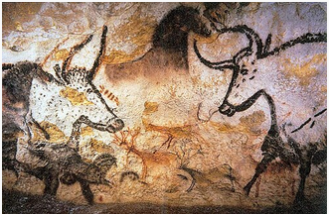 | 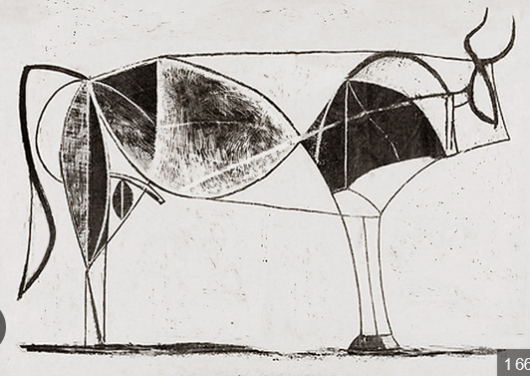

- Stone tools found in Africa and Asia reveal how humans survived by making weapons (instrument for fighting), clothing, and shelters (a place to live, stay: an emergency shelter, like a tent; a bus shelter).
By studying fossils and ancient artifacts, anthropologists piece together (to put together, to assemble) the story of how humans evolved and spread across the Earth.
- Rituals: The Heart of Culture
Rituals (customs, ceremonies, habits) are special actions or ceremonies that hold deep meaning for a community. They can mark important moments in life, connect people to their beliefs, or celebrate shared values. Rituals often involve symbols, music, dance, or food, and they help people feel united and understood.
Here are some types of rituals:
- Rites of Passage: These mark major life changes, such as birth, coming of age, marriage, or death. For example:
  - In many cultures, a quinceañera (a 15th birthday celebration in Latin America) symbolizes a girl’s transition into adulthood.
  - In Japan, Seijin Shiki (Coming of Age Day) celebrates young people turning 20 and becoming adults in society.
- Religious Rituals: These ceremonies connect people to their faith and community. Examples include:
  - Prayer or meditation in religions like Christianity, Islam, or Buddhism.
  - Festivals such as Diwali in India (the Festival of Lights) or Christmas in Western cultures.
- Daily Traditions: Smaller, everyday rituals help people feel connected to their culture. For instance:
  - Sharing a family meal can be a way to bond (a connection, a link, a form of government or company debt) and pass down traditions.
  - Storytelling in many Indigenous cultures preserves history and teaches values to younger generations.
Rituals are not just about the actions—they carry emotions, memories, and a sense of identity. They remind us of who we are and where we belong.
Eid al-Fitr marks the end of Ramadan and is one of the most important Islamic celebrations. It begins with a communal prayer and is followed by visits to relatives, giving gifts, and sharing meals. There are many rituals associated with this celebration, including family gatherings, giving money to poor people (one of the most important things), giving presents to children.
It is also a day of forgiveness and unity.
When a baby is born, there is a celebration after one week. The ritual is to cut the child’s hair and then give an equivalent weight in gold for charity.
- Traditions: Passing Down Culture
Traditions are customs or beliefs that are handed down from generation to generation. They can include holidays, foods, clothing, music, and even ways of speaking. Traditions help people maintain their cultural identity and feel connected to their ancestors (members of the family who lived before you. Some religions practice ancestor worship: to pay respect in a religious way, to pray. In the mono-theistic religions people worship God and prophets.).
Examples of traditions:
- Food: In Italy, making pasta from scratch is a tradition that families share. In Mexico, cooking mole (a rich sauce) for special occasions is a way to honor heritage.
- Clothing: Wearing traditional outfits, like a kimono in Japan or a kilt in Scotland, celebrates cultural pride.
- Music and Dance: Flamenco in Spain, samba in Brazil, and hula in Hawaii are all traditions that express cultural stories and emotions.
Traditions can change over time, but they often remain an important part of people’s lives, even in modern societies.
- Why Anthropology Matters
Anthropology teaches us that while cultures may look different, all humans share basic needs: love, belonging, and meaning. By studying rituals and traditions, we learn to appreciate diversity and understand the world from different perspectives.
For example:
- A wedding ceremony in India might look very different from one in France, but both celebrate love and commitment.
- A harvest festival in Africa and a Thanksgiving dinner in the U.S. both give thanks for food and community.
Anthropology helps us see that, despite our differences, we are all part of the same human story.
Last summer, I translated a very interesting book about how humans stopped being hunter-gatherers, and settled throughout the world – about 10,000 years ago.
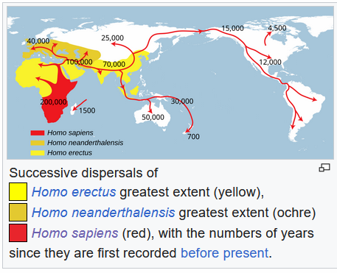
My very simple conclusion was that men have not changed much in 10,000 years. The big change is that in the last 50 to 60 years, women have gained some control over their own bodies and sexuality, and become more economically independent.

Vocabulary by Le Chat/Mistral
- Artifact; an object made by humans, typically of cultural or historical interest; relic, object, antique
- Kin; a person's relatives or family members; relatives, family, clan
- Myth; a traditional story, especially one concerning the early history of a people or explaining a natural or social phenomenon; legend, folklore, tale
- Taboo; a social or religious custom prohibiting or restricting a particular practice or forbidding association with a particular person or thing; prohibition, ban, restriction
- Cultural relativism; the principle that an individual's beliefs and activities should be understood in terms of their own culture; cultural perspective, relativism, cultural understanding
- Society; a group of individuals who share a common culture, institutions, and norms; community, civilization, population
- Norms; the shared expectations or rules that guide behavior within a society; standards, customs, conventions
- Symbol; an object, word, or action that represents an idea, belief, or entity; emblem, sign, representation
- Ancestor; a person from whom one is descended, especially one more remote than a grandparent; forebear, forefather, progenitor
- Ethnocentrism; the tendency to judge other cultures based on the values and standards of one's own culture; cultural bias, cultural chauvinism, cultural superiority
- Adaptation; the process of adjusting to new environmental, social, or cultural conditions; adjustment, modification, acclimatization
- Matrilineal; relating to or based on kinship with the mother or the female line; maternal, mother-right, female lineage
- Shamanism; a practice involving a practitioner (shaman) who is believed to interact with the spirit world for healing, divination, or guidance; spiritual healing, spirit mediation, animistic practice
- Patriarchy; a social system in which men hold primary power and dominate roles of political leadership, moral authority, and social privilege; male dominance, father-rule, androcentrism
- Matriarchy; a social system in which women hold primary power and leadership roles, often in family and community structures; female dominance, mother-rule, gynecocracy
- Totem; a natural object, plant, or animal that is considered the emblem of a clan, family, or group and often holds spiritual significance; clan symbol, spiritual emblem, ancestral sign
- Colonialism; the practice of a powerful country controlling another country or territory and exploiting its resources, often leading to cultural domination; imperialism, occupation, territorial expansion
- Globalization; the process of interaction and integration among people, companies, and governments worldwide, often leading to cultural exchange; worldwide integration, cultural exchange, internationalization
- Oral tradition; the transmission of cultural material—such as stories, songs, and histories—through speech rather than writing; verbal lore, spoken history, unwritten tradition
- Cultural diffusion; the spread of cultural beliefs, social activities, and artifacts from one group or society to another; cultural spread, cultural exchange, cross-cultural transmission

Quick recap
Professor Nicholas welcomed students to his anthropology class and addressed technical issues before leading a discussion on human evolution, tools, and early human expressions through cave art. The class explored various cultural traditions and rituals, including Islamic practices during Ramadan and Eid, while examining how anthropology helps appreciate cultural diversity and understand different perspectives. The session concluded with a discussion about human societal transitions and future topics, including education and research, with confirmation of upcoming Duolingua tests.

Next steps
- Nicholas: Confirm availability for next Friday's class and inform students
- Nicholas: Choose and prepare topic for next week (technology or education and research based on student suggestions)
- Nicholas: Post the anthropology text and vocabulary on the site
- Students (optional): Send any texts or writing exercises about Ramadan and Eid to Nicholas via email
- Students (optional): Send any personal statements or English documents that need review to Nicholas via email
- Nicholas: Prepare more Duolingo test materials for Monday's class

Summary

Anthropology Class Introduction Meeting
Nicholas welcomed students to his class and addressed technical issues with email delivery due to incorrect contact information. He announced plans to cover anthropology, explaining that this topic frequently appears in tests. The class began with Nicholas preparing to share his screen, with Nader mentioned as joining the session.

Anthropology Text Discussion Overview
The meeting involved reading and discussing an anthropology text, with students taking turns to read sections about the study of humans, human evolution, and early human development. Professor Nicholas guided the reading and clarified vocabulary, particularly around terms like "tools" and "Australopithicus." The discussion focused on ensuring students understood key concepts, with Professor Nicholas asking clarifying questions about vocabulary and tools, and students confirming their understanding.

Common Tools and Their Uses
The group discussed various tools and their uses. Nicholas led the conversation, explaining tools like an axe for cutting wood, hammers for driving nails, screwdrivers, wrenches, saws, and files. The participants, including Lia and Aseel, provided examples and confirmed their understanding of these tools. The discussion aimed to clarify the definitions and uses of common tools in English.

Early Human Tools and Art
The group discussed early human expressions through cave art, specifically mentioning Lascaux, France, where hunting scenes were drawn. They explored the concept of stone tools found in Africa and Asia, discussing their uses in making weapons, clothing, and shelters. The conversation included explanations of what constitutes a weapon and shelter, with examples like tents and bus shelters provided to illustrate these concepts.

Early Human Art and Evolution
Nicholas discussed early human art, specifically referencing the Lascaux Caves in France, which are approximately 37,000 years old, and mentioned how these designs inspired artist Picasso. He showed examples of Picasso's work, including his famous painting of the bombing of Guernica during the Spanish Civil War, and explained how Picasso was inspired by the cave art. The discussion then shifted to Aya reading about anthropologists studying fossils and ancient artifacts to piece together the story of human evolution and spread across Earth.

Cultural Rituals and Traditions Discussion
The group discussed the concept of rituals, defining them as special actions or ceremonies with deep cultural meaning. Students shared examples including Ramadan practices, coming of age celebrations, religious ceremonies, and daily family traditions. The discussion concluded with Nicholas proposing to divide the students into two groups of three to four people to discuss which rituals they prefer.

Group Formation and Ritual Discussion
Nicholas created two groups, with one containing Dana, Toka, Lia, and Sarah, and the other containing Asil, Aya, and Nader. He instructed participants to automatically move into their respective groups. The conversation ended with Nicholas asking Lia about which ritual she liked in particular, though her response is not captured in the transcript.

Islamic Traditions and Rituals
The group discussed Islamic traditions and rituals, particularly focusing on Ramadan and Eid al-Fitr. Lia explained that Ramadan promotes unity and reminds people about helping the poor, while Nader and Aya described Eid al-Fitr as a day of happiness and gratitude marked by family gatherings, special meals, and the tradition of giving money to children and the poor. The discussion also covered the celebration of a newborn's first week, which includes a hair-cutting ritual followed by giving gold weighted to the child's hair.

Cultural Traditions and Their Significance
The group discussed traditions and their cultural significance, with Nicholas explaining concepts like ancestor worship and religious practices across different faiths. They reviewed examples of traditional practices including food preparation, clothing, music, and dance from various cultures such as Italy, Mexico, Japan, and Scotland. The discussion concluded with an exploration of how anthropology helps us appreciate cultural diversity and understand different perspectives through the study of rituals and traditions.

Human Evolution and Social Change
Nicholas discussed anthropology, focusing on how humans transitioned from hunter-gatherer lifestyles to settled communities about 10,000 years ago. He shared insights from a French book he translated into English, concluding that while humans haven't changed much genetically over 10,000 years, recent changes include women gaining more control over their bodies and economic independence. The group discussed potential topics for future sessions, with Sara suggesting education and research, and Nicholas confirmed they would continue with Duolingua tests on Monday, though he noted uncertainty about next Friday's availability.

