Some points about inequality and poverty
(Le Chat, Mistral) Inequality refers to the unequal distribution of resources, opportunities, or outcomes among individuals or groups in society. It can manifest in various forms, such as income, wealth, education, health, and social status. Economists and social scientists often focus on economic inequality, particularly income and wealth inequality, as key indicators of societal well-being and fairness.

Key Measures of Inequality

1. Gini Coefficient
- What it measures: The Gini coefficient (or Gini index) quantifies the degree of income or wealth inequality within a population. It ranges from 0 (perfect equality) to 1 (perfect inequality).
- How it works: It compares the actual distribution of income/wealth to a perfectly equal distribution. A higher Gini coefficient indicates greater inequality.

2. Income/Wealth Quintiles or Deciles
- What it measures: Divides the population into fifths (quintiles) or tenths (deciles) based on income or wealth, showing the share of total income/wealth held by each group.
- How it works: For example, if the top 20% of the population holds 50% of the total income, it indicates high inequality.
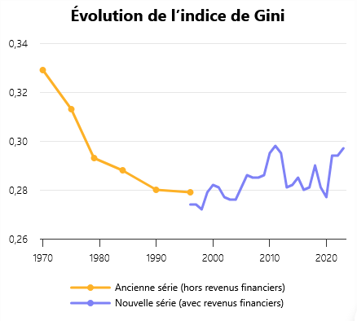
https://www.inegalites.fr/evol-inegalites-long
In France, there seems to have been a moderate fall in income inequality (excluding financial income) since 1970.
WEALTH
The Gini coefficient can also be used to measure inequalities of wealth, and normally, the distribution of wealth is much weaker: i.e. wealth is much more concentrated. The Gini for wealth is roughly twice the size of the Gini for income.
According to Perplexity Pro, France's wealth Gini coefficient stands at 0.652 in 2024, according to official INSEE data, far exceeding the income Gini of around 0.30.^{[1][2]}
This reflects high wealth concentration, where the top 10% of households hold 48% of total gross wealth, and the top 5% hold 34%.^{[1]}

Recent Trends
Wealth inequality has edged up slightly from 0.645 in 2015 to 0.652 in 2024, driven mainly by rising real estate disparities (Gini from 0.644 to 0.655).^{[3][1]}
Earlier data shows 0.662 in 2021, indicating some fluctuation but persistent high inequality compared to income (0.299 in 2023).^{[4][2]}

Key Comparisons
Metric | Wealth Gini | Income Gini | Notes
2024 (latest) | 0.652 | ~0.30 | Wealth over twice as unequal ^{[1]}
2021 | 0.662 | 0.294 | Top 10% hold 48% wealth vs. 25% income ^{[4]}
2015 | 0.645 | N/A | Pre-rise in housing-driven gaps ^{[1]}

The median gross wealth is €205,100, with the bottom 50% holding just 7% of total wealth.^{[1]}
- https://tradingeconomics.com/france/gini-coefficient-of-equivalised-disposable-income-eurostat-data.html
- https://www.insee.fr/fr/statistiques/8672665
- https://www.leconseilpatrimoine.fr/actualites/patrimoines-un-fosse-qui-se-creuse-encore-entre-les-menages-francais/
- https://data.worldbank.org/indicator/SI.POV.GINI?locations=FR
- https://www.alternatives-economiques.fr/inegalites-de-patrimoine-augmentent/00113227
- https://gateway.euro.who.int/en/hfa-explorer/gini-coefficient/france/
- https://www.oecd.org/content/dam/oecd/en/data/datasets/income-and-wealth-distribution-databases/idd-key-indicators.xlsx
- https://www.insee.fr/fr/statistiques/7941439?sommaire=7941491
- https://www.insee.fr/fr/statistiques/3561260
- https://fr.wikipedia.org/wiki/Liste_des_pays_par_égalité_de_revenus
- https://statbase.org/data/fra-gini-index/
- https://fr.theglobaleconomy.com/France/gini_inequality_index/
- https://www.oklein.fr/en/income-inequality-france-trapped-by-treating-symptoms-rather-than-root-causes/
- https://www.worldeconomics.com/Processors/Economics-Countries-Inequality-GiniCoefficient.aspx?Country=France
- https://www.cashbee.fr/the-interest/la-france-est-elle-particulierement-inegale

Thomas Piketty, Capital in the Twenty-First Century, Harvard University Press, 2014
Piketty et al. have emphasised the wealth of the top 1%. In particular, they note that the “great compression” of inequality of wealth in the 20th century ended in the late 1970s with the move to neoliberal policies.
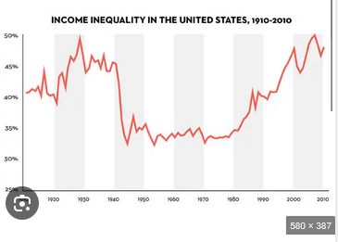
(Wealth held by the top 1% of US households.)
Piketty’s big idea is that under capitalism the real interest rate on investment is higher than the growth rate (r > g ). Therefore, wealth accumulates and concentrates.
The great compression, Piketty argues, was due to the Great Depression and then World War II, and high taxation after 1945, until 1981. Otherwise, during times of peace, capitalism tends to lead to income and wealth inequalities.

Branko Milanovic is famous for his “elephant”:
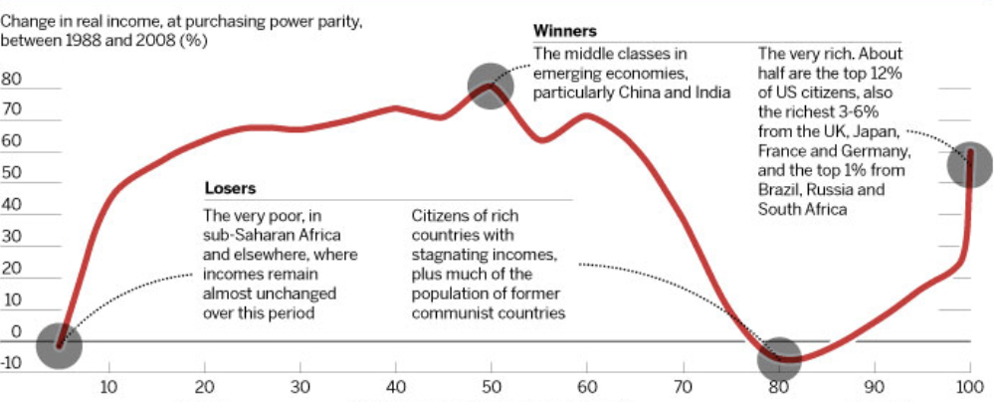

The graph shows growth in income per percentile of the global population between 1988 and 2008. The major rise in income occurred in Asia and especially China. The very rich (the trunk of the elephant) also experienced real income growth.
The “losers” are middle classes in the “rich countries” and much of Eastern Europe.
Significantly, Milanovic has shown that “peak global inequality” occurred from the 1950s to 1970s
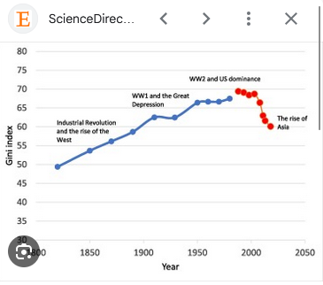

Apart from that, you can also see the “Deaton Review” for a much broader study of inequalities in English-speaking countries: https://ifs.org.uk/inequality/

